Eng. Hasan AL-Haddad

Mechanical Project Engineer

Personal Information

Name: Eng. Hasan Al-Haddad
Major: Mechanical Engineering
Experience: 10 Years
Current Residence: KSA, Riyadh
Area of expertise: Supervising implementation projects

Eng. Hasan AL-Haddad

Mechanical Project Engineer

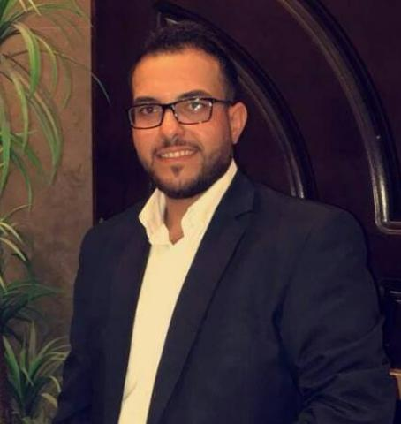

Personal Information

Nationality Jordanian
Date of Birth 12-7-1989
Place of Birth Jordan
Marital Status Married
Religion Islam
Association
- Member of Jordanian Engineers Association, Mechanical engineering.

Address Jordan-Zarqa

Email hasan.j.h@hotmail.com
Mobile 00962799325216 (Jordan)

00966593836199 (KSA)

Career Objective

- To secure a challenging position as a Mechanical Project Engineer where I can utilize my expertise in mechanical systems, project planning, and execution to contribute to the success of engineering projects while continuously developing my skills in advanced mechanical and project management techniques.

Professional Summary

- Experienced Mechanical Project Engineer with a proven track record in designing, managing, and delivering complex engineering projects. Expertise in mechanical systems, HVAC, fire safety, and drainage systems. Skilled in project planning, risk management, and team coordination to achieve timely and cost-effective solutions. Adept at leveraging technical acumen and leadership skills to drive efficiency and ensure compliance with safety and quality standards.

Core Competencies

- Project Engineering & Execution
- Mechanical System Design & Analysis
- HVAC, Water, Drainage & Firefighting Systems
- Risk & Budget Management
- AutoCAD Proficiency
- Maintenance Planning (Predictive & Corrective)
- Vendor & Stakeholder Coordination
- Health & Safety Compliance

Education

B.Sc. in Mechanical Engineering
Al-Balqa Applied University – Faculty of Engineering Technology, Amman, Jordan
Graduated: January 2013
Professional Experience

• Mechanical Engineer: At 45 holding Company, Riyadh
Since January 2025– till now

- Oversaw the installation and commissioning of mechanical systems across [type of projects, e.g., residential, commercial, or industrial sites].
- Coordinated with contractors, architects, and stakeholders to ensure project alignment with design specifications.
- Monitored project timelines, budgets, and resource allocation to ensure efficiency.
- Conducted on-site inspections to enforce safety standards and compliance with local regulations.
- Prepared and reviewed technical documentation, including blueprints, Auto CAD drawings, and reports.

Mechanical Project Engineer: At Ajwan Construction Company, Jordan
Since July 2017 – DECEMBER 2024
- Managed projects, including timelines, budgets, and technical specifications of hospital.
- Developed and maintained project execution plans of hospital.
- Supervision of mechanical and electrical system, facility management and operational continuity of hospital.
- Coordinated with cross-functional agents and vendors to ensure the best maintenance needs of hospital.
- Managing the work team and determining tasks according to the required priorities of hospital.
- Managed spare parts inventory and maintenance budgeting of hostiptal.
- Delivered internal projects.

Mechanical Site Engineer at Al-Qiyadiya Company for Engineering (Maani Metalform), [Jordan & Saudi Arabia Projects]
June 2014 – May 2016

- Analyzed designs and layout analysis for sheet metal fabrication projects.
- Coordinated mechanical system design, testing, and validation with contractors and vendors.
- Ensured adherence to quality and safety standards in mechanical design.
- Conducted value engineering to optimize project cost and efficiency.
- Developed executive drawings and recommended system improvements.
- Effective communication with the customer to ensure the required specifications according to the terms of the contract and the site.
- followed up the manufacturing and design departments to ensure the best required standards.
Training & Certifications

- MODERN WORKSHOP MANAGEMENT, Automotive Technology and Industrial
Automation Academy, Amman- 19/8/2013-5/10/2013.

- AUTOMATIC TRANSMISSION DIANOSIS & REPAIR, Automotive Technology and Industrial Automation Academy, Amman- 21/8/2013-15/9/2013 .

- CAR SERVICE, Bustami and Saheb Trading (Nissan), Amman- 16/9/2012-24/12/2012.
- HEATING VENTILATION AIR CONDITIONING., The Engineers Training Center, Amman- 21/1/2012-5/2/2012 .

- FIRE-FIGHTING SYSTEMS, Engineers Training Center.

- VARIABLE REFRIGERANT VOLUME (VRV), Engineers Training Center.
Languages

Arabic: My native language is Arabic.
English: Fluent conversational, writing.

Skills

- Project Planning and Execution
- Mechanical Systems Design and Analysis
- Maintenance Planning (Predictive and Corrective)
- Team Leadership and Time Management
- Proficiency in AutoCAD
- Compliance with Health and Safety Standards
- Expertise in Water, Drainage, and Firefighting Systems

Interests

- Follow-up to technological development.
- Sports in general.

References

Available upon request.

