C | i c u I urn
I | _ ViEa,€
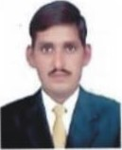
Rashid Manzoor

Position Land Surveyors
Nationality Pakistan
CMC No 36601-7476312-7
Languages Known English, Arabic, Urdu
Marital Status MARID
Address SAUDI ARABIA
Contact No +966580480699, Pak No.0092 307 6996549 Email Rgshidmanzoor631@gmaiI.com
PERSONAL PROFILE
Well-Organized (Excellent basic surveying math s ability skills) reliable. hardworking with 06 years ofexperience in Topographic Survey, Irrigation Survey, As Built Survey, GIS Mapping. City Mapping. Traversing and Drafting.
Able to render results and handle work efficiently under pressure. retain calm and composure. Ability to manage, motivate and work as a team. Good Communication and Computer skills.
AIMS AND CARRER OBJECTIVE

To secure a challenging position where I can apply my skills. I am adoptable to a variety of roles and relishing challenges of the numerous disciplines. My abilities have been demonstrated with the levels of responsibility that I have been given to date. My career history below merely touches on the variety of work in which I have been involved. To ensure company policies and procedures are followed and to del ßer results as expected.
To have a mission and vision related to the Organization's benefit and to achieve the same. I wish to continue my services in similar type of environment in future as well.
ACADEMIC QUALIFICATION
Diploma in Civil Surveying Technology from PBTE Lahore, Pakistan
Secondary School Certificate from Govt. Higher Secondary School (iaggoo Mandi
Auto CAD, Civil & Mechanical 2D, 3D
MS Office .Window XP vita and window, Full Command on software installation.
EXPERIENCE DETAILS:
Project No. I. In Muscat Oman
Jan 29 2012 to 27 may 2013
Employer: Development ofMuscat International Ariport
Position: Land Surveyors
Client: TAV Construction
Project No. 2. In Doha Qatar 14 June 2014 to 31 Dec 2016
Employer: | Consolidated Constractors Group S.A.L. (Offshore) (CCC)
Position: | Land Surveyors
Project: | Laffan Refinery 2 - RAS LAFFAN, Doha, Qatar
Consultant | Qatar Gas Chiyoda CTCI Joint Venture
Project Detail
Project composes construction of building, swimming pools, Playground
10 building, 2 swimming pools, 6 playground & Mosque
Project included the drainage, irrigation network storm network substation
Project No. 3. In Doha Qatar
5 Feb 2017 to Until
Employer: Ammico Contracting
Position: Land Surveyors
Project: WMRC-C,AI- Thamama project Qatar, Doha Consultant ENERGOPROJEKT ENTEL LTD
Project Detail:
Project composes construction of villas, road, buildings and sewerage storm pipe line i.e.
1100 villas
15 buildings and main road and street road
Water network, Sewer network, Irrigation network, Storm network, Substation.
Electrical.
HV & LV Shopping Centre and Mosque
JOB RESPONSIBILITIES
Performing the full range of surveying for building, infrastructure and road etc.
Ensuring timely completion of all the undertaken, operation and project. Supervise on all works to ensure compliance with the survey team, drawing. and specification.
Ensuring all work is covered under H5C with proper demarcation at site. Strictly enforcing the compliance of Ilealth, Safety and Environment policy plans and regulation.
Process topographic survey files from Total station and GPS taken as built surveys.
Liaise with the sub Contractors and other agencies related to the project. Organize the accumulation of assigned discipline date for the final project turnover and report.
Get final approval of work form consultant and arrange handover.
Scope to handle all infrastructure work and road work for designated project.
To guide and facilitate mobilization site facilities in order to secure.
Location and leveling with respect to different components of the project To check and control earth work with reference to master plan shop and drawing.
Checking level for grading and make setting out for boreholes.
Setting out of piles, footing raft, columns and walls with total station.
Leveling for cut of pile and to prepare as built coordinates of piles.
Setting out for 04 nos. tower cranes with reference to drawings.
Making and leveling for.
Piles, cut-off pile level, pile heads, pile caps, swimming pools fountains, tie beams, strip footing, columns shear walls, retaining wall, anchor bolt for steel structure, slab on grad,
Layout for roads formation kerb stone, manholes sewerage, storm water.
Street pools, signboards.
To have a close look at all finishing work levels and layout.
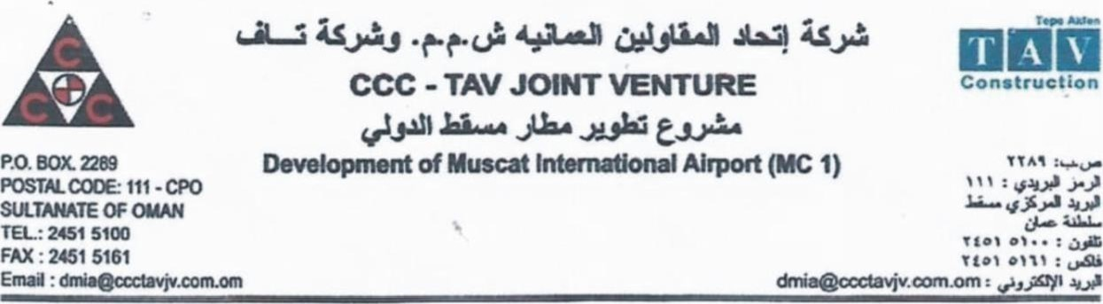
REF: A&P/DMlN46316 (R) Date: 2705/2013
TO WHOM | MAY CONCERN
This is to certify that Mr. Rashid Ma'!zoor of Pakistani Nationality hc\oing
Passport No: BK 0713121 was in the employment of Consc!idated Contraclorc Co. Oman L.L.C. from 29 January 20-:2 27 May 2013, in the capacity cf Land Survey
This certificate was issued upon his request without any obligation the company.
For CCC TAV Joint Venture
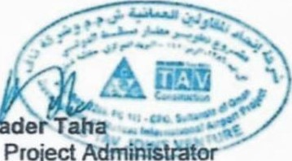
Kh
Sr.
Project


CFRTIFICAT
Ths is to certify that Mr. Rashid Manzoor and nabonal holder Passport
^{No} ZQLLUZLHasworked tn our company as an _ Land Survyors
This certficate has been issued upon his request without any responsibility on our part
During hsjobhewasengaged in Construction an Land Survyors
We found him hone* sincere. and hardworking and his exceptimal interest. dedication.
Skills and profession have been of immense help to tiis organization .He has proved to
Be a valuable asset to our organzation.
We wish for his beter futures.
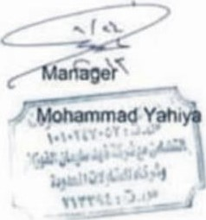
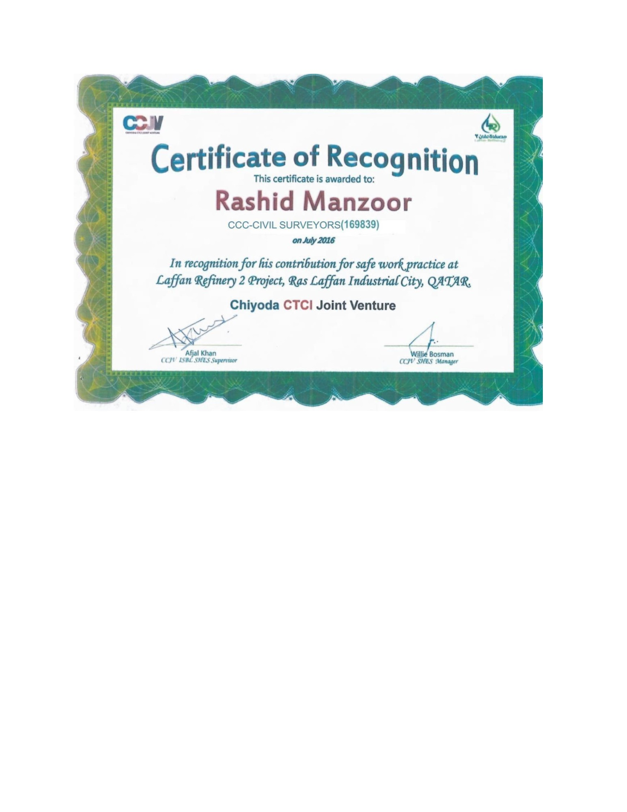

Consolidated Contractors Group S.A.L. (Offshore) (CCC)
Laffan Refinery 2 Project - uS LAFFAN, DOHA. QATAR P.O. BOX 22056, Tel: 44339555 Fax: 44238140
Date: 7-January-2017

TO WHOM IT MAY CONCERN
NAMERASHID MANZOOR
BADGE NO.169839
NATIONALITYPAKISTANI
PASSPORT NOBK 0713122
TRADELAND SURVEYORS
DATE OF ENGAGEMENT14-Jun-2014
DATE OF RELEASE31-Dec-2016
REASONTRANSFER WITHIN AREA
PROJECTLAFFAN REFINERY 2
This certificate is issued to him upon his request without any liabilities towards the company.
For Consolidated Contractors Group S.A.L (OFFSHORE) (CCC)
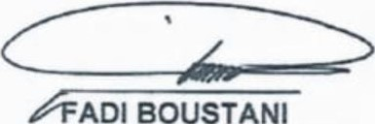ADI BOUSTANI 
Head of Admin & Personnel
CONSOLIDATED CONTRACTORS GROUP S.A.L. (OFFSHORE) (CCC) I
TEYSEER CONTRACTING COMPANY W.L.L. - JOINT VENTURE
GTC/626A/2014 & GTC/626C12014

CONSTRUCTION OF MEGA RESERVOIR
PRPSs (PACKAGE A) UMM BIRKA & (PACKAGE C) AL THUMAMA
Date : 01-May-17

TO WHOM IT MAY CONCERN
NAME | RASHID MANZOOR
BADGE No. | 169839
NATIONALITY | PAKISTANI
PASSPORT No. | BK 0713122
TRADE | LAND SURVEYORS  FREE SINGLE ACCOMMODATION AND  MESSING AT COMPANY CAMP
DATE OF ENGAGEMENT | 31-Dec-16
DATE OF RELEASE | 01-May-17
PROJECT | Water Mega Reservoir Project (WMRP)
THIS CERTIFICATE IS ISSUED UPON HIS REQUEST AND NO OBLIGATION TO THE COMPANY.
For Consolidated Contractors Group S.A.L
(0 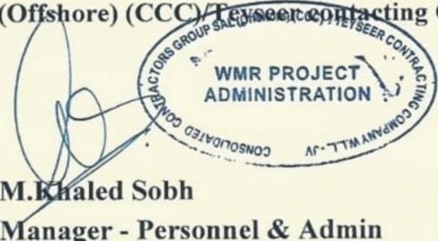 ing Company
anager
Personnel
&
Admin

P.O. BOX 22056 • DOHA • QATAR
TEL: +974 4041 8300, 4041 8500 • FAX +974 4041 8333, 4041 8555
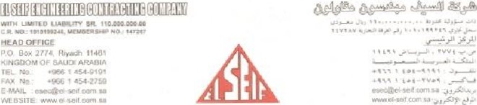
Date: 12-Dec-201g

To WHOM IT MAY CONCERN
It Is certifry'ing that Mr. Rashid Manzoor SIO Manzoor Ahmad Woking with El-Seif International Contracting . from 27-Apr-2018 to 12-Dec-2019 as a Land Surveyor Different project in Neom Sharma city Complex Saudi Arabia.
During his stay, he was proved himself to be hard working productive, relible and dedicated person. We wish him best of luck in his future endeavors.
This certificate is issued upon his request for reference purpose.

P-
120
HEIR
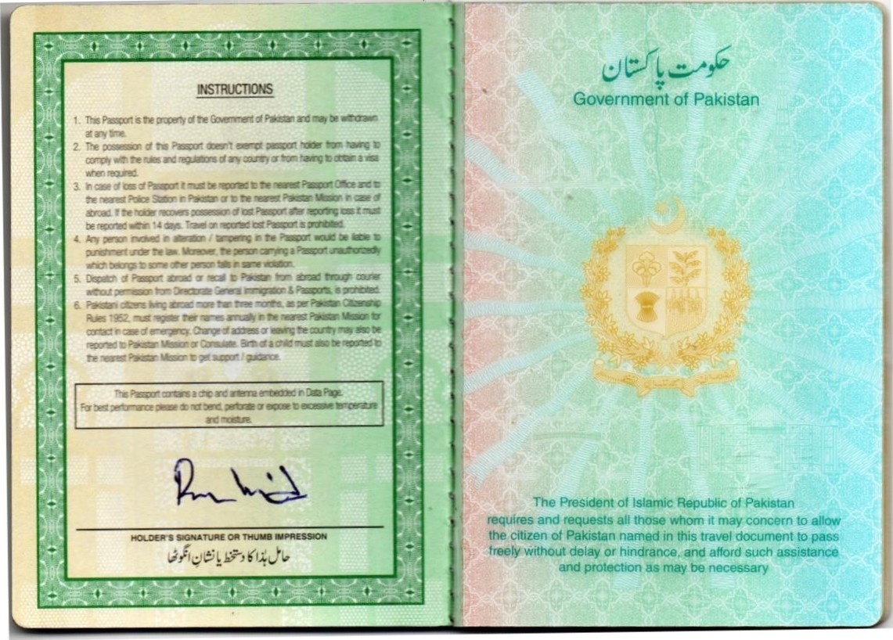
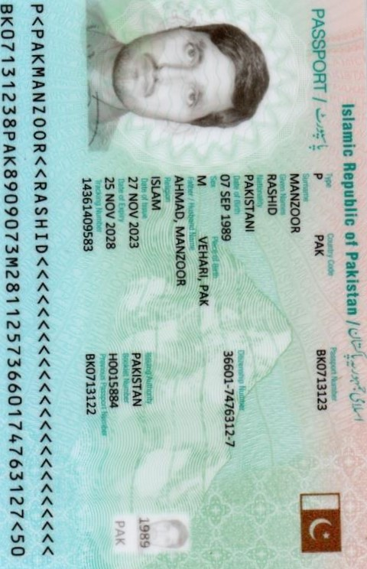 | 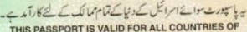  THE  WORLD  EXCEPT  ISRAEL  ANNOTAYIONS    H0015884  
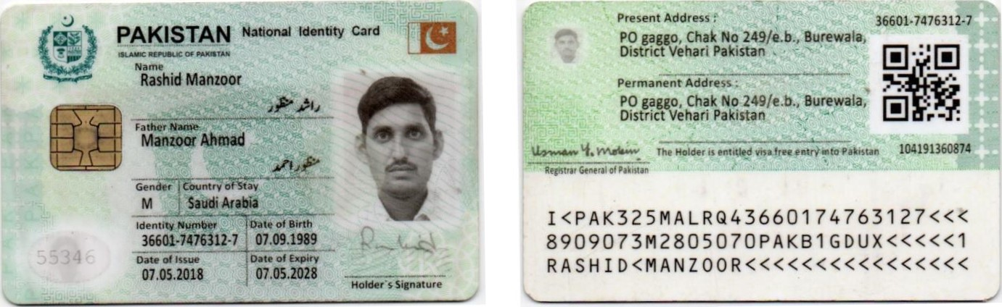
EXIT

KINGDOM Of SAUDVARABIA
Date: 17/04/18 6046557951 pj
- Validity : 90 D 90 uoa.,.æ :
- Name : RASHID MANZOOR MÄNZOOR AHMAD
3
6
8 180 : 700146561 :
14390762<013 : 70045212063—5
Number Of Entries: Single Duration of Stay: 180 Days
z.il

E243645339
V<SAUAHMAD<<RASHID<<<<<<<<<<<<<<<<<<<<<<<<<<

