Wael AlFarra
Civil Engineer
Personal Data:
Marital Status: Married
Nationality: Jordanian
Current Residence: Riyadh, KSA
Phone Number: 0504535007
E-mail: waelalfera@gmail.com
Introduction:
Civil engineer with experience of more than 22 years in the field of road and site construction.
Education:
Faculty of Engineering, Al Esraa University Civil Engineering
Academic Degree: Bachelor’s Degree
Graduation Year: 2000
Language Skills:
Arabic: Mother Tongue.
English: Good at speaking, reading and writing.

Work Experience:
- Organization Name: Arabian Rock Contracting Company
- Job Title: Civil Engineer
- Tasks: Manage site and technical office teams regarding technical issues, management issues and improving team techniques
- Duration: 2/2002 till Today
Engineering Certificate:
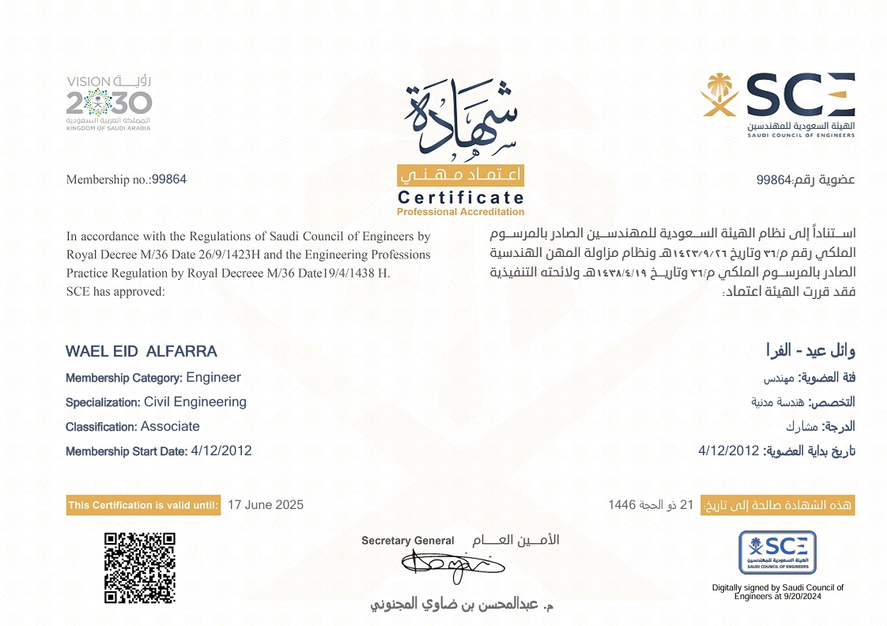
Soft Skills:
I have great driving skills for over 25 years, and I own a Saudi Driving License.

