MD ABU TALIB
FACILITY ENGINEER
Riyadh, Saudi Arabia
talibarman@gmail.com

Nov 2023 – Present
FACILITY ENGINEER (Riyadh Metro Project, LINE 1&2)
- AL MAJAL GROUP, RIYADH, SAUDI ARABIA
- Conduct a schedule for regular inspection of all facilities and equipment. This will help in identifying any maintenance or repairs needs promptly.
- Once issues are identified, coordinate with maintenance staff to schedule repairs or upgrades. Ensure that routine maintenance tasks are also scheduled and completed on time to prevent larger issues and maintaining accurate records of maintenance activity, inspection and repairs.
- Schedule and implement preventive maintenance programs. This ensures the ongoing reliability and safety of facilities, reducing unexpected downtime and costly repairs.
- Ensuring that all maintenance activity comply with safety regulations and industry standards. This includes providing proper training and conducting regular safety inspections.
- I always looking for opportunities to improve operational efficiency and reduce costs without compromising safety or reliability. This might involve evaluation energy usage, optimizing maintenance schedule, or upgrading to more efficient equipment’s.
- Prepared to respond any facility emergencies promptly. Develop contingency plans and ensure that maintenance staff are trained to handle emergencies such as power outages, leaks, equipment failure, or natural disasters.

July 2019 – Aug 2023
FACILITY ENGINEER (King Palace Tabuk, KSA)
EL SEIF GROUP, RIYADH, SAUDI ARABIA
- Coordinate and oversee maintenance and repair activities, including inspection, maintenance, repairs and upgrades.
- Develop and implement preventive maintenance programs to ensure the ongoing reliability and safety of facilities.
- Operation and maintenance of HVAC, BMS, Fire Fighting, Plumbing, Water treatment plant and Electrical equipment’s.
- Complete corrective and preventive maintenance work and close the workorder according to Maximo (CMMS) given time to avoid the KPI affecting.
- Inspection of MEP spare parts and if required parts then communicate with procurement departments for purchase request.

PROFILE
Experienced Facility Engineer with a robust background in diverse industries. Expertise in coordinating and overseeing maintenance activities across multiple facilities & departments. My role involves developing and managing maintenance schedules to ensure timely completion of both routine and preventive maintenance tasks. Looking to be connected with a progressive and established company where I will have the chance to help the insight of its goals, while at the same time being exposed to an environment where my skills and capabilities will be utilized.

+966 571287096
+918873497874
WORK EXPERIENCE

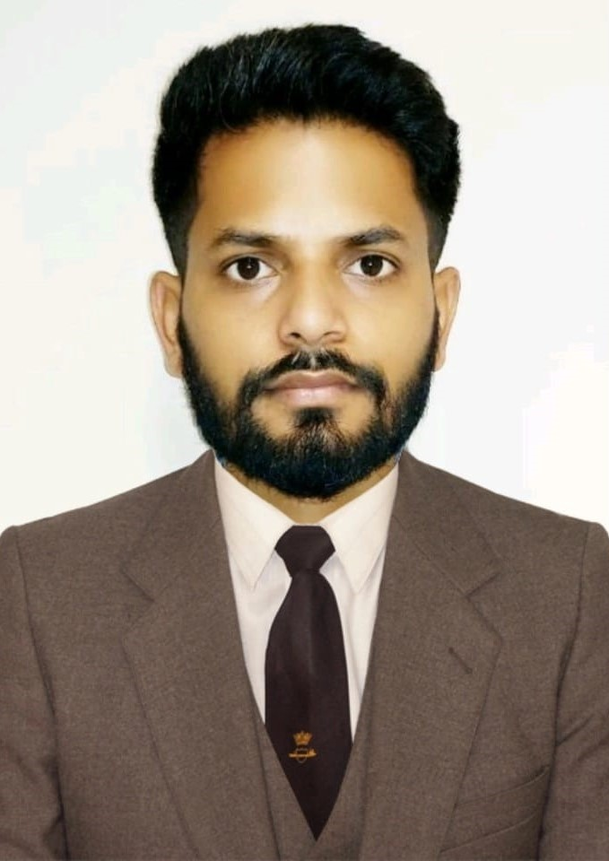
Adaptability

Decision Making

Multitasking

Technical Support

Scheduling/PTW

Continuous Learning

Efficiency

Inspection & Reporting

Emergency Response

Leadership & Teamwork

Time Management

Communication & Coordination

Prioritization

Problem Solving

Organizational Skills

Work Order & SR Management

S K I L L S




CONTACT

- In emergency situation visit the site and handle the situation.
- Prepare technical reports for any failure of equipment’s and prepare incident reports and verify with HSE department.
- Assist the client on site visit and explain completed and ongoing work status.

June 2016 – June 2019
FM SHIFT SUPERVISOR (BUILDING MAINTENANCE)
HEMA ENGINEERING, JAIPUR, INDIA
- Schedule preventive maintenance task and implement on site to complete on time.
- Supervise installation, inspection repairing and maintain building systems including mechanical, plumbing, electrical and HVAC.
- Maintain accurate records of all maintenance and repair activities and submit to management.
- Provide technical training for the facilities maintenance staff.
- Handle client complaints and concern professionally and ensure timely resolution and follow up.
- Conduct weekly HSE meeting with team and ensure all using proper PPE.
- Ensure all employee’s work in safe environment, including proper equipment, procedure and training.

SOFTWARE SKILLS

IBM -MAXIMO (CMMS)

AUTOCAD

OUTLOOK
MS OFFICE

EDUCATION
- BACHELOR IN MECHANICAL
ENGINEERING
Maharishi Dayanand University, Haryana
India | 2016

- INTERMEDIATE
BSEB, Bihar, India | 2012

PERSONAL STRENGTHS
PERSONAL INFO
Nationality : Indian
DOB : 12.01.1994
Gender : Male
Marital Status : Single
Passport No : N8847361
Date of Expiry : 15.03.2026
Visa Status : Employment Visa

- Organizational Skills
- Ability to manage and track multiple tasks and schedules with high accuracy. Skill in prioritizing tasks and resources effectively to handle urgent maintenance issues while managing routine tasks.
- Problem Solving Abilities
- Capacity to analyze complex situations, diagnose issues, and develop practical solutions quickly. Make informed decisions under pressure, especially in emergency or high-stress situations.
- Communication Skills
- Ability to communicate clearly and effectively with maintenance teams, facility managers, vendors, and other stakeholders. Proficiency in negotiating with vendors and contractors to ensure favorable terms and successful outcomes.
- Leadership & Teamwork
- Skill in leading and coordinating maintenance teams to ensure tasks are completed efficiently and effectively. Ability to motivate and guide team members, fostering a collaborative and productive work environment.

LANGUAGES KNOWN
English
Hindi
Urdu
Arabic

DECLARATION

\
I hereby declare that the above-mentioned information is correct to the best of my knowledge and belief.
MD ABU TALIB

