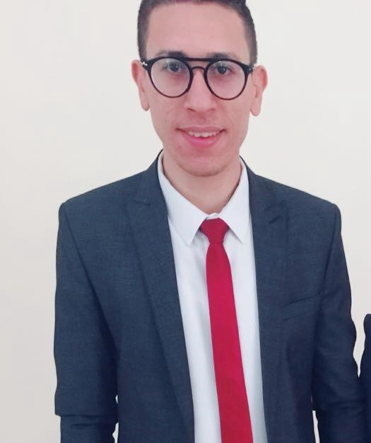
HADY ELSAYED AHMED SWILAM
📍 El Shorouk City, Cairo, Egypt | 📞 +20 112 150 9910 / +966 545 486 642 |
PROFILE SUMMARY
Energetic and detail-oriented Civil Engineer with 6+ years of experience in site supervision, infrastructure, and residential project management across Egypt and Saudi Arabia. Adept at managing complex site activities, ensuring compliance, and leading cross-functional teams. Expert in AutoCAD, Revit, SAP2000, and MS Office.
PROFESSIONAL EXPERIENCE
Site Civil Engineer – SARH ATTQNIA Co., Jazan, Saudi Arabia
Oct 2023 – Present
- Led infrastructure works for 1,200 villas (SAR 1.6B project) under Khatib & Alami supervision.
- Managed road construction, utility networks, and safety compliance.
- Optimized coordination between stakeholders for timely delivery.
Site Civil Engineer – Soltan Construction, New Capital, Egypt
Apr 2022 – Oct 2023
- Oversaw 100-building social housing project (EGP 850M).
- Supervised structural, finishing, and landscape phases.
- Produced site reports and resolved on-site execution issues.
Site Civil Engineer – El-Afify Engineering, Badr City, Egypt
Nov 2020 – Apr 2022
- Delivered structural and finishing work for 54-building prison project (EGP 7B).
- Ensured design compliance and coordinated with consultants.
Site Civil Engineer – Tabarak Construction, New Cairo, Egypt
Jan 2019 – Oct 2020
- Worked on 10-building residential complex (EGP 100M).
- Monitored concrete and finishing stages; managed site documentation.
EDUCATION
B.Sc. in Civil Engineering
Al-Salam High Institute for Engineering & Technology, Egypt
Graduation Project: Structural Design – Very Good | Overall Grade: Good
KEY ACHIEVEMENTS
- Delivered infrastructure for 1,200 villas with 0 safety violations.
- Reduced waste on site by 15% via better material tracking.
- Managed coordination with 3 top engineering consultancies.
CERTIFICATIONS & TRAINING
- Certified: Revit Structure Course
- AutoCAD, SAP2000, ETABS, SAFE (Proficient – Self-Taught)
- Training: Arab Contractors, El-Motaheda Construction
TECHNICAL SKILLS
- AutoCAD, Revit, SAP2000, ETABS, SAFE
- Microsoft Excel, Word, PowerPoint
- Data Analysis & Internet Research
SOFT SKILLS
- Problem Solving, Team Leadership, Communication
- Time Management, Flexibility, Resilience
LANGUAGES
Arabic – Native | English – Very Good (Reading/Writing), Good (Speaking)
PROFESSIONAL AFFILIATIONS
- Member – Egyptian Syndicate of Engineers
- Member – Saudi Council of Engineers (SCE)
PERSONAL INFORMATION
Date of Birth: October 1, 1994 | Nationality: Egyptian | Marital Status: Married | Military Service: Completed

