Mohammed Baseer Uddin 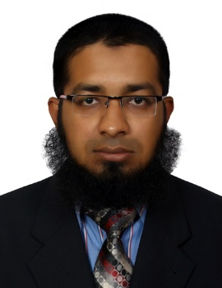
Mobile: +966546510504 +917680990272 (IMO&WHATSAPP)
E-mail id: baseeruddin123@gmail.com
skype id: baseeruddin7
IMO & WHATSAPP NUMBER : +917680990272
VISA STATUS TRANSFERABLE

Career Objective:

To be in a challenging position where I can use my technical skills coupled with people skill to build a team driven by value and performance, enhance my knowledge and skills and be an assets towards the organization.

Professional Experience:

AL MAYAL CONTRACTING COMPANY LIMITED KSA

Worked as electrical Draftsman

SV POWER LINKS PRIVATE LIMITED HYDERABAD INDIA

Worked as Civil and Electrical Draftsman

Working Contracts :

NUMALIGARH REFINERY EXPANSION 220KV PROJECT IN ASSAM MAIN CONTRACTORS TECHNIP INDIA LIMITED.
UPPTCL SECTOR 129 NOIDA 132KV PROJECT UTTAR PRADESH.
PSPCL PROJECT 132KV IN SUMAN PUNJAB LEAD PARTNERS HAVELS INIDA LIMITED.
NMDC LIMITED PROJECT 132KV MAIN CONTRACTOR L&T LARSEN & TOURBO LIMITED, CONSTRUCTION.

Work as : SLD Drawings , Typical RCC Trench Drawings , Route Marker Drawings , Section Drawings ASBUILT Drawings , Route Drawings , LAYOUT Drawings ,
ELEVATION Drawings Cable Route Drawings, Earth Pit Drawings, Making Cable Drum Length ETC.

ORGANISATION:
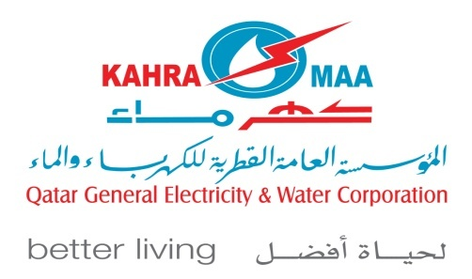

Rashid Bin Hussain Rashid Trading & Contracting Co established in 2007 as trading and contracting Co. The remarkable and encouraging market response and enormous good will the venture started growing. The company has various ranges of activities. Civil contracting, trading, transporting, manpower etc. are prominent among them. Rashid Bin Hussain Rashid Trading & Contracting Company is the Main Contractor of ‘KAHRAMAA’ in Electrical & Civil Department.

Worked as Civil and Electrical Draftsman ( Approved from kahrama )
From JUNE 2021 to AUGUST 2023
COMPLETED CONTRACTS:

CONTRACT : GTC-837/2016 (DISTRIBUTION CABLE FAULT LOCATION (L.V& M.V) REPAIR ROUND THE CLOCK)

Working Contracts :

GTC-996/2020 (DISTRIBUTION CABLE FAULT LOCATION (L.V & M.V) REPAIR ROUND THE CLOCK)

GTC-918/2018 LOT-2 (11 KV REINFORCEMENT WORKS)

GTC-931/2019 (MAIN EXTENSION OF LV U/G NETWORK SERVICE
CONNECTIONS

GTC-939/2020 LOT-1 & LOT-2 (LV REINFORCEMENT & EMERGENCY (MV) CABLE FAULT REPAIR)

Example : To show the cable sizes, Joints, Shutdown and Jointing Date & Jointer name with his License number and all details.

To prepare as-built drawing of the cable laid at the site.
Making trance drawings for cool length cable.
To submit as-built drawing in KAHRAMAA GIS department

Worked as Draftsman
Freelance from 2019 to 2020
Work as : Shop Drawings, As Built Drawing , Working Drawings , Section Drawings , Layout Drawing , Interior Drawings, and Elevation Drawings.
➢Preparing as built drawings.
➢Visiting site to take necessary dimensions and prepare drawing as per site

MS Construction , Hyderabad, (INDIA)
Worked as a Auto Cad Draftsman for From February 2018 To November 2018
Responsible for following duties and services:
Work as : Shop Drawings, As Built Drawing , Working Drawings , Section Drawings , Layout Drawing , Interior Drawings, and Elevation Drawings.
➢Preparing as built drawings.
➢Visiting site to take necessary dimensions and prepare drawing as per site

Saudi Ceramic, Riyadh, (KSA)
Worked as a Auto Cad Draftsman and Equipment Inspector from December 2015 to December 2017
Responsible for following duties and services:
Work as : Shop Drawings, As Built Drawing , Working Drawings , Section Drawings , Layout Drawing , Interior Drawings, and Elevation Drawings.

Sing marble Art international Dubai UAE
Worked as a Auto Cad Draftsman from August 2014 to may 2015
Responsible for following duties and services:
Work as : Shop Drawings, As Built Drawing , Working Drawings , Section Drawings , Layout Drawing , Interior Drawings, and Elevation Drawings.
- Preparing as built drawings.
- Visiting site to take necessary dimensions and prepare drawing as per site.

JUAM ASSOCIATES ARCHITECT & ENGINEERS.
Worked as a Auto Cad Draftsman from January 2011 to May 2014 (3.5 years).
Responsible for following duties and services:
Work as : Shop Drawings, As Built Drawings , Working Drawings , Presentation Drawings , Section Drawings , Electrical Drawings, Layout Drawing , Interior Drawings, and Elevation Drawings.
- Preparing as built drawings.
- Visiting site to take necessary dimensions and prepare drawing as per site.

PROJECTS:

Project Name: SHARJAH MILITARY HOSPITAL . (Sharjah)
Project Name: THE BINARY. (Dubai)
Project Name: JUMEIRAH GOLF ESTATES VILLAS. (Dubai)
Project Name: GENERAL WOMEN’S UNION MUSEUM-. ( Abu Dhabi )
Project Name: The Pointe palm Jumeirah -. ( Dubai )
Project Name: Jean Samman Villa Jumeirah -. ( Dubai )
Project Name: United Arcade Commercial Complex ( India )
Project Name: Masaba Habitat Residential Complex ( India )
Project Name: Symphony Villas. ( India )
Project Name: Apple Hospitals. ( India )
Project Name: Y.S Shopping Mall. ( India )
Project Name: Agriculture Art Exhibition For Tourism Department Govt of AP. ( India )
Project Name: Sara Homes Residential Complex. ( India )

ACADEMIC QUALIFICATION:

Diploma in Auto Cad 2D and 3D from Indo British Academy Hyderabad.
Diploma in Civil Draftsman from Indo British Academy Hyderabad.
Diploma in Revit from Indo British Academy Hyderabad.
Board of Secondary
Board of Intermediate

PROFESSIONAL SKILLS:

Auto- cad: Version 2000, 2006, 2007, 2009, 2010, 2011, 2014,2015,2019,2020,2022 2023
Revit : Version 2009, 2010,2014, 2015
Computer knowledge: Ms Office, Excel

PERSONAL INFORMATION

Father’s Name : Mohammed Asif Uddin
Languages known : Hindi, Urdu , English and basic Arabic
Marital Status : Married
Covid-19 vaccinated : Moderna Both Doses
Nationality : Indian
Religion : Muslim
Date of Birth : 16-08-1988
Passport no : S1966269
Driving license no : DLFAP012167172006
Current address : MADINAH SAUDI ARABIA
I hereby confirm that the information given above is true to the best of my knowledge and belief.
(Mohammed Baseer Uddin).

