MUHAMMAD AWAIS LATIF

+966595017361 awaissurveyor4@gmail.com

Personal Details
Date Of Birth: 6 Oct 1996

Languages Known : ENGLISH,ARABIC URDU
Nationality : PAKISTANI
Profession : LAND SURVEYOR
Visa Type : Transferable
Cell No : 0595017361
E-mail awaissurveyor4@gmail.com
Iqama Number : 2489018271

CAREER OBJECTIVE:
With over +8 years of dedicated experience in the field of land surveying,
I have had the privilege to collaborate with renowned companies in
Saudi Arabia, consistently delivering exceptional results across a
spectrum of projects. From residential house construction to intricate
infrastructure development, roadways, pipelines, highways, bridges,
and various other construction ventures, my expertise has spanned a
wide range of domains. I have honed my skills with a mastery of essential
surveying tools such as total stations, AutoCAD, GPS systems, and
more, ensuring the utmost precision in data collection and analysis. I
am now seeking a job position where I can continue to apply my wealth
of knowledge and skills, contributing to innovative projects, and
advancing the dynamic field of land surveying. My unwavering
commitment to excellence and adaptability positions me as a valuable
asset to any project or team, ready to drive success and deliver quality
results.
I believe in doing my job with full intention and energies.I desire to work in an environmental which is dynamic and challenging.I never believe in doing anything against the organization at any cost.I want to be enthusiastic with full energies with my job.

• EDUCATION:
• DAE Civil Engineering From(Punjab Board Technical Education).
• CITY COLLEGE TECHNOLOGY OF NAROWAL INSTITUTE.

SUMMARY EXPERIENCE:
Total experience +8years

(1) Work Experience
SAMA GULF 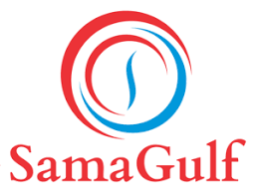 40MW PRIME DIESEL POWER PLANT,ALSHAMLY

● Land Surveyor●
Project Name: 40MW PRIME DIESEL POWER PLANT,ALSHAMLY
• DURATION •
Feb 2025 to Present
•DUTIES & RESPONSIBILITIES ON PROJECT•
• Reviewing of shop drawing and giving approval for execution to start work at site.
• Coordination of shop drawings for all trades.
• Reviewing& give survey report and check from work on site.
• Reviewing& give approval for all type instruments used at site.
• Reviewing & give all types benchmark as per project specification.
• Taking NGL or AS BUILT before and after execution.
Established control card drawing in site coordinates and levels.
• Inspection for site work with consultant.

(2) Work Experience
SAMA GULF
● Land Surveyor●
Project Name: CONSTRUCTION OF NEW 132/33KV SUBSTATION FOR RIYADH CEMENT FACTORY
• DURATION •
Feb 2023 to Aug 2024
•DUTIES & RESPONSIBILITIES ON PROJECT•
• Reviewing of shop drawing and giving approval for execution to start work at site.
• Coordination of shop drawings for all trades.
• Reviewing& give survey report and check from work on site.
• Reviewing& give approval for all type instruments used at site.
• Reviewing & give all types benchmark as per project specification.
• Taking NGL or AS BUILT before and after execution.
Established control card drawing in site coordinates and levels.
• Inspection for site work with consultant.

(3) Work Experience:
China Chengdu Huanqui Dingxin Construction Company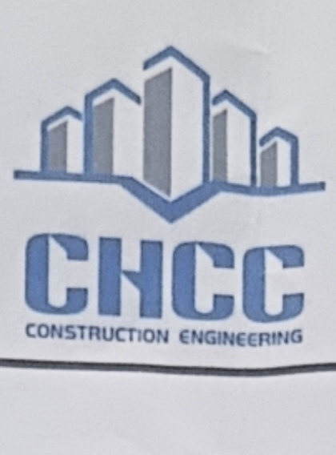
● Land Surveyor●
Project Name: DHP Yanbu NHC
• DURATION •
Sep 2024 to Feb 2025
•DUTIES & RESPONSIBILITIES ON PROJECT•
• Reviewing of shop drawing and giving approval for execution to start work at site.
• Coordination of shop drawings for all trades.
• Reviewing& give survey report and check from work on site.
• Reviewing& give approval for all type instruments used at site.
• Reviewing & give all types benchmark as per project specification.
• Taking NGL or AS BUILT before and after execution.
Established control card drawing in site coordinates and levels.
• Inspection for site work with consultant.

(4) Work Experience:
BUILT CONTRACTING COMPANY
Project Name: NHC VILLAS PROJECT ALKHARJ
• DURATION •
6 JUNE 2021 TO 10 NOV 2023.
•DUTIES & RESPONSIBILITIES ON PROJECT•
• Reviewing of shop drawing and giving approval for execution to start work at site.
• Coordination of shop drawings for all trades.
• Reviewing& give survey report and check from work on site.
• Reviewing& give approval for all type instruments used at site.
• Reviewing & give all types benchmark as per project specification.
• Taking NGL or AS BUILT before and after execution.
Established control card drawing in site coordinates and levels.
• Inspection for site work with consultant.
(5) Work Experience:

(M C C) METALLURGICAL CORPORATION OF CHINA

● Land Surveyor●
Project Name: DUWADMI ALQASIM NHC VILLAS PROJECT
• DURATION •
6 JUNE 2019 TO 10 NOV 2022
Conduct precise land surveys to determine boundaries,
topography, and legal considerations, ensuring accurate project
planning and compliance.
– Utilize advanced surveying instruments and software to collect,
analyze, and interpret data, producing detailed maps and reports.
– Collaborate with project teams, architects, and contractors to provide
critical survey information for design, layout, and construction
phases.
– Assess potential environmental impacts and regulatory requirements
related to land use and zoning, contributing to permit applications.
– Implement safety protocols and monitor field operations to guarantee
the integrity of survey data and protect the workforce.
– Manage project timelines, budgets, and resources, coordinating
survey activities to support the successful completion of construction
projects.

Professional Skills
– Surveying
– Mapping
– CAD
– GIS
– AutoCAD
– Total Station
– GPS
– Data Analysis
– Land Records
– Boundary Determination
– Topography
– Site Inspection
– Construction Layout
– Geodetic Survey
– Survey Equipment
– Geographic Information
Systems
– Cartography
– Report Writing
– Communication
– Project Management
– Quality Control
– Computer Skills
– Auto Levels
– Team Collaboration
COMPUTER SKILL
• MS Excel, MS World
• AutoCAD 2d,3d AutoCAD civil 3d

