 | 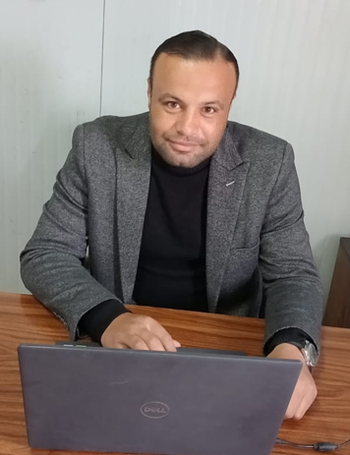  Profile:  Seeking new challenges in the field of MEP contracting / Real Estate in a reputable organization that effectively utilizes my capabilities , benefits from my potential , invests in my commitment for high quality performance and allow for professional growth and career development  personal information:  Nationality : Egyptian  Driving License: Egypt valid  : Saudi Arabia valid  Marital Status : Married  Location : Riyadh , Saudi Arabia  Contact  PHONE:  00966 -535266856  00966 -546378454  002- 01288518317  002- 01098248755  Membership Saudi Council of Engineers  Membership ID : 190821  Languages:  - Arabic – Native  - English - Excellent  EMAIL:  enghaythamsalah@yahoo.com  enghaythamsalah4@gmail.com  INTERPERSONAL SKILLS  - Team building  - Influencing  - Motivation  - Negotiation  - Conflict management  - Emotional intelligence  - Decision making  - Leadership |  |  | Haytham Salah Aly AbouShanab  ELECTRICAL MANGER  WORK EXPERIENCE  More than twenty-one years of experience  Starting in Egypt working in companies specialized in the MEP field designing, construction, maintaining and operating most of MEP systems starts from 2004  And experience in K.S.A (Riyadh & Eastern Region &Western Region (starts from 2009 (Saudi Lebanese Tarouk Contracting , Al Kifah Contracting Company, Al Mashariq Company , Rakan Contracting Company)  I have worked successfully in construction fields in all fields and on a wide range of various and specialized projects, I always strive to achieve high productivity with quality and safety on time for projects and maintain the company's policies and objectives, I am experienced in Projects Management.  Work details experience  1-RAKAN CONTRACTING COMPANY (SAUDI ARABIA)  Job title: MEP Section Head  Inclusive Dates: from January 2024 –Till Now  PROJECTS:  1- CONSTRUCTION OF ALRAHJI BANKS BRANCHE A- (ALMAHDIA - RIYADH )  B- (BAISH - JAZAN )  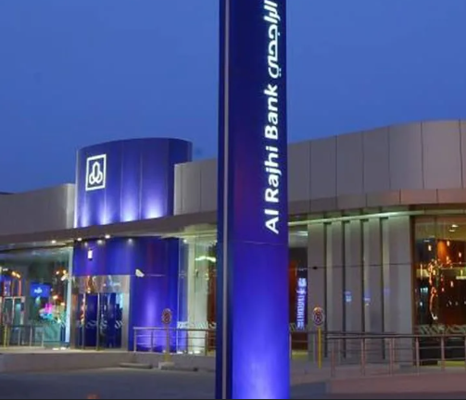  2- CONSTRUCTION OF AL ENMAA BANKS BRANCHES )ALQUNFUDA JEDDAH)  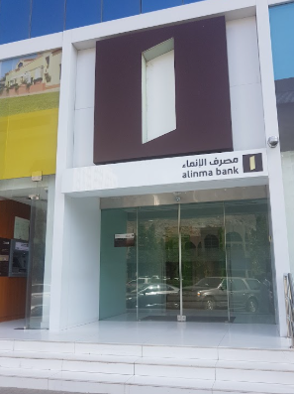  3- CONSTRUCTION OF SECURITY FENCE FOR THE BUSSINEESS CENTER  AT RIYADH CORRECTION FACIITY  4- ISLAMIC MILITARY COUNTER TERRORISM COALITION (CONSTRUCTION  OF EXPANSION OF THE OPERATIONL BULIDING)  JOB OBJECTIVES  - Follow up electrical , mechanical work on all projects  - Hires, trains, and manages MEP engineers, electricians and plumbers.  - Follow-up and audit of procurement requests and contracts with subcontractors  - Field visits to sites to follow up on implementation conditions  - Ensuring coordination between departments and coordination with site consultants and their satisfaction with the quality of work Reviews and files all daily project reports  - Oversees all facility department operations.  - Investigates and resolves any client complaints.  - Leads weekly team meetings.  - Works closely with other facility department leaders and company executives.  - Develops and improves departmental policies and procedures.  - Suggests ways to increase revenues and efficiency.  - Determines the work schedule and assignments.  - Sets and tracks the departmental budget.  Stocks all equipment and tools.  Giza Power Transmission & Distribution (Egypt)  Job title: Project Manger  Inclusive Dates: from January 2022 – January 2024 (2year)  Project: Execution of the works of the main expansion distributors and  The Cables feeding them from the existing transformer stations in the western & eastern regions in the new administrative capital  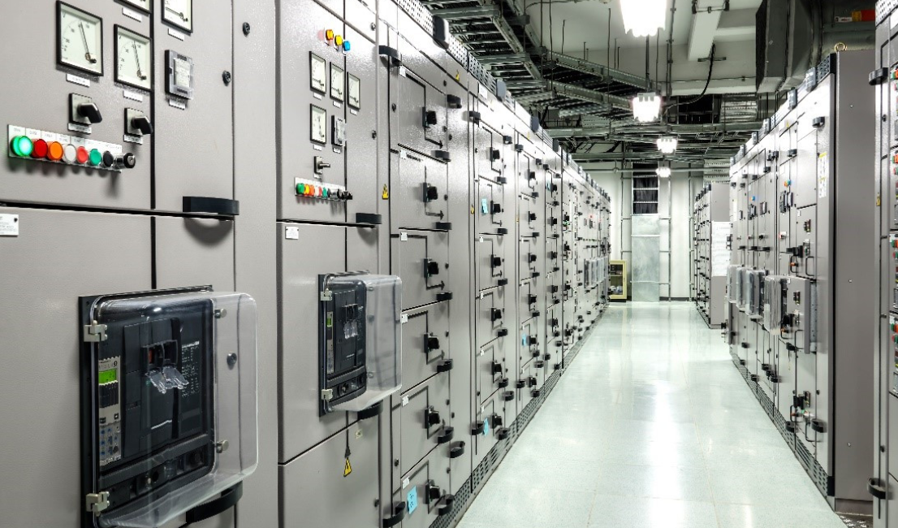  JOB OBJECTIVES  - Coordinating with cross-discipline team members to make sure that all parties are on track with projects requirements, deadlines, schedules.  - Meeting productive and fun with projects team mangers and members to identify and resolve issues. Also, to keep moral and engagement high  - Ensures professional interaction between teams and stakeholders  - Preparing status reports by gathering, analyzing, and summarizing relevant project's information.  - Establishing effective projects communication plans and ensuring their execution.  - Facilitating change requests to ensure that all parties are informed of the impacts on schedule and budget.  - Coordinating the development of user manuals, training materials, and other documents as needed to enable successful implementation and turnover of the process or system to the clients.  - the main communication point with all clients  - Identifying and developing new opportunities with clients.  - Obtaining customer acceptance of projects deliverables.  - Managing customers satisfaction within the projects transition period.  - Conducting post-projects evaluation and identifying successful and unsuccessful projects elements.  - ensure that all projects are delivered on-time, within scope and within budget  2- Fern Pro Global - Down Town Delta (Egypt)  Job title: Electrical Section Head  Inclusive Dates: from February 2021 to December 2021 (1 year)  Project: Logistics area, Downtown Delta, Matrix Club and Tanta Mall 2nd phase, includes the “Matrix gym”, the medicine area and the car service center  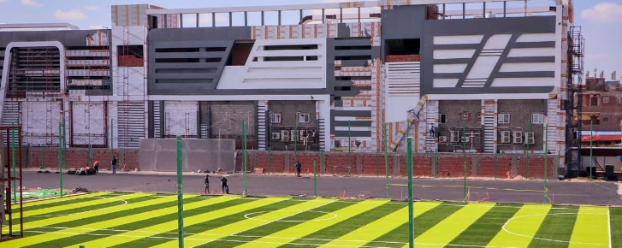  JOB OBJECTIVES  - Monitors and reports on construction productivity and schedule performance (including trends) to the Lead Construction Manager  - Coordinate all activities of the group  - Usually involves work in several areas or functions that are often beyond the scope of standard procedures  - Integrates all pieces of a project into a whole  - Develop and execute long-term category vision and forecast  - Manage relationships with strategic partners  - Works with the team to keep as close as possible to the Plan  - Provide leadership to the Electromechanical Requisition Team in the day-to-day activities  Al Mashariq Company (Saudi Arabia)  Job title: project Manger  Inclusive Dates: from August 2015 to September 2020 (5 years)  Projects:  Project (1): APPROVED IN ROYAL COMIISION SENIOR ENGINEER  (Royal Commission) Contract No. 204-C62 Engineering, Procurement & Construction (EPC) of Security and Infrastructure for JUBAIL 2 Phase 2,  In cooperation with the expertise of companies THALES Security Solution & Services and L3 Communication Security  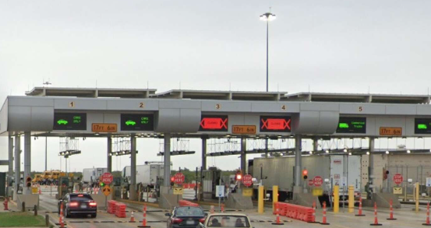  Project (2): APPROVED ARAMCO AREA MANGER  Aramco (Saudi Arabian oil company) – contract no#6600042827 - installation of Power factor correction phase 1 (B-10-09442), 24 plants (gas –oil separation plant factory)  - upgrade with maintenance Substation MCCs, panels  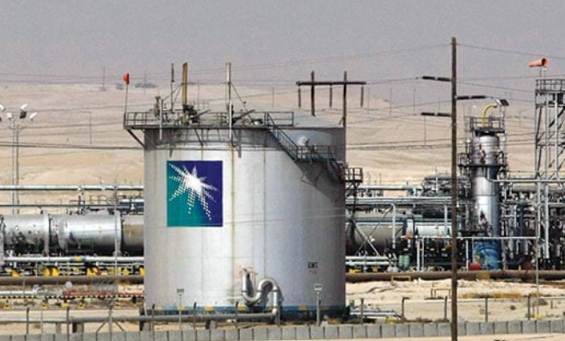  JOB OBJECTIVES  - Coordinate internal resources and third parties/vendors for the flawless execution of multiple projects  - Ensure that all projects are delivered on-time, within scope and within budget  - Assist in the definition of project scope and objectives, involving all relevant internal stakeholders and ensuring technical feasibility  - Ensure resource availability and allocation  - Develop a detailed project plan to monitor and track progress  - Manage changes to the project scope, project schedule, and project costs using appropriate verification techniques  - Measure performance using appropriate project management tools and techniques  - Report and escalate to management as needed  - Manage the relationship with the client and relevant stakeholders  - Perform risk management to minimize potential risks  - Establish and maintain relationships with third parties/vendors  - Create and maintain comprehensive project documentation  - Meet with clients to take detailed ordering briefs and clarify specific requirements of each project  - Delegate project tasks based on junior staff members' individual strengths, skill sets, and experience levels  - Track project performance, specifically to analyze the successful completion of short and long-term goals  - Meet budgetary objectives and make adjustments to project constraints based on financial analysis  - Develop comprehensive project plans to be shared with clients as well as other staff members  - Use and continually develop leadership skills  - Attend conferences and training as required to maintain proficiency  - Perform other related duties as assigned  - Develop spreadsheets, diagrams and process maps to document needs  - ERP project oversight.  - Ensures professional interaction between team and stakeholders.  - Ensures collaboration within the team.  - Resolves personal conflicts.  - Protects the team from internal politics with Identifies all key stakeholders.  - Leads and facilitates the planning process.  - Selects and controls processes that can deliver the required quality.  - responsible for developing a realistic schedule.  - Participates in procurement processes.  - Ensures that deliverables are accepted by the customer.  - Works with the team to keep as close as possible to the Plan.  - Moves the project towards its goal on a daily basis.  - Controls the project in all aspects (scope, time, costs, risks, quality, etc.)  - Logs lessons learned.  Al KIFAH Contracting Company (Saudi Arabia)  Job title: Senior electrical Engineer  Inclusive Dates: July 2011 to July 2015 (4 years)  Projects: APPROVED IN ROYAL COMISSION SENIOR ELECTRICAL ENGINNER  Project (1): Construction and maintenance of Neighborhoods Centers at  Jalmudah area  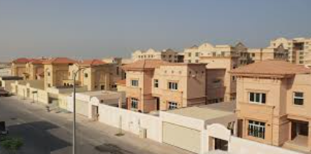  Project (2) : Construction and maintenance of infrastructure and buildings  for Defense Force, phase1  JOB OBJECTIVES  - Responsible for Supervision and self-execution of all Electrical projects in the field of Constructions according to the designed/Construction drawings.  - Manpower allotment to each activity.  - Projects in site trouble-shooting, meetings, modifications, financial follow up, reporting, evaluation, commissioning and closure.  - Monitor and control expenses related to the work and ensure organizational forecasts and budgets are met for these expenses  - Handle procurement activities relating to contracts and sub-contractors in accordance with company procedures and procurement department activities.  - Correspondence and Co-ordination with project Manager, QA/QC team, Sub-ordinates, subcontractor as well with consultant.  - Follow up and evaluate the daily weekly & monthly progress reports.  - Prior planning for Quality control, Cost control and Safety precaution’s  - Ensure safety standards and procedures are implemented and followed in accordance with contract requirements and company guidelines  - Willing for follow up with a potential subcontractor and suppliers over weeks and even months, developing a relationship with them until they were ready to close deal and also, I can develop good long –term relationship with others  - Executing & supervising all Sites Electrical works  - Checking site installations, RFI reports, material requests, and Hold Points release for finishing works. As per BOQ  - Review and approval materials submittal, shop drawings and as built for all Electrical work  - Work in a way that achieve a goal quickly and thoroughly, using the least amount of resources possible (find a way to reduce our cost)  - Investigate problems and recommend solutions for ongoing site Electrical works.  - Manage project schedules and budgets, and obtain permits for operations.  - Make engineering calculations in connection with field and office assignments.  - Focused on products, being most concerned about the result of the work  - Review Construction /Project Schedule Daily work Schedules that pertain to electrical work.  - Planning and Sequencing the Integration of all the Electrical Systems with the Architecture, Structural Plans. Review Construction /Project Schedule Daily work Schedules that pertain to electrical work.  - Providing test procedures and Testing & Commissioning of Electrical Systems as per the approved drawings.  - Check the Purchase request and follow up for the project materials as  - Make Daily, weekly programming to boost the productivity ratio.  following for Fees and Metering Charges, Training of Royal Commission  Operation and Maintenance Personnel, Mobilization, Demobilization  and work permit with All Stock holders Such as (Aramco, SEC  underground and overhead, STC, Marafiq, Road) departments  - hand over the project with all Operation and Maintenance Manual  and all documents, As Built Drawing)  Saudi Lebanese Tarouk Contracting (Saudi Arabia)  Job title: Electrical Superintendent Engineer  Inclusive Dates: July 2009 to July 2011 (2 year)  Project: New Riyadh National Hospital (Capacity200 bed)  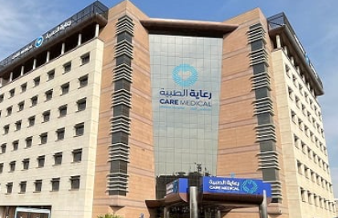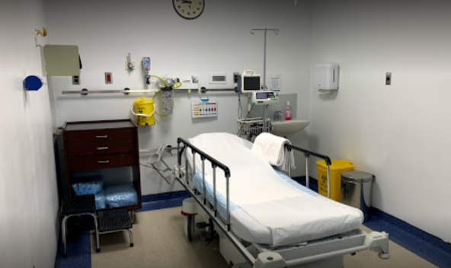  CONSULTANT : Al-Ittihad Engineering Company - Khatib & Alami  JOB OBJECTIVES  - Scrutinizing the Engineering drawings and explain to subordinates  - Preparing Purchase request and follow up for the project materials  - Report in details the status of electrical work and specialties subcontractors to Executive management  - Maintains proper channel of communication with the other works managers to ensure full cooperation and successful coordination of the works on site. Oversee and advise the senior engineer regarding any potential critical problems/obstacles that work progress may face or cannot be resolved and achieved  - Conducting the internal Inspection and Client Inspection for the Electrical materials in the site and store  - Takeoff materials of all electrical systems and cable routing  - Prepare and supervise the production of Builders’ works shop drawings to ensure compatibility with architectural and structural drawings  - Supervising and monitoring the implementation of subcontractors for all electrical works, including installations, systems and deliveries & Co-ordination and Implementation of company Safety  - Estimating material, labor, or construction costs for budget preparation.  - Writing reports and compiling data regarding existing and potential electrical engineering projects and studies.  Ensuring compliance with specifications, codes, or customer requirements  Egyptian tank plant factory  Location:(Egypt)  Job title: Electrical Engineer  Inclusive Dates: May - 2006 to October - 2009 (3 years)  Project: (200 military factory) (Government Egypt)  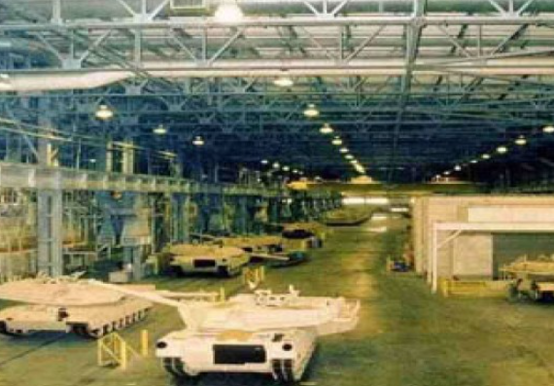  JOB OBJECTIVES  - As a part of the maintenance team  - maintaining electrical fixtures used by establishments. They install electrical equipment such as switches and elevators, repair if the damage is present, and maintain their proper function.  - responsible for repairing machines and providing support when it comes to usage of machines and electrical components.  - Schedule and undertake periodic maintenance on all electrical equipment, components, and installations  - Provide prompt response to inquiries whenever there is a breakdown, and resolve the issue as quickly as possible  - Ensure that equipment's are in good working order so as to prevent disruption of activities  - Installation of fresh electrical components and fittings  - Recommend replacement for old or faulty electrical components or fittings to the management  - Assist in forecasting requirements, creating a budget and scheduling expenses for the electrical department  - Keep record of all stock and supplies, including company’s electrical equipment  - Ensure that all electrical gadgets and instruments are switched off after close of work daily  - Learn new skills and attend training programs in other to increase knowledge of trends and best practices in the industry  - Provide safe working environment for members of staff, and ensure electricity induced accidents and mishaps are prevented  - Purchase electrical fittings and components or supervise the staff charged with the responsibility  8- Total Trading and Contracting Company (Egypt)  Job title: Electrical site Engineer  Inclusive Dates: Nov - 2004 to March – 2006 (2 year)  Project: Construction of Arma soap & chemicals Factory in city of 10th of Ramadan  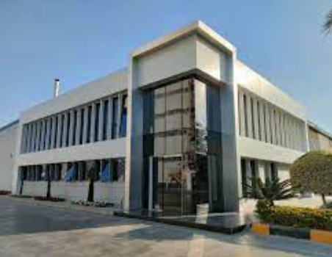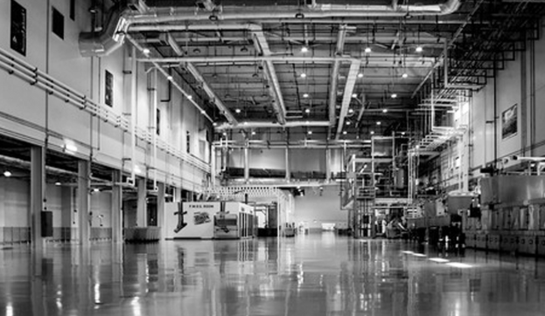  JOB OBJECTIVES
- As part of the engineering team, support the safe operation of the site, including supporting project activity
- Conduct research and studies on site
- Manage field activities and implement engineering designs
- Draft and submit reports
- Supervise and direct onsite crew (e.g., technicians)
- Ensure proper maintenance of onsite equipment
- Inspect and test material and machinery for safety

Skills and capabilities
- Reliable, hardworking, Challenging, adaptable, good Communication Skills and having the willing of working abroad
- Ability to persuade and influence others.
- Empowerment of people.
- Organizing work and people effectively.
- Ability to achieve objectives to time and budget.
- Good understanding of integrating multicultural staff into one team
- Ability to create climate of open communication.
- Willingness and ability to adapt to change

EDUCATION
: University of AL-Menoufia, faculty of engineering
: B.Sc. Electrical and Electronic Automatic Control Engineer
: Graduation date: May 2004

Personal Details
Date of Birth : 9 March1982
Nationality : Egyptian
Marital Status : Married, have 3 children
Military status : Exempted
Languages Known : Arabic – Mother Tongue
: English – Excellent

Driving License : Egyptian Driving License
: Saudi Arabia Driving License

