
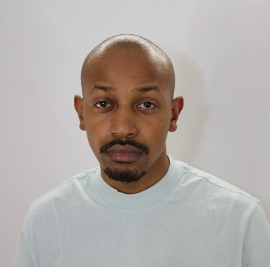
v
PROFILE
Experienced and adaptable Construction Manager with a strong track record in delivering complex infrastructure, civil, and build projects in high-security, live airport environments. Currently leading steelwork, façade, and roofing packages on the £140M Gatwick Pier 6 Western Extension with Mace, following successful delivery of multiple phases of the T2 FCC and CS1 projects at Heathrow. Proven expertise in managing subcontractors, ensuring compliance with programme, quality and safety requirements, and coordinating closely with logistics, design, and operations teams. Adept at working under pressure, driving results in constrained airside conditions, and delivering sustainable solutions in line with modern construction standards (including BREEAM targets).

Mace Training
- CITB – SMSTS
- CITB - Temporary Works Coordinator
- CHSG - Fire Coordinator
- CHSG – Hot Works Permit in Construction
- MACE Working at heights
- Legionella Management
- COSHH for Coordinators Course
- Noise & HAVS
- Tower Crane Planning and Engineering
- Fitout Dry Lining
- NEC4 Introduction to the Engineering and Construction Contract
- CDM Regulations
Eliass-Kassem Arfal
Construction Manager

WORK EXPERIENCE

Construction Manager
Mace, Gatwick Airport – Pier 6 Western Extension
July 2025 – Present

- Leading delivery of structural steelwork, façade, and roofing packages on the £140M Pier 6 Western Extension project.
- Coordinating with design teams, specialist subcontractors, and airport stakeholders to ensure safe and efficient execution in a live airside environment.
- Managing installation of hybrid steel–timber structures in line with embodied carbon reduction targets (~40%), contributing to BREEAM “Excellent” and “Outstanding” ambitions.
- Overseeing logistics and sequencing of high-risk works within constrained airfield zones, ensuring minimal impact to ongoing operations.
- Managing subcontractor performance, ensuring compliance with safety, quality, and programme KPIs.
- Supporting interface coordination with MEP, internal fit-out, and cladding systems.

Construction Manager
Mace, Heathrow Airport – Terminal 2 Security Project
July 2023 – July 2025

- Delivered multiple critical infrastructure packages at Heathrow’s Terminal 2 as part of the Future Cross Campus (FCC) and Central Services 1 (CS1) programmes.
- Oversaw coordination and execution of complex construction activities in live airport environments, managing multiple subcontractors and interfacing with airport operations, logistics, and third-party contractors.
- Ensured compliance with security, safety, and operational constraints within airside red zones, including hot works, access permits, and passenger disruption avoidance.
- Successfully delivered steel, façade, structural modifications, and architectural fit-out works across various terminal upgrade stages.
- Led coordination of logistics and delivery planning in highly constrained, multi-stakeholder environments.
- Supported project handover documentation, snagging/defect resolution, and closeout procedures to airport and regulatory standards.

CONTACT
+44 742 555 7596

eliasskassem.arfal
@macegroup.com

5 Sir James Moody
Way CR5 3GX

SKILLS
- BIM 360 + ACC
- Aconex
- Aphex
- Revit 2024
- Office 360

ELIASS- KASSEM ARFAL
Construction Manager – MACE Construct

WORK EXPERIENCE

Project Manager
A.E Tradesmen London - Design and Build
2018 — 2023

- Providing aftercare services to the customer
- Interpreting work instructions, drawings and schematic diagrams
- Managing external and internal contractors/suppliers to deliver the works safely and within programme and budget.
- Follows health and safety standards and complies with building codes
- Seeking and developing ongoing continuous improvement
- Reviewing methods of working, alternative materials etc in order to maximise profitability
- Reporting progress of projects at regular intervals to client
- Project Coordination, Cost control, Forecasting, Programming, Document management, Health & Safety, Change Management, Contract Administration
- Managing risks to the projects successful outcome
- Managing the communications with all stakeholders
- Managing project to the agreed level of quality, programme and budget
- Facilitating the appointment of Contractors to the projects
- Quality assurance and overall integrity of projects
- Responsible for delivery of health and safety on site by the contractors


EDUCATION

Bachelor of Science
Construction Project Management, University of West London
1st Class Honors

Bachelor of Engineering
Electronic Engineering University of Surrey Guildford
Merit

8
XYX University, Bangalore

