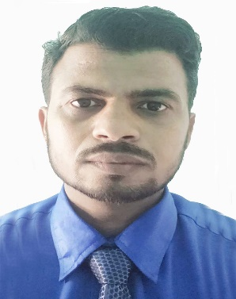
Md Shamsuzzoha
Address: At-Chhoto Sohar, Karandighi, North Dinajpur, 733215
Mobile: - +919775455521
Email: - s.zoha2015@gmail.com / s.zoha007@hotmail.com
Date of Birth: - 16-11-1988
Nationality: - Indian
Marital Status: - Married

Professional Summary

Results-driven IT Support Engineer & Graphics Designer with over 10+ years of Gulf experience (Saudi Arabia, Kuwait) in IT infrastructure, software support, ERP systems, and visual design. Proven track record in technical troubleshooting, system maintenance, and creative design solutions. Skilled in multi-tasking across IT operations and digital media, with strong problem-solving abilities and adaptability in multicultural environments.
Seeking a challenging opportunity in the Gulf region to contribute my technical expertise and design skills while supporting organizational growth.

Core Skills

IT Support & Helpdesk Management
Hardware / Software Installation & Troubleshooting
Networking, Servers, Routers, Switches
ERP Systems (Briton, SAP - basic knowledge)
Database: Oracle (10g/11g/12c), SQL Server
Project Planning (Primavera P6, MS Project)
Graphics Design (Photoshop, Illustrator, Corel Draw)
Web Development: ASP.NET, HTML, CSS, Dreamweaver
Data Backup & Recovery | Security Management

Education:

B.Tech in Computer Science & Engineering, Calcutta Institute of Technology (WBUT), 2013 – 73%
10+2 (Science), Raiganj Mohanbati High School, 2007 – 63.2%
10th, Rahatpur High Madrasah (H.S), 2005 – 77.88%

Professional Experience

IT Support Engineer & Graphics Designer
Alhai General Trading & Cont. Co., Kuwait
📅 Aug 2018 – Feb 2023

Delivered IT support across hardware, software, and network systems.
Managed ticketing, troubleshooting, user training, and system upgrades.
Handled data backup/recovery, security management, and documentation.
Designed branding, marketing materials, and digital content.

Software Application Representative & IT Support
Al-Bassami Group Co., Jeddah, Saudi Arabia
📅 Mar 2015 – Mar 2017
Supported ERP systems (Briton, Fleet, Filecom, Primavera P6).
Installed and configured systems, networks, and applications.
Developed company website and designed corporate profile & ID cards.
Assisted IT Manager in Oracle 11g (Forms & Reports).

Software Engineer (Game Development)
Sisah Technologies Pvt. Ltd., New Delhi, India
📅 Aug 2013 – Jan 2015

Designed and maintained game levels (BlackBerry apps: Panda Run, Guess What).
Conducted testing of puzzle games (2048).

Educational Roles (India & Gulf)

Assistant Teacher, Madrasah Tahfizul Quran Bikour Sohar – May 2024 to Present

Principal, N.Z. Memorial Public School – Feb 2023 to Dec 2023

Certifications

- ASP.NET using C# – CMC

- PC Maintenance – NSIC (Govt. of India)

- IT Application – Raiganj Youth Computer Training Centre

Strengths

Strong troubleshooting and problem-solving ability

Effective communication in multicultural teams

Adaptable and committed to deadlines

Skilled in documentation & reporting

Language Known:

English, Hindi, Bengali – Fluent

Arabic – Working Knowledge

Declaration:

I hereby declare that all the information given above is true to the best of my knowledge. All the documents in original/Self attested copies will be produced whenever required.
Date:
Place: Md Shamsuzzoha

