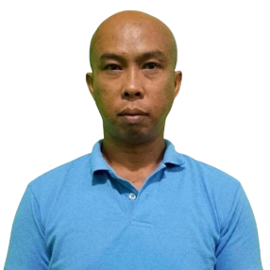
Hilarion Paloma Jr.
Blk. 4 Lot 46 Victoria Reyes Dasmariñas City, Cavite
Mobile No. 0538642816

EMAIL: hilarionpaloma15@gmail.com
Facebook Account: Hilarion Paloma

OBJECTIVE
To find a living for my family, and to have a permanent job.

QUALIFICATIONS
Professional attitude, highly motivated toward goal achievement honest, and hardworking.

PERSONAL INFORMATION:
Birthdate: September 15,1973
Place of Birth: Legaspi City, Albay
Age: 51
Gender: Male
Civil Status: Married
Height: 5'7
Weight: 75 kg
Religion: Catholic
Nationality Filipino

EDUCATIONAL ATTAINMENT:
TERTIARY University of Perpetual Help Rizal
Las Pinas city, metro manila
Business Management
(1995 – 2000)
SECONDARY Saint Perigrine Institute
Banalo, Bacoor Cavite
(1989 – 1993)
PRIMARY Baclaran Elementary School Central
(1981 _ 1987)

WORK EXPERIENCE

Company : Al Ghadeer Group
Address : Al Hasa, Saudi Arabia
Date : October 28, 2008 – May 15, 2020
Position : Trailer Driver

SKILLS

- Driving

I hereby certify that the date and information above are complete, true and correct to the best of my knowledge.

Hilarion Paloma Jr..
Applicant

