Experience
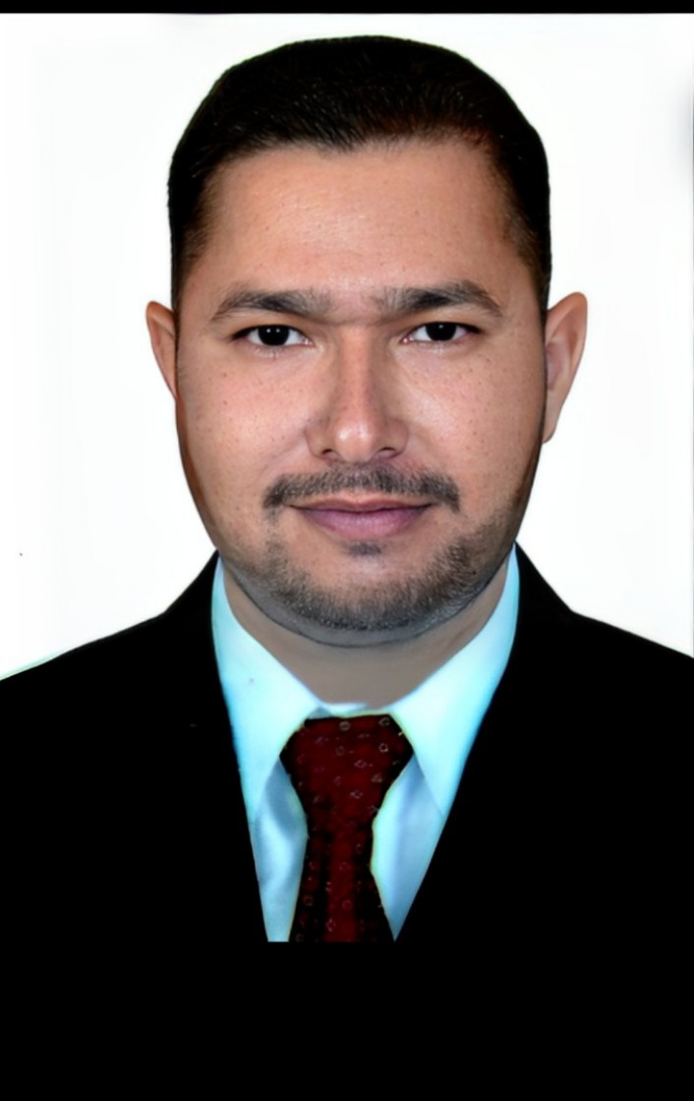

MUHAMMAD MUDDASSAR
  - CIVIL inspector/SUPERVISOR
Mob: +966590848191
email: muddassarbutt010@gmail.com

Objective
A Civil Supervisor/Inspector role where I can use my construction supervision experience and civil engineering aptitude for improving quality of work, reducing the cost of reworks and help the project team to achieve its goal.

Skills & Abilities
Structural and Civil Finishes Soft & Hardscapes, Façade Works. MS Word, Excel and Emails. Aconex (Web based document management)

Languages
English, Urdu and Arabic

personal information
D.O.B: 21st JAN 1988 Marital Status: Married Driving License: UAE, KSA & PAK

CITRUS ENGINEERING & DEVELOPERS, PAKISTAN

DEC 2021 – AUG 2025

pivot engineering & GEN. CONT, DUBAI, UAE.

june 2017 – jan 2020

shankland cox ltd, ABU DHABI, UAE

may 2014 – june 2017

Q.Mix Ready Mix (Br. Star) IND. DUBAI & SHARJAH

Sept 2011 – may 2014

SHAHEEN BUILDERS & DEVELOPERS, LAHORE, pakistan

feb 2010 – JULY 2011

PROJECTS:

Private villas bhalwal, pakistan

mamsha al sadiyat abudhabi, uae

emaar club villas dubai, uae

al bateen wharf abudhabi, uae

makani zakher shopping centre alain, uae

sh. zayed hospital lahore, pakistan

Education

INTERMEDIATE
Government Associate Degree college Bhalwal Punjab, Pakistan.

advanced quantity surveyor (CIVIL)
University of Engineering and Technology Rasul Punjab, Pakistan.

english language certificate
National Technical Training Council Rawalpindi Punjab, Pakistan
OFFICE MANAGEMENT CERTIFICATE Oxford Computer College Bhalwal Punjab, Pakistan

