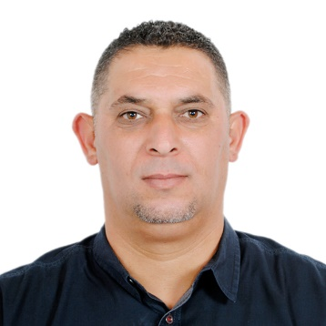
SAUDI ARABIA
JIZAN
MOBILE: 00966569352829
EMAIL: suliman_alazhari@yahoo.com
suliman alazhari
profile | I have a good informed and competent have a long track record of delivering the right work, to the right location and at the right time. Organized, process driven, and have the ability to develop efficient logistics procedures. In my long career had extensive exposure to first tier logistics and manufacturing supply chain management. Pro-active and able to keep numerous plates spinning without losing focus on the customer’s requirements. As a proven leader I am able to quickly establish clear expectations from junior staff this by demonstrating high standards of work practices and having a safety conscious attitude. Always i encourage colleagues to work cross functionally, & not stop at the boundaries of their job description.
Experience | PLANT MANAGER IN CHARGE  EL-SEIF ENGEERING CONTRACTING /JIZAN  15/6/2016 -Present  Responsible for all on site aspects of the logistics, supply chain, and customer delivery operations. In charge of making sure that each stage of the distribution process is progressing on time, on budget and to the right quality standards.  Duties:  • Working with multiple customers at the same time  . • Conducting disciplinary, capability and grievance investigations and taking appropriate action to address any failings.  • Responding to all customer complaints or queries in a efficient manner.  • Visiting key clients to build relationships and identify their key needs.  • Conducting crime and loss investigations into missing stock and loads.  • Ensuring the efficient running of administration and office procedures.  • Securing and alarming premises and monitoring security procedures.  • Actively managing subcontractors to ensure that they perform in line with their contractual agreements.  • Ensuring that all drivers work to established driving time directives.  • Supervising the completion of all checks and documentation required by law.  • Monitoring and tracking the flow of goods into the warehouse  .  • Monitoring and tracking the flow of goods into the warehouse legislators.  PLANT SUPERVISOR  EL-SEIF ENGINEERING CONTRACTING RIYADH  27/11/2013-15/6/2016  RESPONSIBLE FOR ALL ON CENTRAL WORKSHOP,MANPOWER AND EQUPMENTS MAINTENANCE AND REPAIRS .FOLLOW DAILY EPORTS AND BREAKDOWN REPORTS , IMPROVE THE WORK LEVEL AND FOLLOW THE STANDERED OF WORK LEVEL ,  Duties  . Planning the activity for all sections  . follow the daily report and insure to close all the breakdowns  . follow the spare parts requests and insure to deliver on time  . Control the worktime for man power  . Follow safety rules for all team  . Supervising the completion of all checks and documentation required  WORKSHOP SUPERVISOR  COMMODORE CONTRACTING COMPANY ABU DHABI  1/2/2011-26/4/2013  RESPONSIBLE FOR ALL ON CENTRAL WORKSHOP,MANPOWER AND EQUPMENTS MAINTENANCE AND REPAIRS .FOLLOW DAILY EPORTS AND BREAKDOWN REPORTS , IMPROVE THE WORK LEVEL AND FOLLOW THE STANDERED OF WORK LEVEL ,  Duties  . Planning the activity for all sections  . follow the daily report and insure to close all the breakdowns  . follow the spare parts requests and insure to deliver on time  . Control the worktime for man power  . Follow safety rules for all team  . Supervising the completion of all checks and documentation required
Education | 1991  W-ELSSER COLLAGE  AMMAN /JORDAN  DIPLOMA IN MECHANIC ENGINEERING  . SAFETY TRAINING COURSE / SHELL PETROLEOM RIYADH 2015  . CAT EQUPMENT TRAINING COURSE / ZAHED CO. RIYADH 2015&2016  . ISUZU DIESEL ENG. TRAINING COURSE/ FAORY CO. AMMAN 2002
Skills &  interests | COMPUTER SKILLS /DIIVING LISENCES /READING /SPORTS /

