Ghouse Mohiuddin
Planning Manager
Riyadh, Saudi Arabia
Mobile 00966-573387806
E mail: ghouse786mohiuddin.20@gmail.com

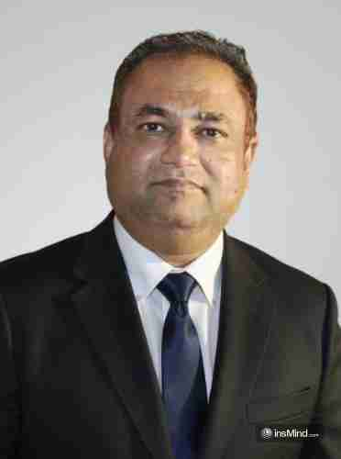
CAREER OBJECTIVE

To obtain a Planning Manager position within a progressive organization where I can apply my 20+ years of experience in project planning, controls, scheduling, and execution management across buildings, infrastructure, healthcare, and oil & gas projects. Dedicated to ensuring project success through effective planning, cost optimization, and risk mitigation, contributing to the realization of Saudi Arabia’s Vision 2030 through world-class project delivery.

PROFESSIONAL BACKGROUND

A detail-oriented and results-driven Planning & Project Controls Professional with over two decades of expertise in project scheduling, planning, design coordination, and construction management across Saudi Arabia, UAE, and India. Demonstrated success in leading multidisciplinary teams, developing baseline programs, implementing Primavera P6-based control systems, and ensuring cost and schedule adherence in multi-million-dollar projects. Adept at collaborating with stakeholders, optimizing resource allocation, and implementing robust EVM (Earned Value Management) and delay analysis methodologies.

CORE COMPETENCIES
Project Planning, Scheduling & Controls (Primavera P6, MS Project)| Baseline Development & Monitoring | Earned Value Management (EVM) | Design & Construction Coordination | Resource & Cost Optimization | Delay Analysis & Recovery Plans | Risk Identification & Mitigation | Project Reporting & Dashboarding | Client & Stakeholder Management | Quality & Compliance (ISO 9001) | MS Office Suite
CAREER HISTORY

Planning Manager | Tata Consulting Engineers Ltd. (India) | Nov 2019 – May 2025
- Implemented Primavera P6, project management methodologies to enhance efficiency, reducing project delivery time.
- Conducted delay analysis, resource histograms, and performance forecasting to support management decisions.
- Led planning and control functions for 15+ projects including commercial and healthcare developments.
- Developed and maintained project schedules in Primavera P6, ensuring alignment with scope, cost, and resources.
Projects Planning Engineer | Nael & Bin Harmal Hydroexports Est. (NBHH, UAE) (ZADCO-Oil & Gas) | Jul 2015 – Oct 2019

- Prepared detailed work programs for major infrastructure and oil & gas projects including artificial islands.
- Supported teams by providing progress reports, S-curves, and variance analysis.
- Managed schedule integration across engineering, procurement, and construction phases.
- Enhanced performance by establishing planning procedures and reporting systems using Primavera P6.
Planning Engineer / Site Selection Manager | URS Dames & Moore. (KSA) | Oct 2008 – May 2015

- Responsible for project scheduling, site analysis, and planning of large-scale GSM projects.
- Managed baseline schedules, monitored progress, and updated forecasts and risk analyses.
- Coordinated with cross-functional teams to mitigate potential delays and cost overruns.
- Maintained strict quality control and compliance, ensuring full client satisfaction.
Project Planning & Control Engineer | Dorrer Al Waleed Contracting Co. (KSA) | Nov 2002 – Apr 2008

- Developed and tracked project schedules and procurement plans for Telecom (GSM) projects.
- Introduced cash flow analysis to improve decision-making and control.
- Supported management teams in maintaining cost, schedule, and quality performance.

Civil Engineer (Planning & Site Supervision) | Al Jazeera Engineers & Consultants (KSA) | Dec 1999 – May 2002

- Supervised and scheduled activities for building, substation, and underground cabling projects.
- Coordinated inspection schedules and reduced rework through proactive planning.
Civil/Structural Engineer– Planning Support | Dar Al Riyadh Consultants, Saudi Aramco (KSA) | Apr 1995 – Oct 1999

- Assisted in planning and progress control of refinery expansion and oil & gas infrastructure projects.
- Generated detailed engineering schedules, manpower plans, and progress reports.
- Certified Lead Quality Auditor (ISO 9001), recognized for QA/QC improvement.
EDUCATION
Bachelor of Engineering (Civil Engineering) – Osmania University, India (A++ Grade, Jan 1993)
CERTIFICATIONS
• Primavera P6 (Project Planning & Controls)
• Lead Quality Auditor – ISO 9001:2015
• MS Office, AutoCAD, STAAD Pro
KEY PROJECT HIGHLIGHTS
• Zakkum Artificial Island (ZADCO-Oil & Gas) Project, Abu Dhabi – Multi-billion-dollar marine, oil & gas, and infrastructure development.
• Medical College & Hospital Complex, India – 29-building, 58-acre integrated development delivered on schedule.
• Saudi Aramco Refinery Expansion Project – Assisted in planning and QA/QC compliance of $25M facility upgrade.

