CURRICULAM VITAE
MOHAMMAD ZUBAIR ALAM SAP NO ARAMCO - 80012982 QA/QC MANAGER
Contact in Saudi : 00966-502644814 E-mail : zubalamkhan179@gmail.com Saudi Driving License
BACHELOR OF ENGINEER (B.E) IRCA CERTIFIED ISO 9001:2015
OBJECTIVE

To work in challenging & responsible position in a dynamically progressing organization which will give scope to apply my skills knowledge and to constantly grow with the company and attaining a challenging position in technical field.
SUMMARY OF SKILLS AND EXPERTISE:
Having total 20.1 -Years QA/QC Management experience in managing quality systems as per SCHEDULE Q and ISO 9001:2015 relating to the Contract Scope of WORK (e.g.; oil, gas, Water treatment plant and petrochemical projects, Chemical Project, High Rise Building, Infrastructure, etc., starting his career in 2003 in an EPC- multinational Company. I am fully conversant in coordinating & team-leading and preparing project quality plan, ITPs, method statement & checklist and internal auditing & inspection checklists in compliance with Clients requirements of construction works. Implement the QA/QC management system at site Coordinate with quality inspections with all the site sub- contractors and vendors coordinate all testing on site. Coordinate with the customer’s representative on all quality matters and all receipt inspections.
Support the Project Quality Manager in the planning and implementation of the Project Quality Management System (PQMS) activities within assigned Offshore Projects.
Implement the Quality Assurance activities within assigned Offshore Projects.
Under the supervision of the Project Quality Manager, coordinate the project Quality activities implementation.
Involved and Familiarity with Commissioning and pre commissioning procedure as well
Sat and factory acceptance test with the vendor client representatives.

Responsible for the Distribute relevant QA/QC documentation to site subcontractors Verify that the quality related site activities are in accordance with the applicable codes and standards

Participate/Conduct in the site internal and external site audits, Coordinate all the quality site inspections through the site QC inspectors.
Ensure all quality control documentation is compiled and competed for as-built hand over through the QC turnover engineer

Control all nonconformance reports and undertake remedial action, Compete site quality control instructions and action remedial responses.

Review the customer’s specification and undertake relevant training to the site QC inspector, Monitor the implementation of the approved site QC Plan, combined with an agile and analytical mind, I looked forward to challenges and aspire to achieve them. Management skills, Communication Skills, ISO certification.

Lead Audit/QMS System ISO 9001:2015 CERTIFIED
Review, Evaluate & Audit the effectiveness of the Quality Management system to ensure, compliance of work output with, or identify Areas of non conformance to specification.
Developing Quality Management System Procedures including Quality Assurance Procedure & Quality Control Procedure.
Management skills, Communication Skills, ISO certification is plus Implementing Quality Management systems.
Developing Quality Manuals, Co-ordinate and obtain approval for QA/QC Manual from clients Representative.
Develop Inspection and Test Plans for various work phases.
Review of material requisition and purchase orders for compliance with applicable standards, drawings and specification. Organizing and establishing the agenda for pre- inspection meetings, issuance and co-ordination of source inspection assignments and review of manufacturer / Vendor Quality Plans.
SPECIAL TRAINING AND SEMINAR
Company’s In-house Training for the QA/QC (Mechanical, Electrical, Instrumentation, Communication and civil works) at Head office Dammam, KSA.
Familiarization and understanding of Complete Saudi Aramco Engineering standard, SAES, SAEP, SATIP SAIC, SAMSS (Saudi Aramco desktop) Schedule ‘Q’ , Royal Commission and SADARA STANDARD and industry codes practices. Closed awareness of QA/QC inspection, Project Quality Plan, and Company’s Quality Manual. Seminar on Awareness of Audit.
Special Skills/Knowledge

To knowledge of quality, engineering. Knowledge of oil and gas terminology. To read, write and communicate fluently in English, Urdu and Arabic.
Knowledge of ISO 9001:2015 Standard to approach correctly all Quality Matters.
Having excellent organizational, verbal, and written communication skills.
To independently use personal computing applications, e.g. MS Word, Excel, Internet Explorer, and Outlook., VB, JAVA SCRIPT C, C++ etc.
Having a proactive approach and willing to learn

Some basic knowledge of Welding, NDE, Coating, and NACE (a plus), Structure.

We have legal authorization to travel / work in all assigned counties – All Gulf Countries and (both North and South America, Europe, and European Union counties.)
Management Skills, Communication Skills, Problem Solving, Leadership and decisions.

PROFESSIONAL WORKING EXPERIENCE:

Company : AL HARBI & PARTNERS CO. Project : MA’ADEN PHOSPHATE 3 PHASE 1
Client = MA’ADEN
Consultant = WORLEY
Position : QC MANAGER
Duration : AUGUST 2024 TO MARCH 2025
PROFESSIONAL WORKING EXPERIENCE:

Company : AL HARBI & PARTNERS CO.
Project : AMIRAL SITE PREPARATION PROJECT, PACKAGE # 07 Client = ARAMCO & TOTAL ENERGY ( SATORP PART-02)
Position : QC MANAGER
Duration : SEPTEMBER 2023 TO JUNE 2024

PROFESSIONAL WORKING EXPERIENCE:
Company : SAUDI ELAF CO.LTD.
Project : NEOM
Consultant : PARSON CONSULTANT
Position : QC MANAGER
Duration : AUGUST 2022 TO JUNE 2023

PROFESSIONAL WORKING EXPERIENCE:
Company : SAPAC CO.LTD.
Project : NEOM
Consultant : AECOM
Position : QA/QC MANAGER
Duration : FEB 2022 TO JULY 2022
PROFESSIONAL WORKING EXPERIENCE:
Company : PETROJET LTD CO.
Project : ARAMCO EAST & WEST PIPELINE PROJECT( ABQAIC TO YANBU)
Position : QA/QC SUPERVISOR
Duration : JUNE 2021 TO DECEMBER 2021

PROFESSIONAL WORKING EXPERIENCE:

Company : AL KIFAH CONTRACTIONG & HOLDING CO. LTD (PACK-1) Project : INCREMENT FACILITY PROGRAM (ARAMCO)
Position : QA/QC SUPERVISOR
Duration : JAN 2021 TO MAY 2021
PROFESSIONAL WORKING EXPERIENCE:
Company : SEPCO ARABIA LTD.
Project : JIGCC EPC # 4, POWER BLOCK PROJECT ARAMCO( JEZAN)
Position : QA/QC SUPERVISOR
Duration : MARCH 2020 TO NOVEMBER 2020
Duties & Responsibilities: AS A QA/QC PIPING SUPERVISOR FOR SEPCO ARABIA JIGCC EPC #4 ARAMCO POWER BLOCK PROJECT (JEZAN)

Support the development and lead the implementation of quality standards and product quality plans as part of the Quality System to assure products will meet expectations of our target customers.

Establish countermeasures for quality flow out by conducting root cause investigation and implementing corrective actions. Develop & maintain Standardized Work Instructions used throughout the manufacturing quality organization by the QC team members.

Manage QC team members and develop the team, Analyzes and resolves work problems, or assists workers in solving work problems.

Assists the Quality Assurance Manager in developing and maintaining the ISO 9001 procedures and work instructions.

Work in cross-functional teams with other departments across the company for product improvement and development.

Manage third-party inspection service provider and provide shipment approval to vendors once QC is complete.

Analyze and resolve work problems, or assist associates in resolving work problems, Improve and maintain department performance according to set objectives and established goals.

Work closely with and perform follow-ups with Purchasing, Vendor(s), Materials Management, Warehouse Department

To lead the team of QC Inspectors for monitoring the on‐going daily construction activity. Reviewing the construction method statements and making comments per project specific- ations, procedures & ITPs.

Regular site visits for foreseeing the potential deficiencies based on his physical experience t o share with construction crew and guidance to QC Inspectors.
Coordination with NDT agencies for inspection & testing requirements. Ensuring the ava- ilability of QC Inspector during any operations.
Initiating internal Log Book Entries/NCR’s to construction crew for effective implement- action of project quality plan, ITP’s, written procedures, project specifications,
IFC drawings etc.
Coordination with Clients inspectors for getting the feedback for open log book entries and preparations of corrective actions to close those violations.
Emphasizing on the control of documents and records by advising the document controllers, QC Inspectors.
Conducting routine internal meetings with QC inspectors for further vigilance to the potential problems which must be tackled accordingly to avoid non‐conformities.
Responsibility for Project QA/QC management including compliance with contractual requirements and follow-up on. Responsible to set up quality Management system. Prepares documentation for approval.

Carry out procedure qualification, Welder qualification, NDE qualification, personnel qualification as per guidelines of Company Policy and Contract requirements.

Responsibility for guiding, supporting, performing and verifying all matters concerning projects’ quality assurance and quality Control Within Projects.

Responsible to give support related to QA/QC to Supply chain department. Participate in selection of suppliers and assessment audits at supplier facility when required.

Conduct the full process of drafting, verifying, commenting and reviewing of QA/QC documentation provided by customers, internal stakeholders and from suppliers and sub- contractors.
Prepare and implement on the operating system the QA/QC procedures, standard documents and templates.
Ensure root-cause analysis, corrective and preventive actions are carried out for the project non-conformances.

Ensure Projects Lessons Learnt Are Conducted and implemented within projects. Carry out Internal audit and Client co-ordination for their visits, audits, meeting etc.

Execute work with in the time frame, Ensure maximum output / productivity. Contribute to the creation and implementation of best practice quality vision, procedures and improve operational performance.

Utilize the project execution model, carry out tasks given in accordance to the company policies, procedures, etc.

Communicate, integrate and cooperate with other discipline to achieve the common goals Competencies and manning:

Follow-up activities of fabrication & identify what’s coming & take necessary preventive action Colleague:

Work closely with team members within the discipline to ensure the product is in compliance to the project requirements and reports to the Quality Manager.

Work closely with engineering team to ensure latest information is available on the ground level (working level).
Strong interpersonal and communication skills. Ability to plan and organize work flow in efficient manner.

PROFESSIONAL WORKING EXPERIENCE:
Company : AL KIFAH CONTRACTIONG & HOLDING CO. LTD (PACK-1) Project : SOUTH DHAHRAN OWNERSHIP HOME PROGRAM(ARAMCO)
Position : QA/QC MANAGER
Duration : FEB 2018 TO DEC 2019
Duties & Responsibilities: AS A QA/QC MANAGER
To lead the team of QC inspectors for monitoring the on-going daily Construction activity. Re-viewing the Construction Method Statements and making comments per project Specifications, Procedure & ITPS.
Regular site visits for for-seeing the potential deficiencies based on his physical experience to share with Construction Crew and guidance to QC Inspectors.

Co-ordinate with NDT Agencies for inspection & Testing requirements. Ensuring the availability of QC inspector during any operations.
Initiating internal log Book entries/NCR to Construction Crew for effective implementation of Project quality Plan, ITP’s, written procedures, Project Specification, IFC Drawing ETC.
Coordination with Clients inspectors for getting the feedback for open log book entries and preparations of corrective actions to close those violations.
Emphasizing on the control of documents and records by advising the document controllers, QC Inspectors.
Involved during FAT factory acceptance test at vendor premises and SAT site acceptance test. Responsible and involved for pre commissioning and commissioning activities with the client and vendor representatives.
Conducting routine internal meetings with QC inspectors for further vigilance to the potential al problems which must be tackled accordingly to avoid non‐conformities.
Responsibility for Project QA/QC management including compliance with contractual requirements and follow-up on. Responsible to set up quality Management system. Prepares documentation for approval.
Carry out procedure qualification, Welder qualification, and NDE qualification, personnel qualification as per guidelines of Company Policy and Contract requirements.

Responsibility for guiding, supporting, performing and verifying all matters concerning projects’ quality assurance and quality Control Within Projects. Responsible to give support related to QA/QC to Supply chain department.

Participate in selection of suppliers and assessment audits at supplier facility when required. Conduct the full process of drafting, verifying, commenting and reviewing of QA/QC documentation provided by customers, internal stakeholders and from suppliers and sub- contractors.
Prepare and implement on the operating system the QA/QC procedures, standard documents and templates. Ensure root-cause analysis, corrective and preventive actions are carried out for the project non-conformances.

Ensure Projects Lessons Learnt Are Conducted and implemented wit
projects. Communicate, integrate and cooperate with other discipline to achieve the common goals Competencies and manning:
Follow-up activities of fabrication & identify what’s coming & take necessary preventive action Colleague: Work closely with team members within the discipline to ensure the product is in compliance to the project requirements and reports to the Quality Manager.
Work closely with engineering team to ensure latest information is available on the ground level (working level). Strong interpersonal and communication skills. Ability to plan and organize work flow in efficient manner.

PROFESSIONAL WORKING EXPERIENCE:
COMPANY: CHINA COMMUNICATION CONSTRUCTION CO. LTD
PROJECT : INFRASTRUCTURE & HIGH RISE BUILDING JUBAIL-2, STAG-3 ,SWCC ( ROYAL COMMISSION PROJECT)
POSITION: QA/QC MANAGER
DURATION: MARCH 2013 TO AUGUST 2017

Duties & Responsibilities: AS A QA/QC MANAGER
Look after projects and develop, implement and measure the Company’s QA/QC strategy in line with project Quality plan Involved to participate Weekly Qc meeting, NCR and LBE meeting with the clients, submittals of Two weeks look ahead Quality Plan.

Involved for the approval of all quality documents such as QCP, material approvals, testing procedures. Responsible for the Rejection of All RFI’ Involved and doing coordination with the project management team, related to all site activities and quality concerns.

Involved during completion of 15% and 60% Audit. Controlling of all test records of test equipment Calibration Co-ordinate the activities required as per the standards, specification, including ISO 9001 QMS System.

Develop, implement and measure best in class improvements activities to ensure value driven processes. Develop, implement and measure the continuous improvement methodology in all aspects of the project. Develop and implement the Lead the verifications and validations process on the project deliverables to the customers by testing and reviewing the deliverables of the projects milestones.
Performance of walk-through and process improvements. Ensure that the Company meets the internal and external quality assurance requirements, including legal compliance and customer expectations. Involved during Audit at the 15% and 60% of the project completion.
Oversee the development and management of the Company’s Business Management portal. Make recommendations to the management team for continual improvements of the Process

Coordinate with quality inspections with all the site sub-contractors and vendors coordinate all non-destructive testing on site. Coordinate with the customer’s representative on all quality matters

Compete site quality control instructions and action remedial responses, Review the customer’s specification and undertake relevant training to the site QC inspector.

Monitor the implementation of the approved site QC Plan, Complete and coordinate the approval of the sites QC technical submittals to the customer

Coordinate with the site construction manager on all quality issues Coordinate and chair the QA/QC site weekly meetings with the projects subcontractor’s QC personnel.

Elaborating inspection and test programs ensure the safety is adhered to at site. Assure all technical documents relative to site quality. Taking care of QA/QC Document Project.

QA QC Manager will report directly to the Project Manager and will work with or manage a team of Officers as necessary. Involved Quality activities during Pre commissioning and commissioning period on the project

QC manager will also work directly with Engineers and Site managers as a liaison to the Project Manager to ensure that quality is achieved effectively. Further this manager will work with prime contracting representatives or customers where applicable to reassure that proper or specified QA QC procedures are being observed and utilized in an effective manner.

Providing training / orientation to the new Production and QC staff so as to create awareness of Quality and to build a team working spirit. Initiating the Corrective and Preventive action for the Customer complaints and completion of it with the help of Production Department and follow up thereafter.

Manage weekly quality meetings with client and subcontractors Responsible for ensuring systems are contractually complete and acceptable prior to being turned over and also prepare the turnover documentation associated with each system.

The QA/QC Personnel’s mobilization and demobilization based on the project Contractual and Clients requirements. Establish the Internal Audit plans notifications for Scheduled internal audits within organization and to the clients communicating to the process owners for Corrective preventive action outcome from internal audits Scheduling the periodic six monthly

Management Review Meetings to highlight the internal external audit results to which need management’s intervention for further improvements in the QMS interface and co-ordination with Clients for Continual improvements in the System by implementation of QMS preparing.
PROFESSIONAL WORKING EXPERIENCE:
COMPANY : TECNICAS REUNIDAS GULF (Spain Co.)
PROJECT : SADARA CHEMICAL PLANT III (AL JUBAIL-2)
POSITION : QA/QC MANAGER
DURATION : MARCH 2012 to MARCH 2013
- Duties & Responsibilities: ASA QC MANAGER
Monitors quality to ensure that it is in accordance with project specifications. Manages and directs the activities of the Quality Control Department. Directs QC personnel to the strict compliance of Quality Controls quality system procedure according to the implementation project standard and specification.

Directs the strict compliance to follow the required specifications, correct measurement. responsible those customers required specifications are fully and rightfully met and ensures that the products conform to the generally accepted quality standard.

Communicate Company’s and the Department’s objectives and business context to ensure alignment and common understanding of the objectives. To delegate and supervise the implementation of quality performance objectives as well as to establish monitoring mechanisms in order to ensure that these objectives are delivered.

Prepare and ensure that the approved Project Quality Plan is understood and implemented. Coordinates the quality assurance and control activities for Civil, Mechanical, Electrical, works. Communicates with Site Management for quality issues and process improvements.

Represents the QA/QC Department in any meeting with Project Management, Consultant/Client Representative and Subcontractors. Follow up closely with concerned parties on prevention and closure of Non-Conformances.

Ensure training programs and development for QA/QC Engineers and give presentations to ensure understanding of procedures and processes. Responsible for the training and certification of Project’s QA/QC Staff.

Responsible for implementing ISO policies, procedures and standards. Responsible for establishing, updating and implementing Quality Inspection plans for project and work sites (workshops etc.)

Develops and institutionalizes Company’s QA/QC expertise, know-how, controls and capabilities. Ensures Project QA/QC Plan is regularly updated and available for consultation Manages the documentation and implementation of lessons learned concerning quality.

Identifies and tracks QA/QC and devises plans and initiatives for improvement. Coordinates with Procurement for conducting inspections of purchased materials. Coordinates with client appointed quality inspection teams to resolve complex QA/QC issues.

Interacts and manages all QA/QC staff on site and operational issues on a daily basis. Coordinates with local and international organizations/institutions for updating Company’s standards.
PROFESSIONAL WORKING EXPERIENCE:
COMPANY : BADAR AL MULLAH & BROTHERS & COMPANY W.L.L
PROJECT : KUWAIT NATIONAL PETROLIUM CO. (KNPC -0028)
POSITION : QA/QC ENGINEER
DURATION : DEC 2009 to FEB 2011
- Duties & Responsibilities: AS A QA/QC ENGINEER

Ensuring that all mechanical construction activities and assembly of components including preservation of equipment for the Central Processing Facility Project (CPF) are carried out in accordance with Client approved Project Specifications, Project Procedures, Method Statements, and relevant Codes & Standards.
Witnessing and monitoring of all site static/rotating equipment, package equipment and skid mounted vessels/machinery inspections including structural steel erection. Ensure that all inspection reports are accurate and relevant documents are current status.

Review all inspection reports for compliance. Prepare nonconformance reports to the QA manager and assist in developing corrective actions. Coordinate with the client QC inspectors for the resolution of site problems.
Completion of QC site instructions and coordinate their closure and review of inspection test packages during the course of construction activities. Compliance with the site’s health and safety regulations.
Attend weekly QC meetings. Ensure all the equipment inspection activities are performed to approve procedures, codes and standards. Executes the specific inspections on materials, equipment and construction/installation activities on site.
Issues the relevant Quality records and, when necessary, writes and sends to QC Manager Non-conformance reports. Controls equipment installation, alignment and leveling. Performs functional checks and mechanical completion checks.
Witness the test, controls and inspection, authorizing the acceptance at quality control completion, obtain the relevant documentation and ensure the correct implementation of the approved Inspection Test Plan according to Client’s requirements.
Monitor the construction activities of subcontractors to ensure that the works are safely performed according to good engineering practices and standards. Inspection and witnessing of testing and commissioning of rotating equipment and related documentation in accordance with project procedures.
Attend all necessary inspections as identified in the approved Inspection and Test Plan (ITP). Inspect the production quality to establish if the client requirements are being achieved.
Shall perform a variety of inspection functions under supervision. Record and document any and all deviations from the Project Quality Program (PQP) and the Company Integrated Management System (IMS).
Update the system with any and all deviations from the Project Quality Program and the Company Integrated Management System (IMS). Coordinate with the client representatives to ensure that inspections are carried out expediently.
Generate client Requests for Inspection (RFI) where required providing sufficient notice for hold, witness and inspection points. Carry out inspections on Exception Items (EI) as documented and sign off a closed when activity is complete.
Continually carry out surveillance inspections on the project recording and documenting any and all deviations from the (PQP) and the company Integrated Management System (IMS).
Review the calibration status of any test equipment being utilized on the project ensuring the equipment is within calibration prior to use.
Provide support and advice to the construction personnel in relation to the Project Quality Program and the Company Integrated Management System (IMS)

Maintain a good working relationship with all Client personnel. Maintain good record keeping of activities carried out and inspection reports, surveillance reports, etc.
Comply with all Project HSE requirements i.e. PPE, work Permits etc. Any other duties as assigned from time to time.
PROFESSIONAL WORKING EXPERIENCE:
COMPANY : SAUDI OGER LTD W.L.L ( RIYADH)
PROJECT : PIPELINE NORTHEN PROJECT (1000km) & Potable Water System POSITION : PIPING QC INSPECTOR
DURATION : Feb 2007 to Dec 2009
PROFESSIONAL WORKING EXPERIENCE:
COMPANY : PUNJ LLOYD LTD

PROJECT : DABHOL – BANGLORE PIPELINE PROJECT (INDIA)

POSITION : PIPING ASSISTANCE ENGINEER
DURATION : Aug 2003 to Jan 2007
Duties & Responsibilities: AS A INSPECTION ENGINEER

Ensure the Inspection & Test Plan of each activity is fulfilled and "hold points" of the company are completed in due time. Involved during FAT factory acceptance test at vendor premises and SAT site acceptance test.

Responsible and involved for pre commissioning and commissioning activities with the client and vendor representatives. Ensure all the personnel employed and operating in welding and NDE activities is duly skilled and qualified in accordance with the applicable specifications, codes and regulations.

Monitoring daily QC activities of Sub Contractors, to ensure erection is in compliance with contract specifications, review of inspection and test plans and erection procedure to ensure the implementation of the project approved QA/QC procedures and standards are followed.

Perform routine surveillance, inspection, monitoring, auditing & assurance of Sub- Contractor's site activities (Fabrication and Welding, NDT, Coating and Painting) in accordance with the Project and Contractors Specifications, ITP and Quality Plans.

Identifying the test medium to be used for Hydro Test for Piping Lines in the Test Packages, inspecting the water to be used for Hydro Test as per the ASME B-31.3 Standards.

Piping line check, witness hydro testing and review hydro test packages to verify the completion of NDT requirements, gauge calibrations, verifying that pipe supports, hangers and guides have been installed in accordance with the piping drawings and the pipe support details, analyze the requirement of temporary supports for above ground piping during hydro test, reinforced pads leak testing.

Assure that all joints are exposed for examination during pressure test. Ensure that isolation or disconnection of equipment not to be tested. Check vents are open when filling and draining lines.

Making Punch List with client and attained the same Hydro Test witness with client. All the inspection report making and taking the signature from the client.

Receiving Incoming materials from vendors and preparing inspection reports for Fit-up and welding. Co-ordinate with client quality Engineer for final Punch listing.
Control of quality Control documents and maintain its status list. Inspection of deliveries of Materials to assure that they are within tolerance, grade in quality as specified. They are properly stored and handled, and that they have been not damaged.

Raising RFI’s for each item of work completed and at site for witness. Orientation checking, Identification of Radiography joints, taking NDT clearance from Clients, Repair attending of joints, Documentation maintenance for ISO records.

Control of management and execution of all activities as per specification codes, approved procedure. Familiar with Hydro test knowledge of Plant piping and Fittings.
Valve testing RFI rising with Construction Team Coordination. Valve inspection and testing arrangements and witness with EPC/Client Inspectors as per API 598.
Duties & Responsibilities: AS A INTERPRET AND EVALUATE NDT, WITNESS HYDRO TEST, PNEUMATIC TEST AND POST TEST REINSTATEMENT:

Ensure that all required NDE shall be performed prior to final system hydro/ pneumatic testing unless otherwise specified by engineering, reviewing all the NDT reports with coordination of NDT Personnel & Third party Inspectors. Identification of risks to the quality of work and the completion programs and associated solutions.

Trouble shooting, Maintain day-to-day liaison with Contractor's site QA/QC staff. Prepare daily reports of all site QC activities performed. Valve drawings and calculations, including outline dimensions, weights, section drawings, part lists and materials for approval.

Trim shall include the nozzle, the disc holder, stem, guide, blow down ring, ring pin, bushing and all internal parts, except the body, in contact with the process fluid. The nozzle and disc shall be forged / bar stock SS 316 with machined stainless steel guide and spindle.

The valve spring design shall permit an adjustment of +/- 5 % of the set pressure as a minimum. Spring materials supplied shall be suitable for the relieving temperatures given on the data sheet.

Alloy steel shall be used for temperature below 230°C. Plain lifting levers shall be provided on all valves for steam service unless specified otherwise on the data sheet.

Caps shall be provided over the spring adjusting screws on all valves. The cap and bonnet shall be provided with a wire seal to prevent unauthorized adjustment.

Only safety relief valves incorporating adjustable blow down rings shall be offered for protecting process equipment. Safety / Relief valves shall be painted in accordance with manufacturer standard unless otherwise specified.

The safety or relief valve shall be of adequate size to relieve the capacity at the specified pressure and temperature conditions and fluid physical properties regardless of any preliminary sizing calculations or orifice designation shown on data sheet.
Accumulation used in calculating size of relieving devices shall be 10%. The valves shall be suitable for continuous operation under the operating conditions indicated in data sheets.

For very low capacity applications, if API orifice is offered, vendor shall provide mechanical stop to prevent lifting. Vendor shall also arrange for witnessing capacity test of such valves. A permanently attached (with drive pins or equal) stainless steel tag (s) stamped with the following information shall be provided on each valve.

Tag Number Manufacturer's Name. Trademark Model Number. Serial Number and Year of manufacture Size of Valve with flange rating for inlet and outlet Body Material. Body and Trim Material Set Pressure Set Pressure Range Orifice Description Code stamp.

Each valve shall be factory set and tested in accordance with the appropriate code Procedures. When the valve is subjected to the specified set pressure, destructive chattering shall not occur when raising the pressure to the pipping point and then lowering to below the closing pressure.

Set pressure tolerances shall be as required by the appropriate code. Operational tightness test - the valves shall be bubble tight when tested at 90% of set pressure in accordance with the appropriate standard.

Test & Test Certificate The supplier shall issue with each valve test certificates confirming that it complies with the relevant codes for: Hydrostatic pressure test, Seat leakage test, relieving set pressure, Functional test, Material test certificate for pressure-containing parts.

Material test certificates with detailed chemical analysis from the foundry for each casting Certificate of radiography / X-ray for valve casting. Certificate in form III C for all valves covered under IBR certification.

Factory Inspection The complete valve and actuator assembly shall be inspected by the owner and third party prior to dispatch unless otherwise advised. Owner/MMCI shall be informed at least 6 weeks in advance for the inspection and FAT TEST.

Vendor shall provide as a minimum the following documents Valve general arrangement Drawing showing main components, main dimensions and weights. Technical data /

catalogues Installation Requirements Calibration certificate, hydrostatic pressure test, Seat leakage, relieving set pressure Material test certificate for pressure containing parts.

All documents mentioned in certification Inspection clearance certificate (Owner /consultant / Third Party Inspector). Manuals and drawings
SAFETY TRAINING ATTENDENT
Elementary first aid and fire prevention and fire fighting Familiar with operation of fire extinguishers like DCP, CO2 Operation of fire hydrants, deluge valve systems and MCP Lock out Tag out (LOTO) procedures
Safety procedures for Tagging and scaffolding
All types of permit system& preparation of permits
Familiar with personal protective equipment’s and life guards Barriers, barricades &fencing
Lifting, Rigging, Excavations, Confined Space entry procedures Elementary PPE, harness, work at heights, welding procedures Toxic chemicals, gases, hazardous chemicals
STRENGTHS AND VISION:
Willingness to learn
Ability to deal with people diplomatically Ability to deal with people diplomatically
Excellent verbal and written Communication skills. Good leadership quality.
CONTACT INFORMATION:
NAME: MOHAMMAD ZUBAIR ALAM
NATIONALITY INDIAN MARITAL STATUS MARRIED
DATE OF BIRTH 4TH MARCH 1980
DRIVING LICENCE NO SN 04003502232033/325253 (SAUDI ARAB) LOCATION AL JUBAIL (SAUDI ARAB)
DECLARATION OF TRULY INFORMATION:

I hereby declare that, the information given above is true the best of my knowledge and I assure you that
I will in the write earnest and full fill the expectations of my superiors.

2/14/22, 4:16 PM Aconex

07 NEOM Mountain NEOM Mountain NEOM
Saudi Arabia

MAIL TYPE
Workflow Transmittal
MAIL NUMBER
ACM-WTRAN-004192
REFERENCE NUMBER
ACM-WTRAN-004192

Final (WF-001827) 07-0000100322/009-IN-Quality - IFR

From Mr Mostafa Darwish - AECOM

To (3)

Cc (5)
Neom Pmc Region 07 - AECOM (+2 more...) Bengt VonSchwerin - AECOM (+4 more...)

Sent Monday, 14 February 2022 3:59:33 PM AST (GMT +03:00)

Status N/A

DOCUMENT ATTACHMENTS (2)

(0 selected)
File | Document No | Revision | Revision Date | Title | Status
 |  |  |  |  | B - Incorporate
  07-141101-0000100322-SPC- |  |  |  | 0000100322/009 CV- Mohammed
 |  | 01 | 10/02/2022 |  | Comments -
HRM-CRS-000008 |  |  |  | Zubair Alam (QA/QC Manager)
 |  |  |  |  | Proceed
 |  |  |  |  | B - Incorporate
  07-141101-0000100322-SPC- |  |  |  | 0000100322/009 CV- Mohammed
 |  | 01 | 10/02/2022 |  | Comments -
HRM-CVS-000008 |  |  |  | Zubair Alam (QA/QC Manager)
 |  |  |  |  | Proceed

MESSAGE

Workflow Review History
The attached documents have completed the "07-0000100322/009-IN-Quality - IFR" workflow with the following results :

This transmittal was automatically generated.

Doc No Step Participant Review Outcome Comments

07-141101-0000100322- SPC-HRM-CVS-000008

AECOM/ETSD Review M Ismail
B - Incorporate Comments
- Proceed
See ETSD comments on CRS.

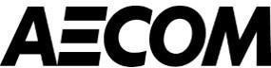
SPM/PM Review M Darwish B - Incorporate Comments

https://ksa1.aconex.com/Logon 1/2

2/14/22, 4:16 PM Aconex
- Proceed
07-141101-0000100322-
SPC-HRM-CRS-000008
B - Incorporate Comments See ETSD comments on
AECOM/ETSD Review
M Ismail
- Proceed
CRS.
SPM/PM Review
M Darwish
B - Incorporate Comments
- Proceed

https://ksa1.aconex.com/Logon 2/2

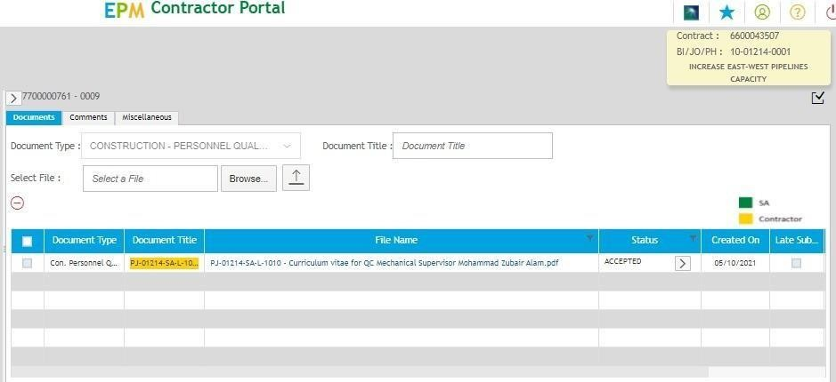

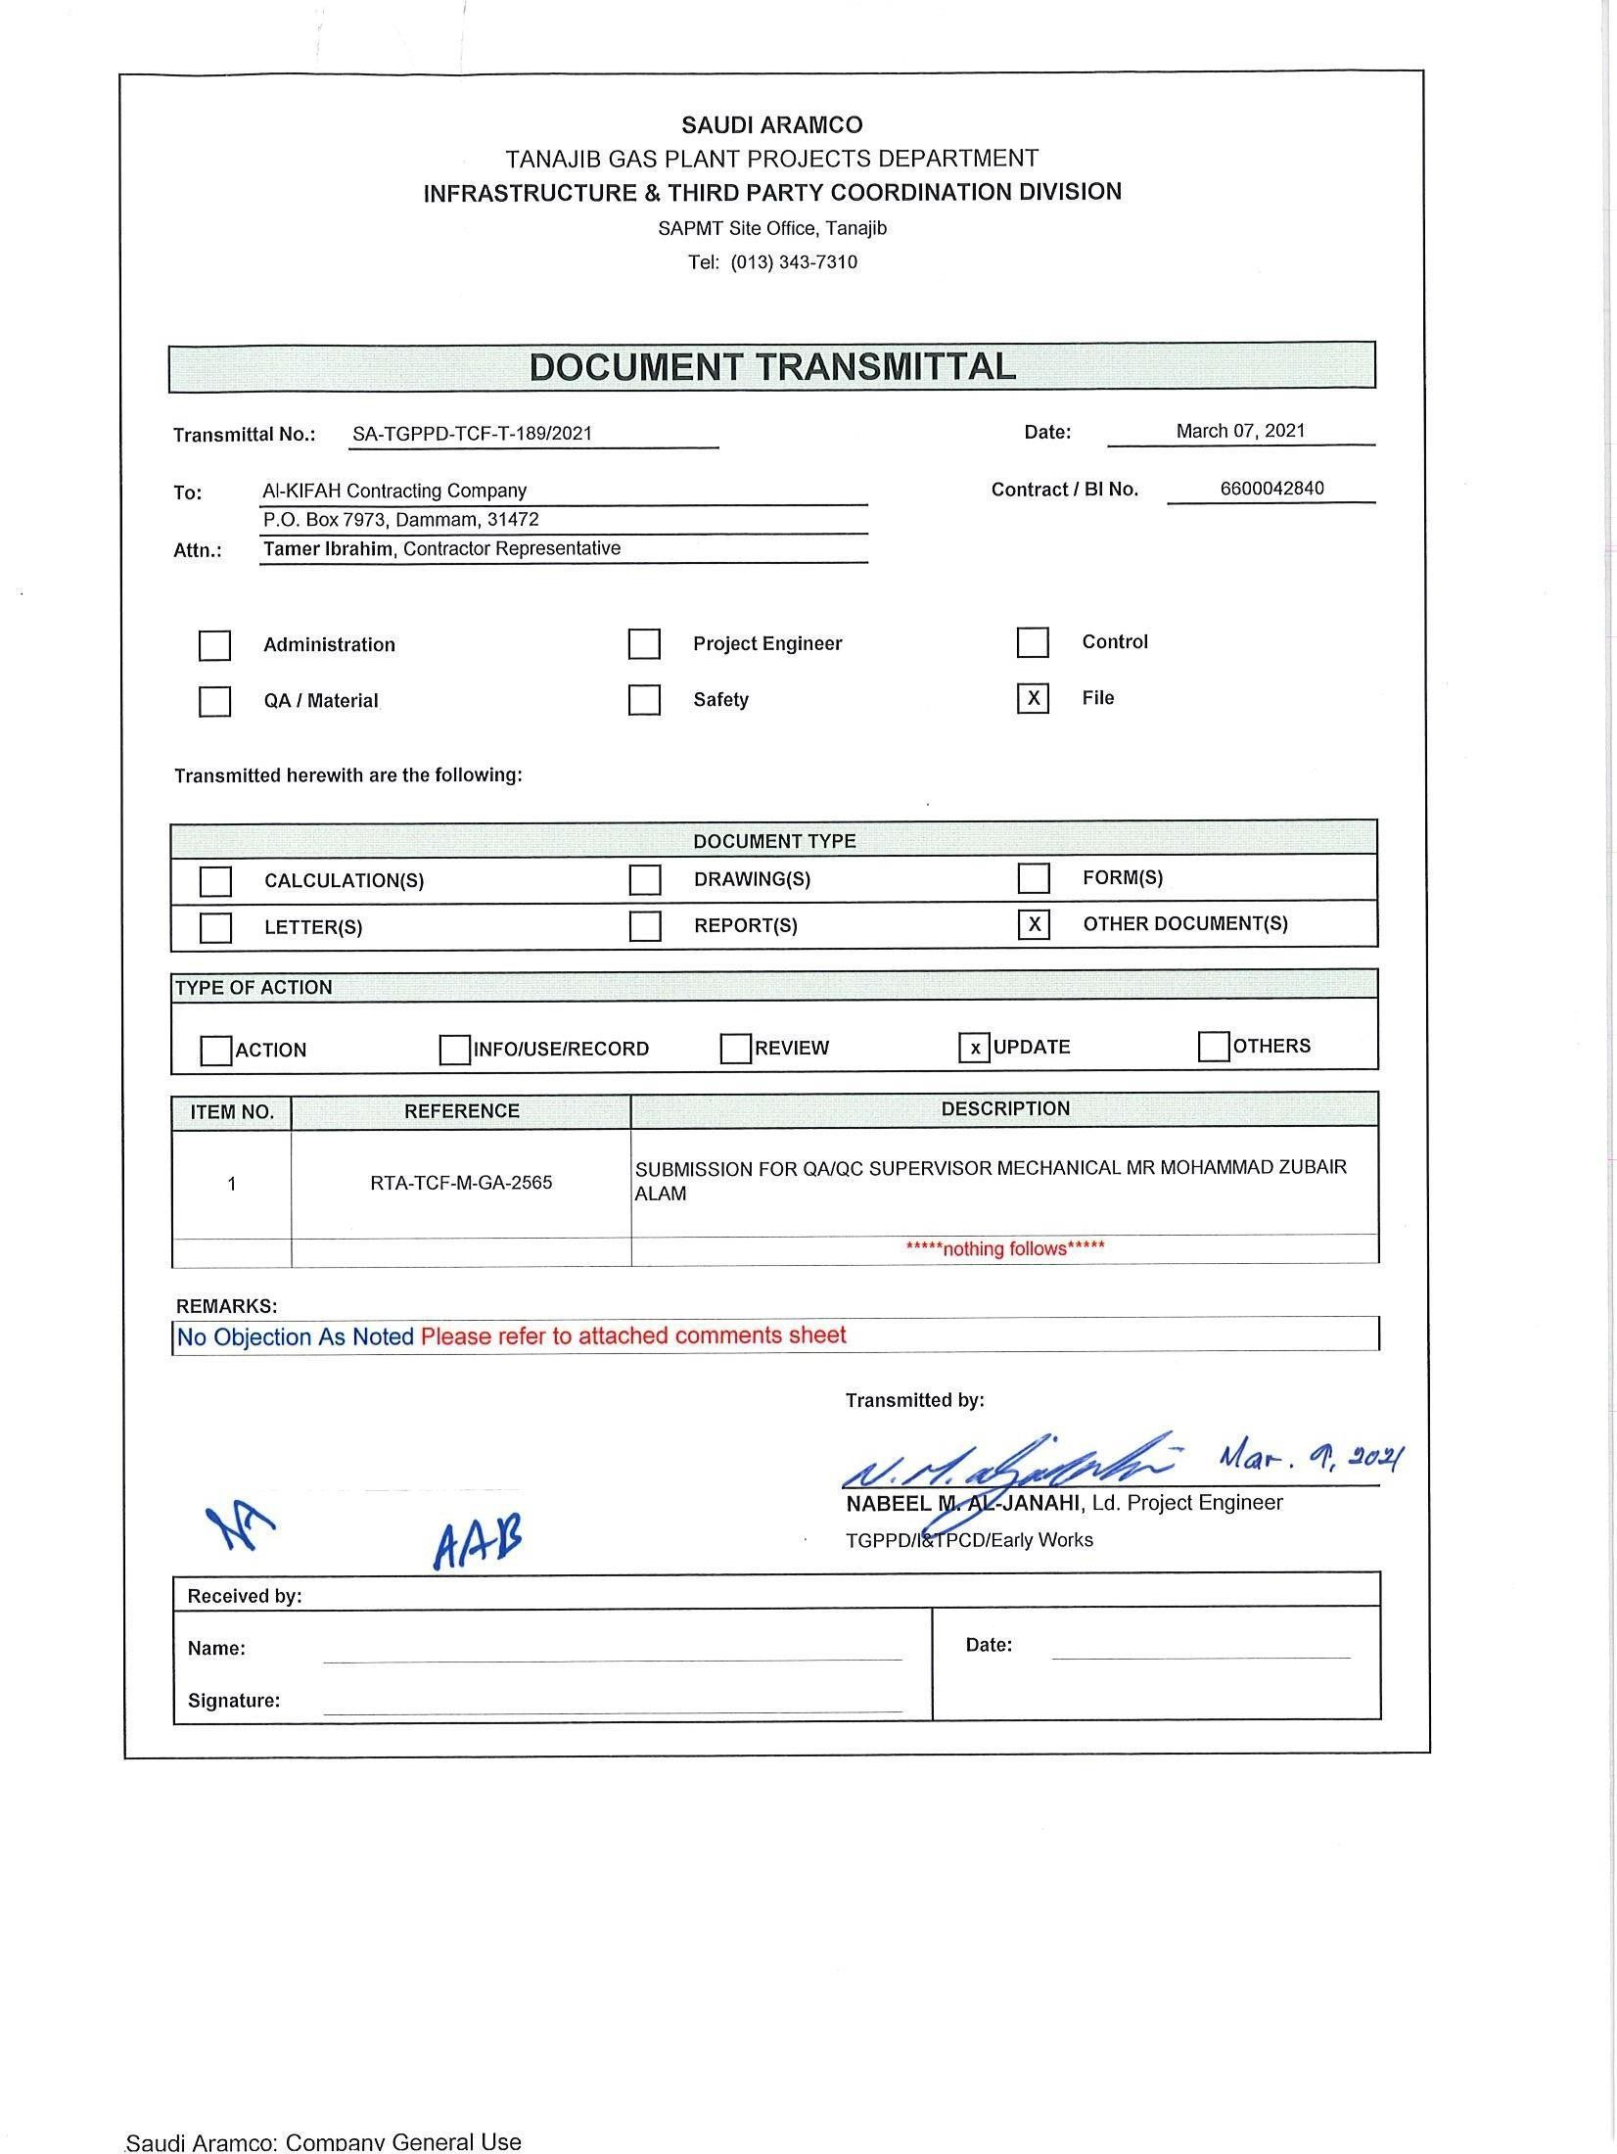

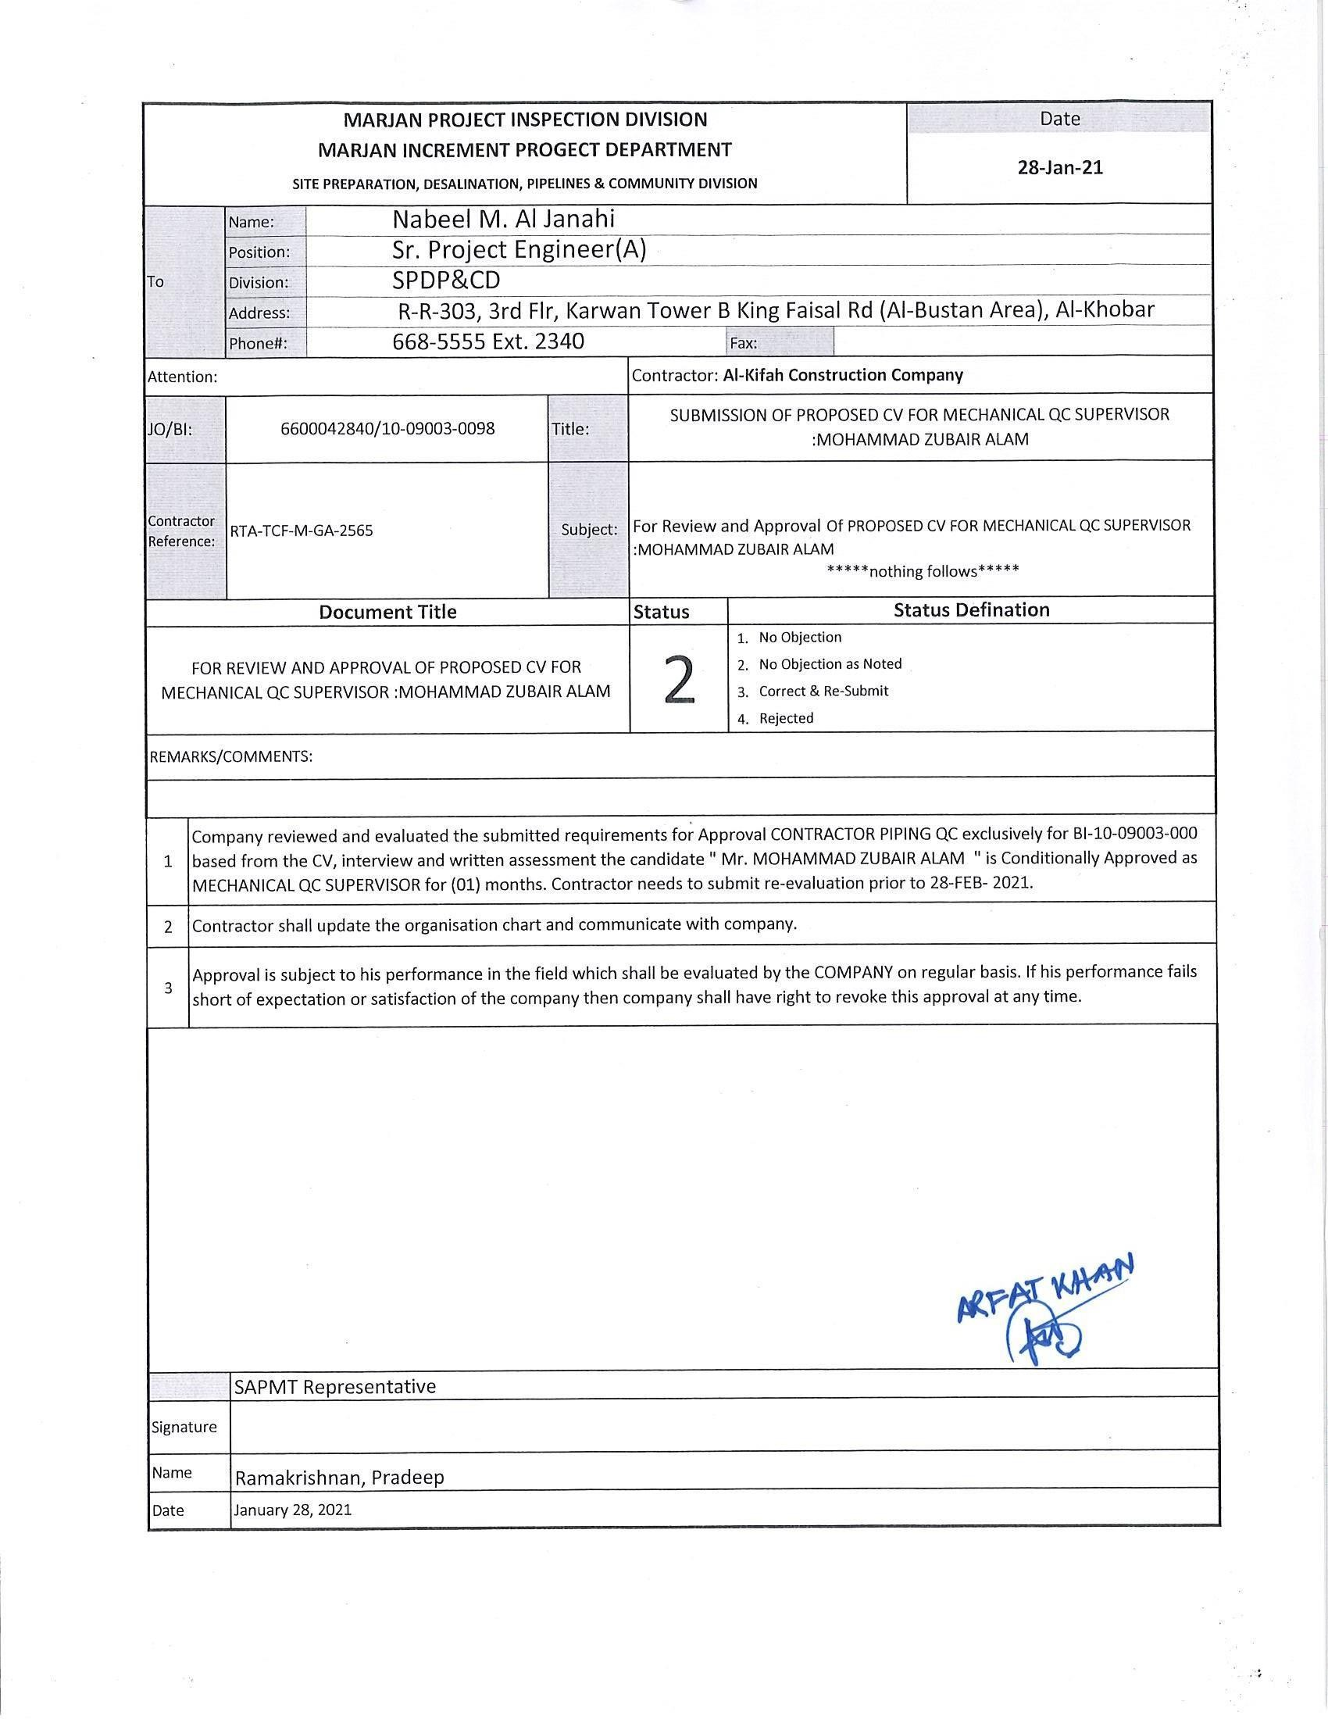

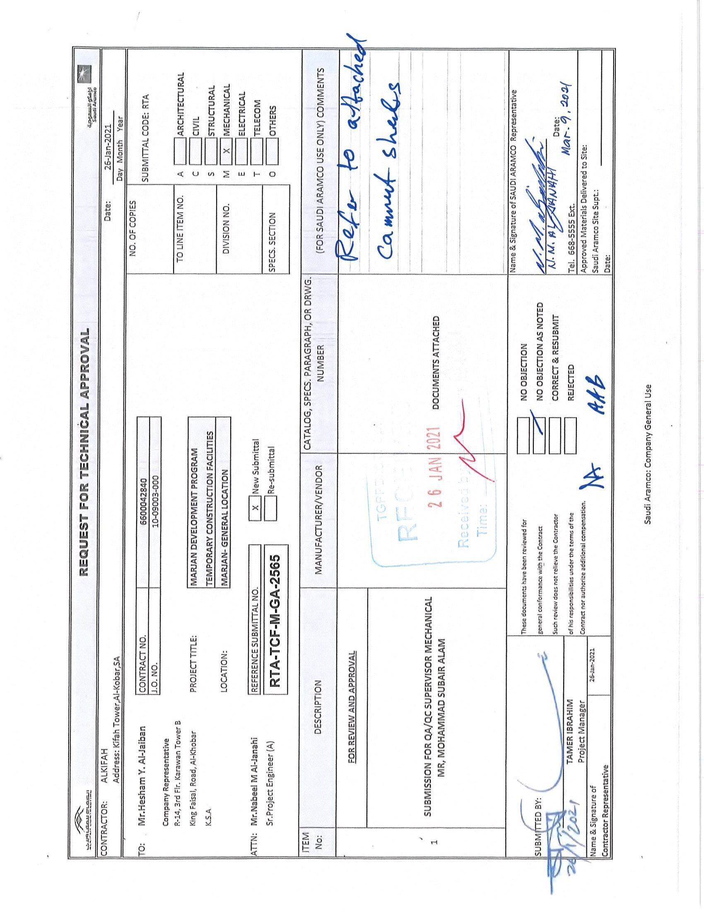

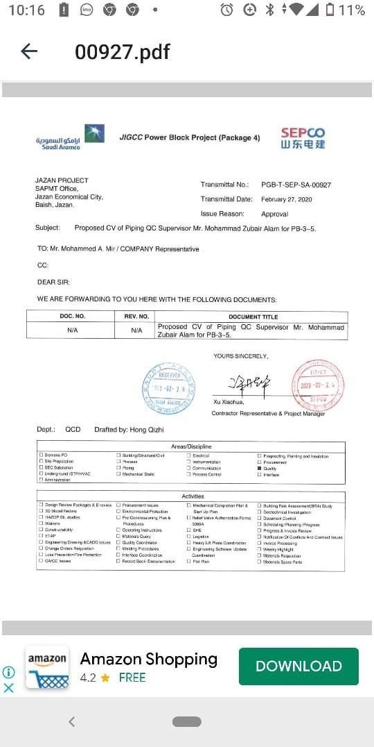

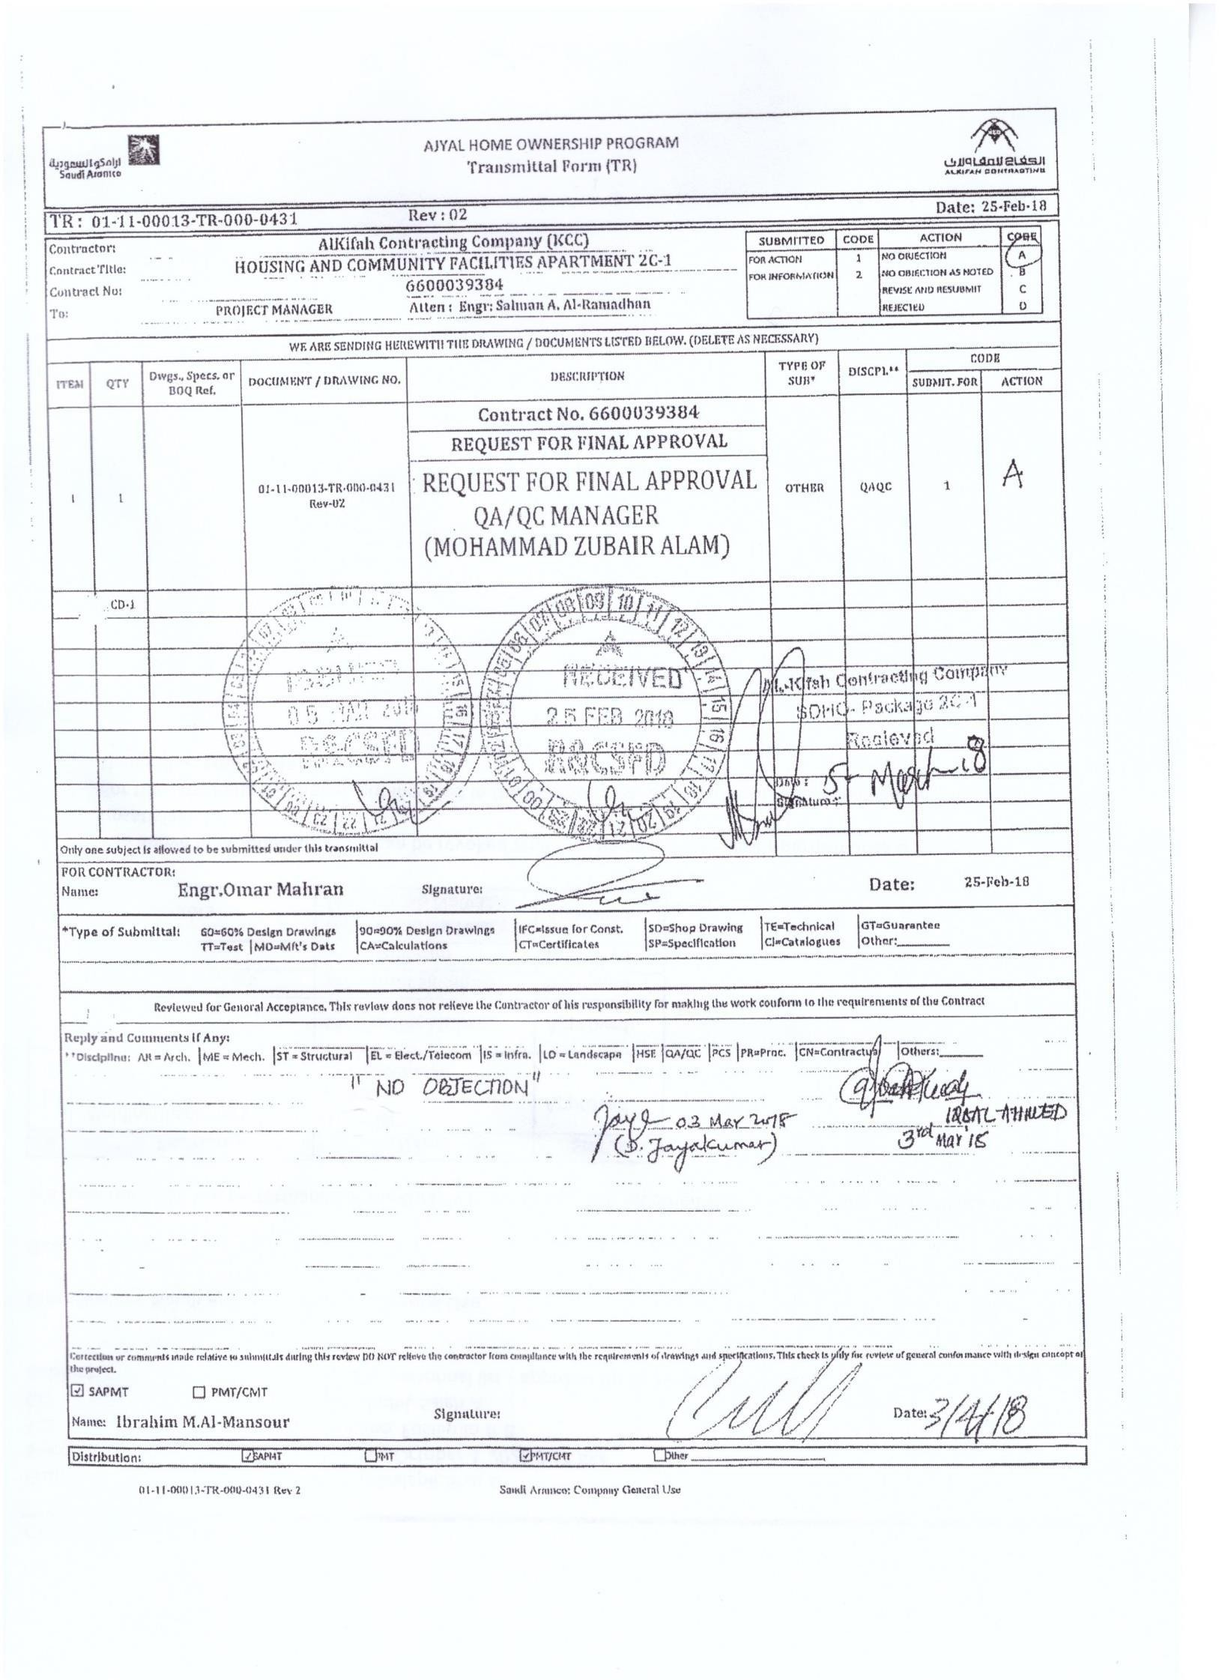

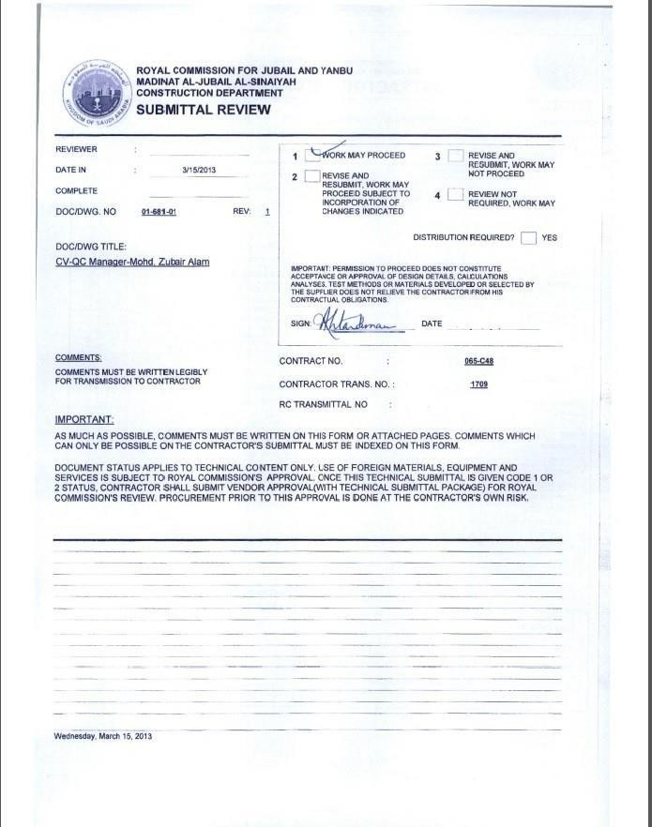

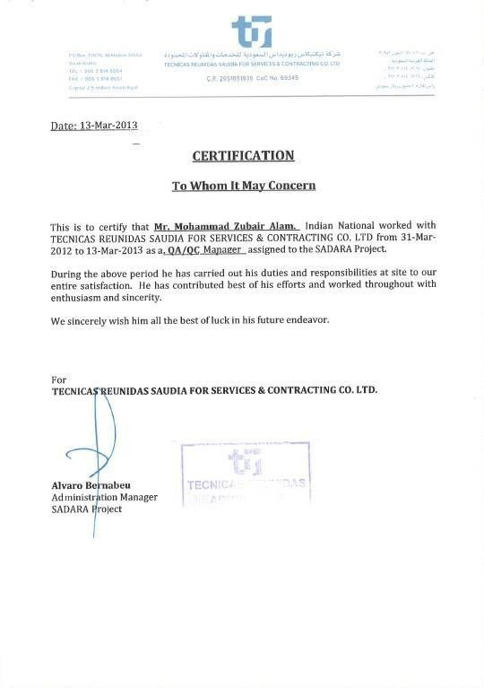

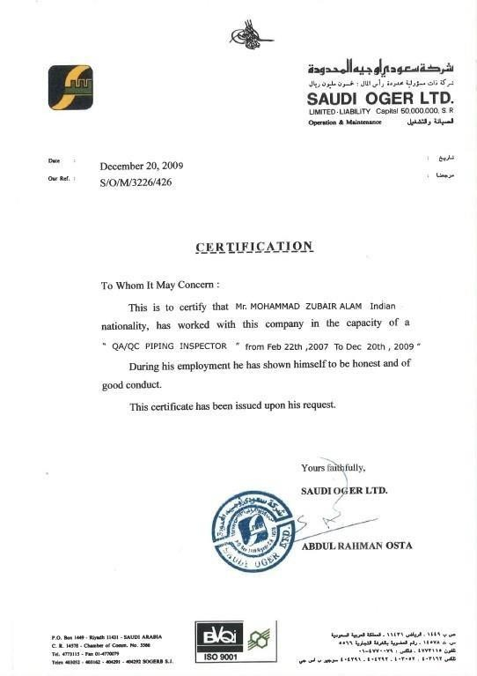

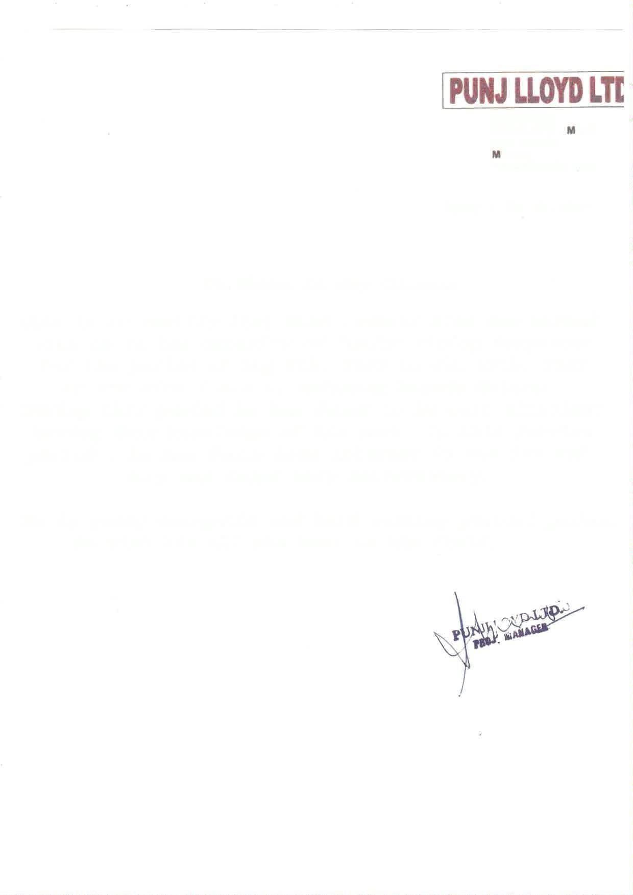
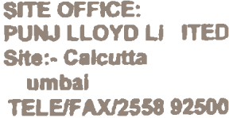

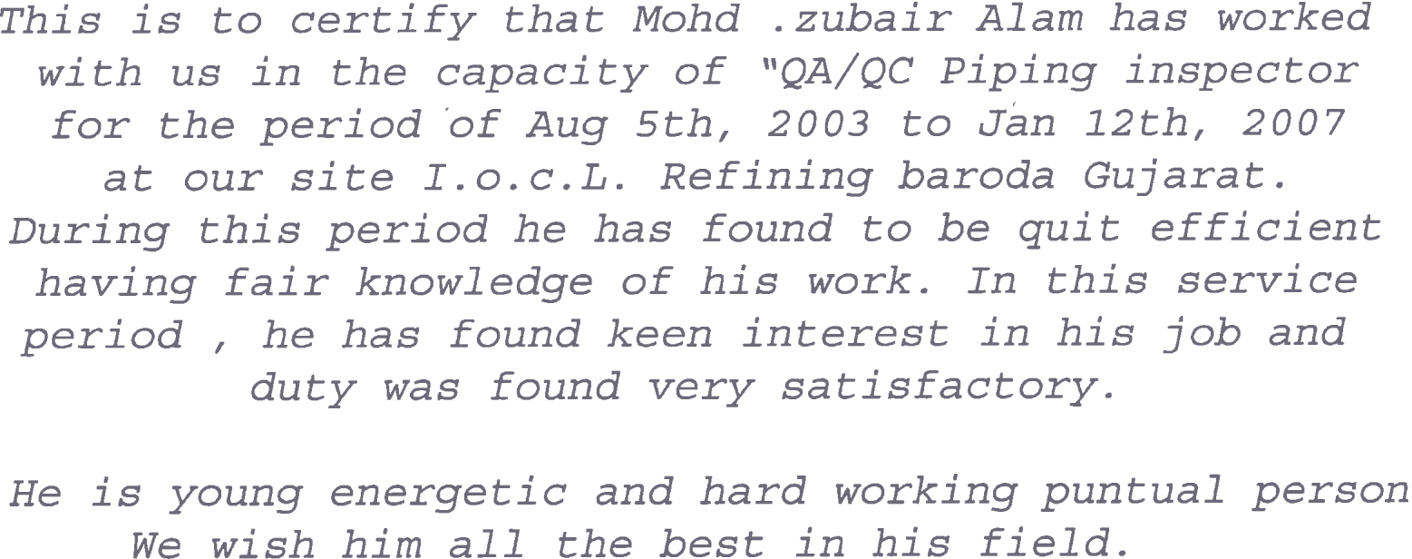

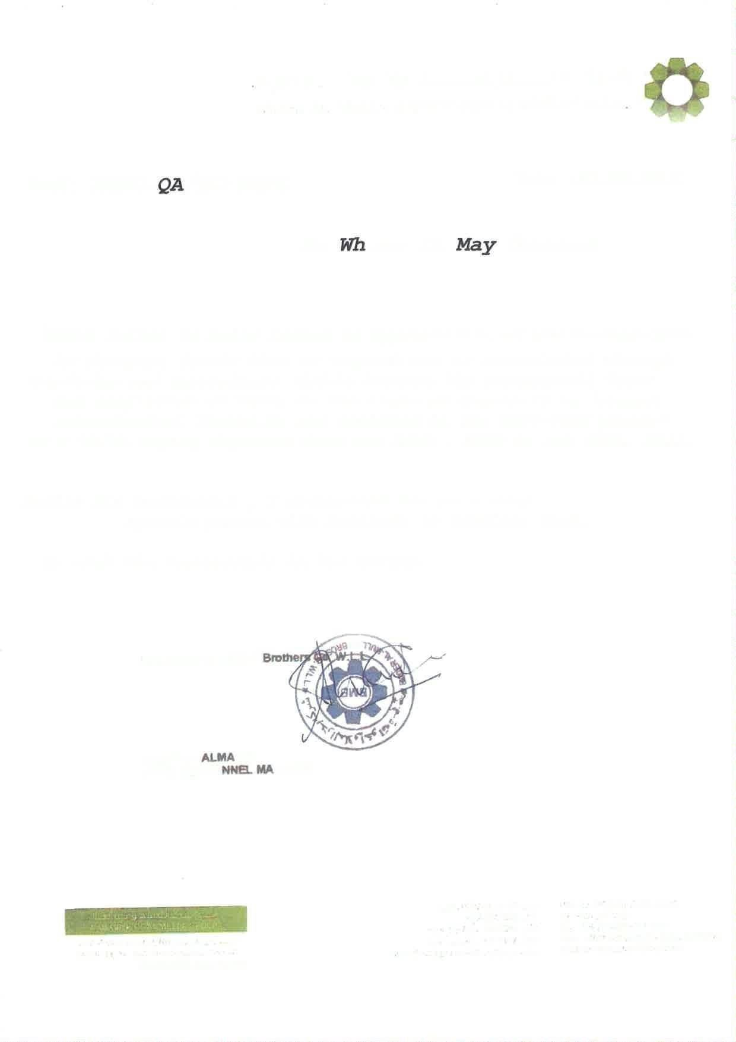
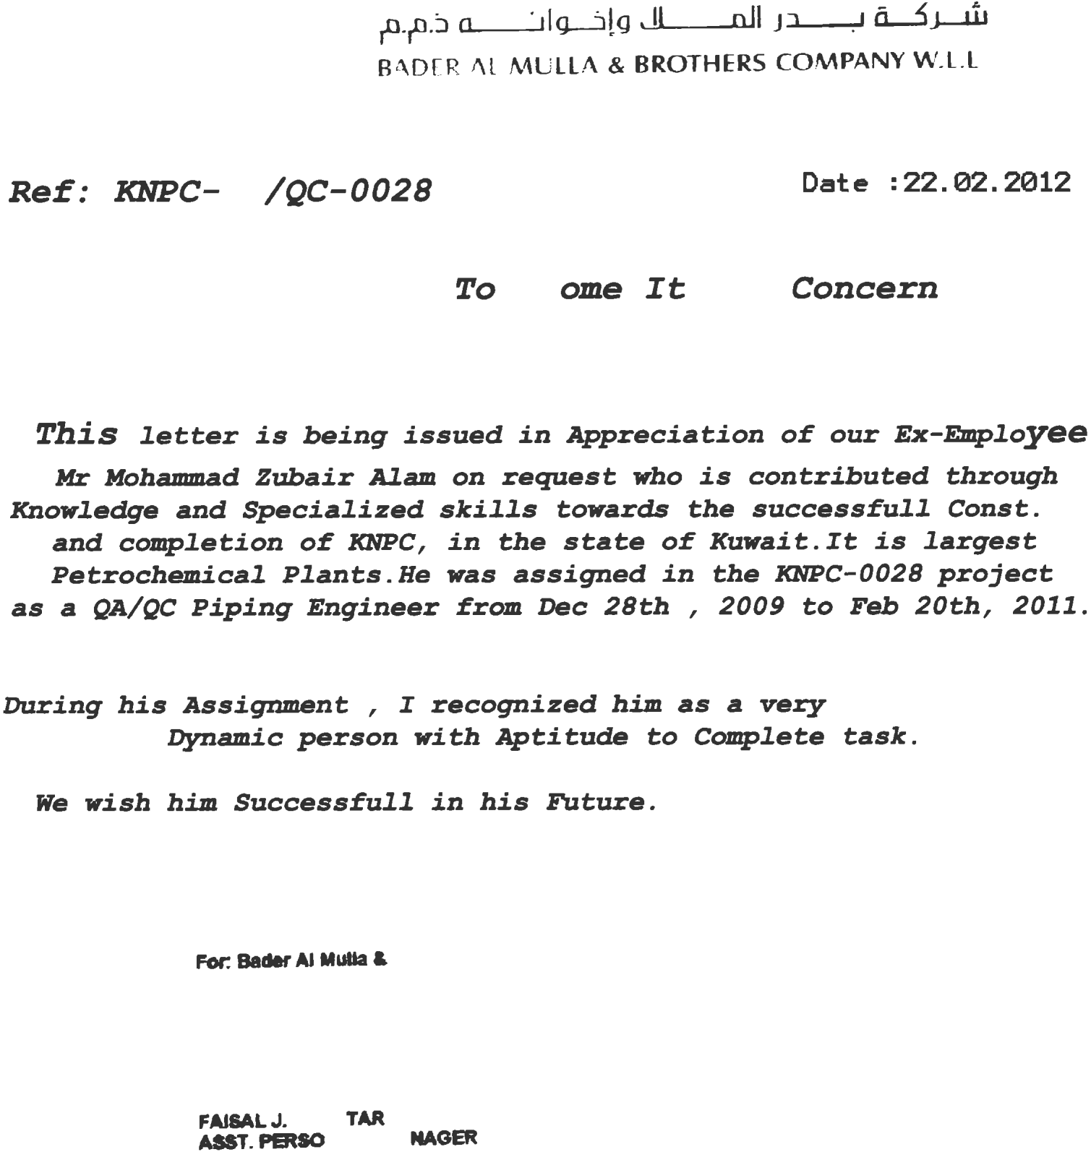



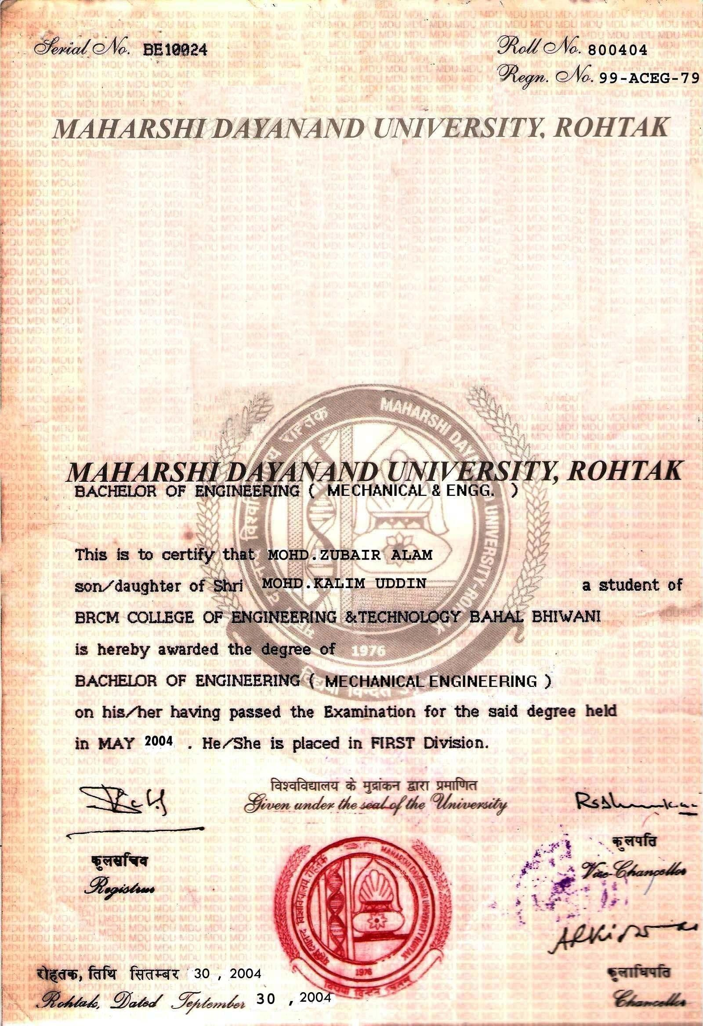



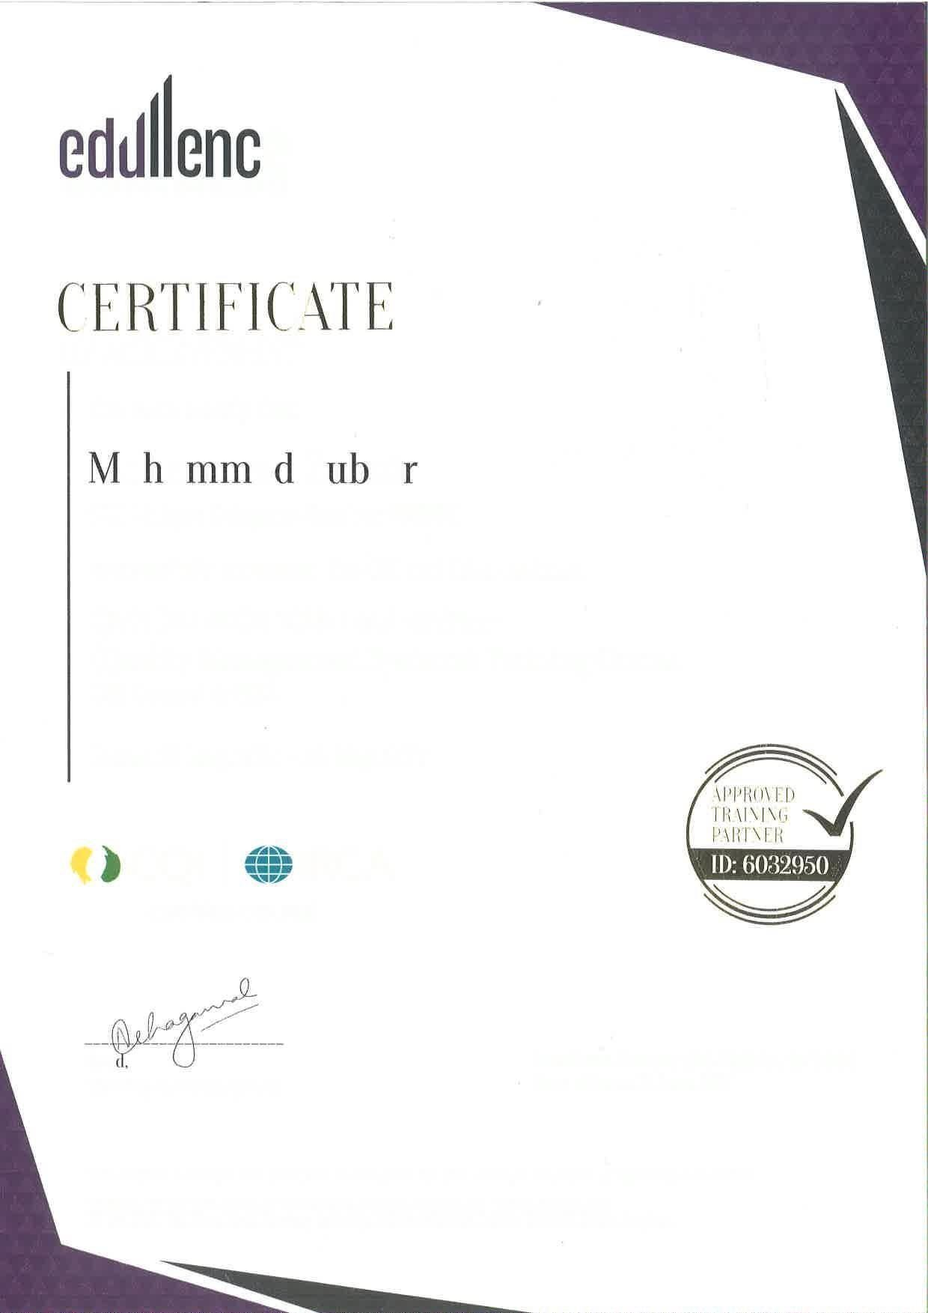
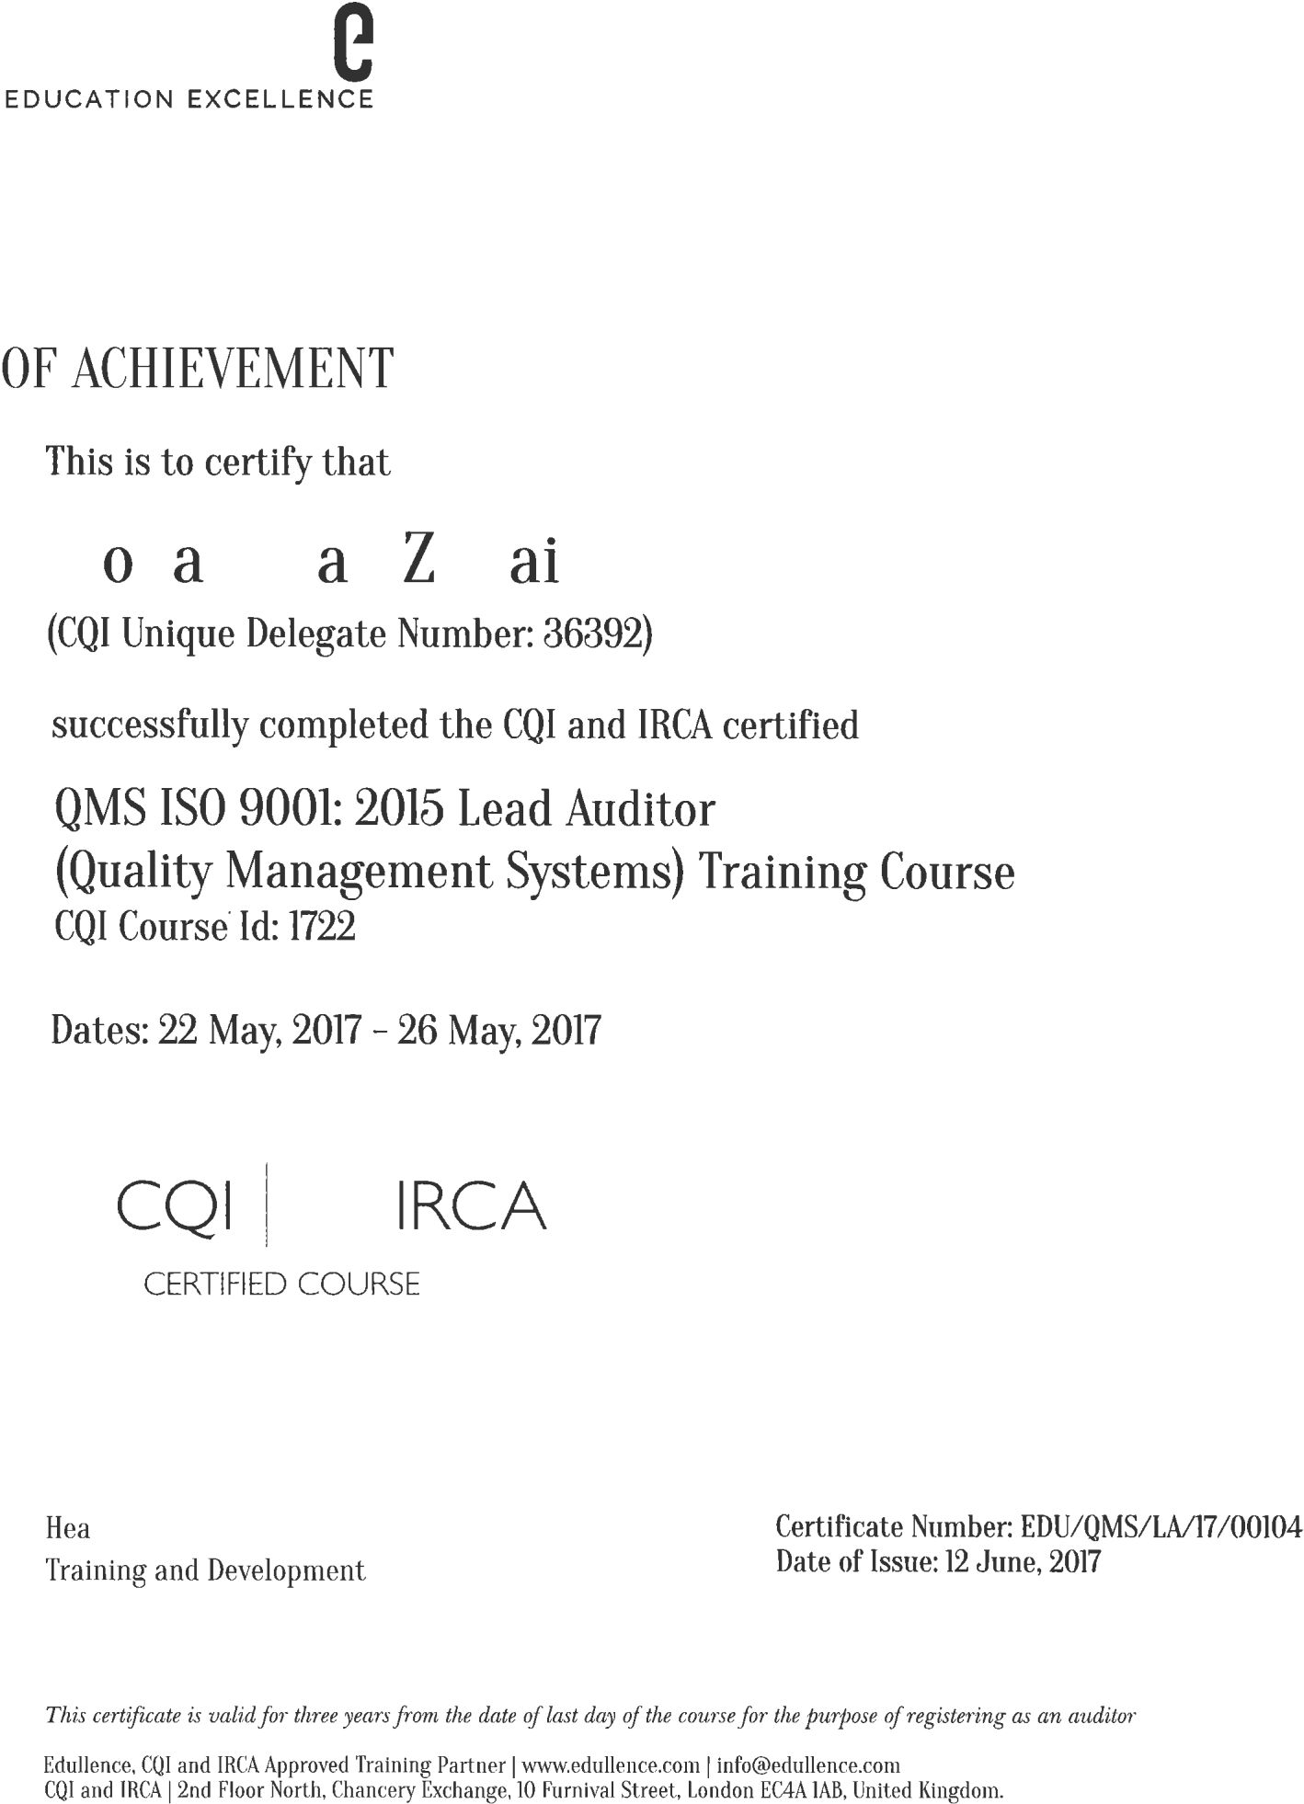


2/5/23, 3:47 PM Aconex

03 OXAGON
NEOM Industrial City NEOM
Saudi Arabia
NEOM - Engineering & Technical Services Dept
ITCC Complex, Al Raidah Digital City
Level 2, Building IN01
Riyadh An Nakheel 12382 Saudi Arabia

MAIL TYPE
Workflow Transmittal
MAIL NUMBER
NEN-WTRAN-050635
REFERENCE NUMBER
NEN-WTRAN-050635

Final (WF-041829) 4800000442/000/ Saudi Elaf QC Manager MOHAMMAD ZUBAIR ALAM
From SHEHZAD AKHTAR - NEOM - Engineering & Technical Services Dept

To (3)

Cc (6)
SHEHZAD AKHTAR - NEOM - Engineering & Technical Services Dept (+2 more...)

NEOM Quality & Excellence Document Control - NEOM - Engineering & Technical Services Dept (+5 more...)

Sent Wednesday, 25 January 2023 10:51:13 AM AST (GMT +03:00)

Status N/A

DOCUMENT ATTACHMENTS (1)

(0 selected)
File | Document No | Revision | Revision Date | Title | Status
 |  |  |  | 4800000442/000/ Saudi Elaf QC | B - Incorporate
03-620000-4800000442-
 |  | 02 | 23/01/2023 | Manager MOHAMMAD ZUBAIR | Comments -
SEC-HRM-CVS-000023
 |  |  |  | ALAM | Proceed

MESSAGE

Workflow Review History

The attached documents have completed the "4800000442/000/ Saudi Elaf QC Manager MOHAMMAD ZUBAIR ALAM" workflow with the following results :
This transmittal was automatically generated.

Doc No Step Participant Review Outcome Comments

03-620000-4800000442- SEC-HRM-CVS-000023
PMC Qlty A Spyridon B - Incorporate Comments
- Proceed
1) Internal assessment report is missing 2) Valid SCE to be attached 3) Bachelor Degree to be attached Final approval subject to submission all

https://ksa1.aconex.com/hub/index.html 1/2

2/5/23, 3:47 PM Aconex
above mentioned documents and based on his satisfactory performance of the following 2 months
probation period.
Further to PMC comments, final approval will be subject to successful completion of 2 months probation period and to provide the following missing
B - Incorporate Comments documents. (1) Internal
- Proceed
ETSD
S AKHTAR
assessment sheet with reference to schedule Q - sec A3.1; (2) Attested copy of Bachelor's degree; (2) copy of engineering degree's transcripts; (3) Valid SCE
registration copy.

https://ksa1.aconex.com/hub/index.html 2/2



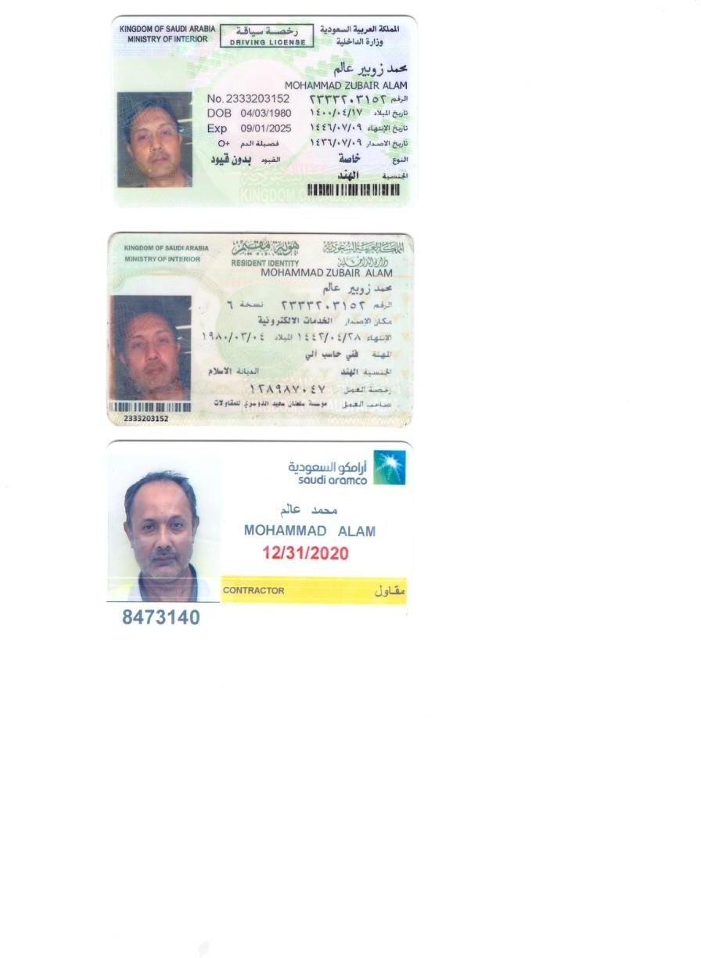

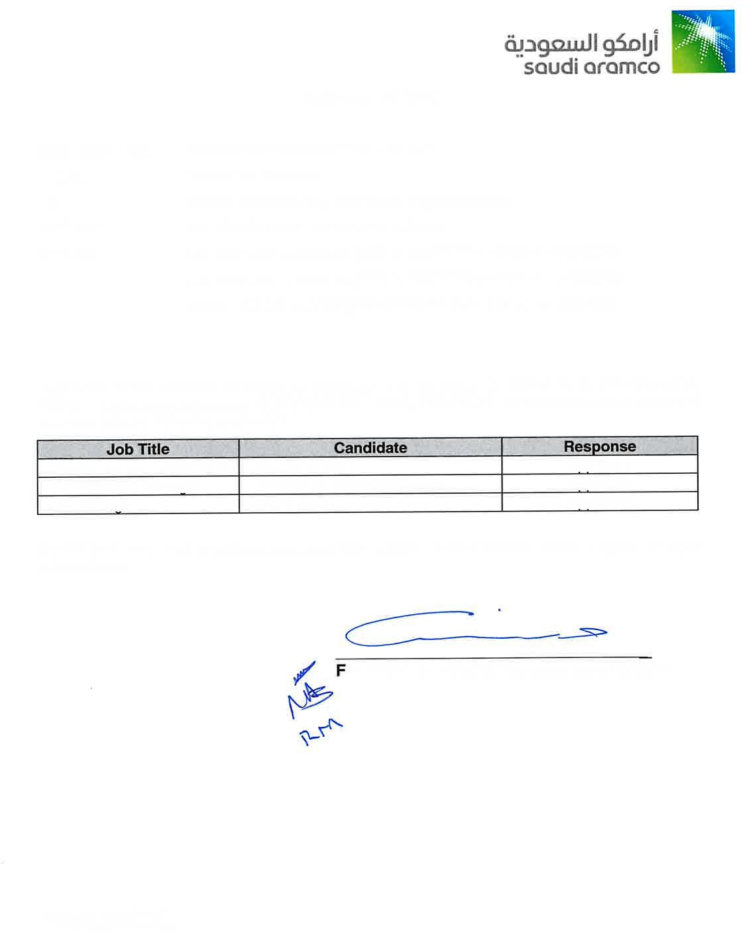
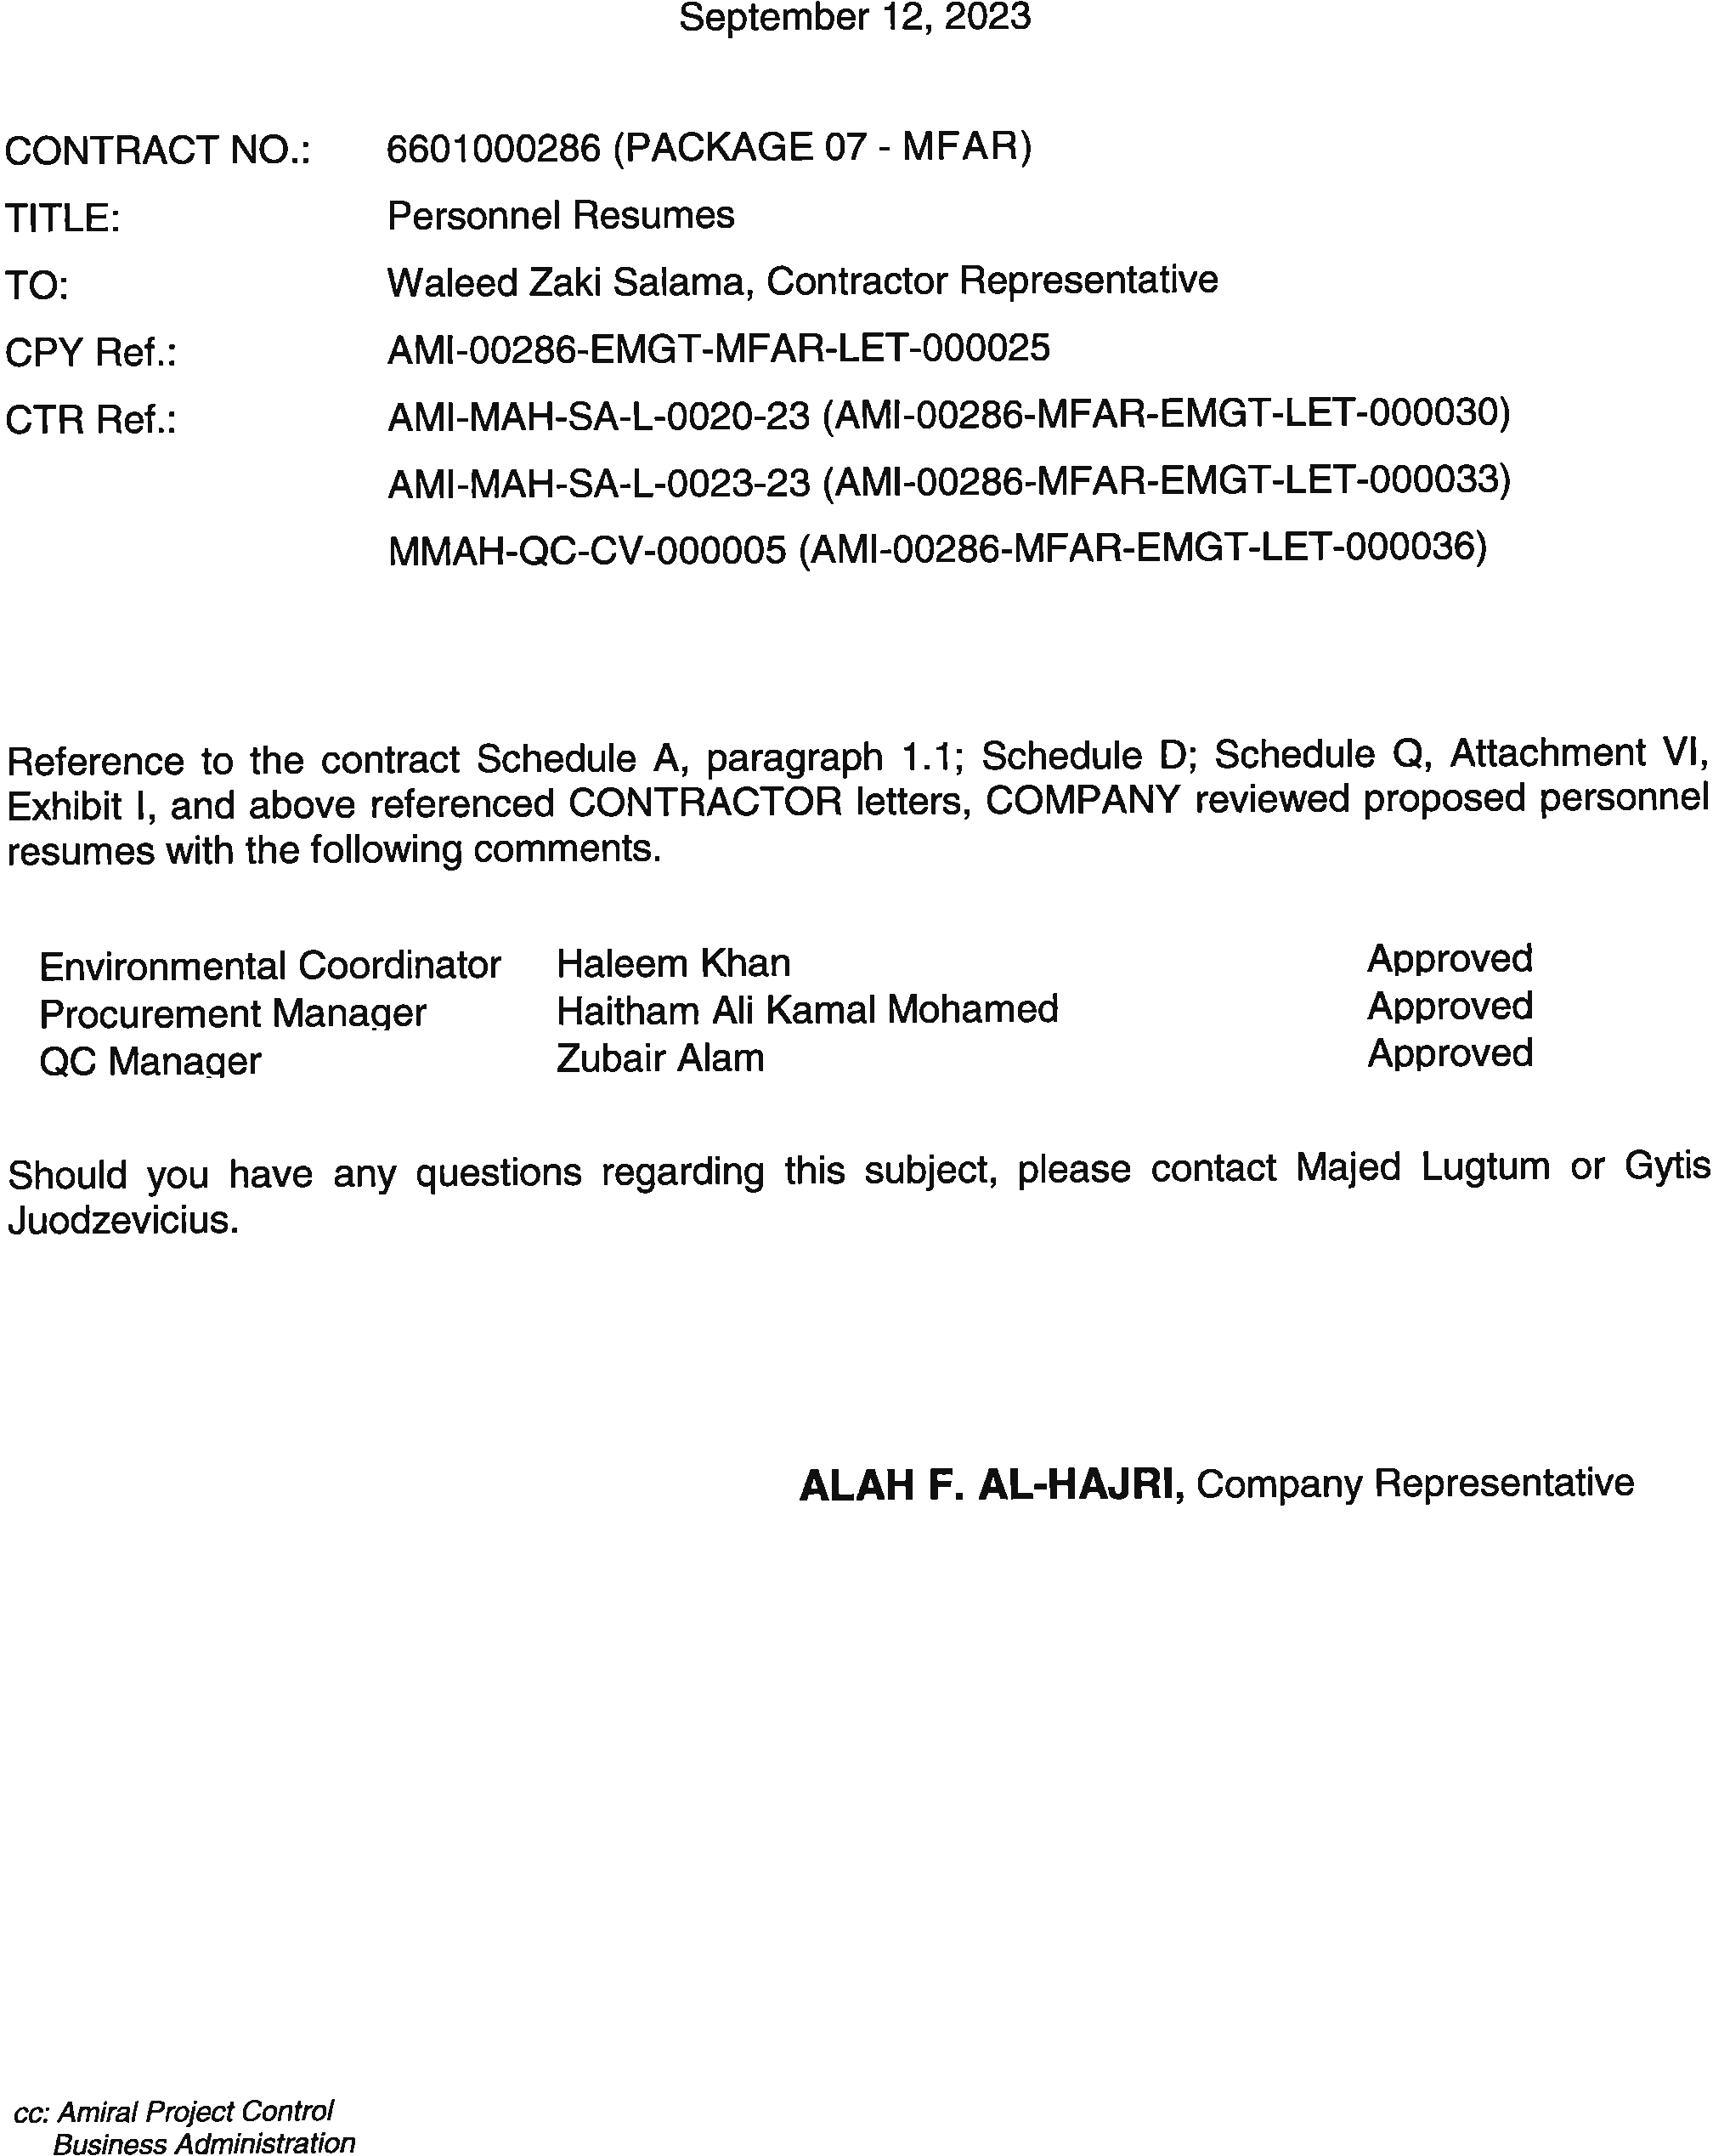

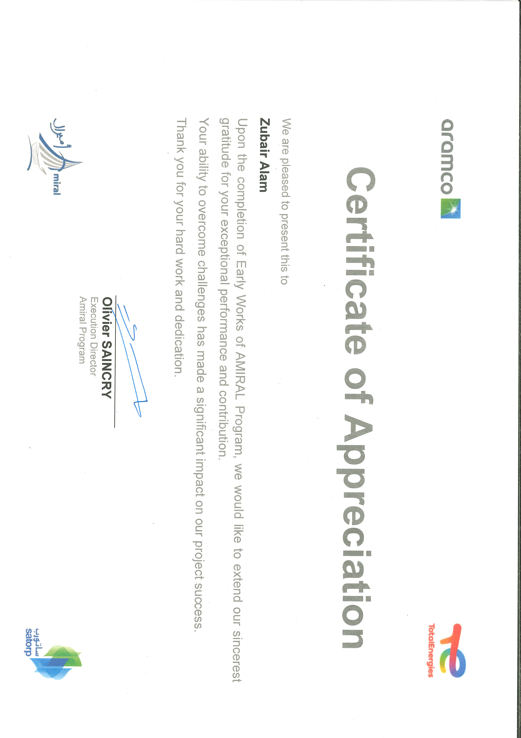

20 / α /
807924
ϡϗu¹΍

(ϡ 6 Sep 2020 ) ¿ϳu¹Η¹΍

(ϥϭ¹Α) :n¹Ϙϓua¹΍ Δ΋ϳϬ¹¹Α ϝϳΟγΗ u¹όη· :Qϭοϭa¹΍

ϑϳuόΗ Ώ¹ρ:
Introduction Letter

To Whom it May Concern
Saudi Council of Engineers hereby certifies that
ή------ϣϻ΍ ﻪ-----ϤϬϳ Ϧ-ϣ ϰ ϟ΍
ϥ΄--Α Ϧ---ϴ~ΪϨϬϤϠϟ Δ----ϳΩϮ--ό~ϟ΍ Δ--ΌϴϬϟ΍ Ϊ ϬθΗ ΍ά-ϬΑ

Engineer \ MOHAMMAD ZUBAIR ALAM
has been registered with SCE as follows: Identity No.: 2333203152
Membership ID: 684468 Specialization:
Membership Start Date : 9/6/2020 Validity: 9/6/2021
This letter is issued upon his request without any liabilities towards the Council.
Best regards,
ϡ¹¹ϋ uϳΑϭί ¹aΣa \ α¹ϧϬa
:ΔϴϟΎΘϟ΍ ΕΎϧΎϴΒϠϟ ΎϘϓϭ ΔΌϴϬϟ΍ ϲϓ ﻪϠϴΠ~Η ęΗ
2333203152 :ΔϣΎϗϻ΍ /ΔϳϮϬϟ΍ ęϗέ
684468 :ΔϳϮπόϟ΍ ęϗέ
:ϲ~ϴ΋ήϟ΍ κμΨΘϟ΍
9/6/2020 : ΔϳϮπόϟ΍ Δϳ΍ΪΑ ΦϳέΎΗ
9/6/2021 :ϰΘΣ tϴΠ~Θϟ΍ ΔϴΣϼλ
ΔϴϟϭΆ~ϣ ϰϧΩ΃ ϥϭΪΑϭ ﻪΒϠρ ϰϠϋ ˯ΎϨΑ ΏΎτΨϟ΍ ΍άϫ ϲτϋ΃ Ϊϗϭ
.ΔΌϴϬϟ΍ ϩΎΠΗ
, ΎϨΗΎϴΤΗ κϟΎΧ ΍ϮϠΒϘΗϭ






ϡ¹ό¹΍ ϦϴaϷ΍

ϱuaθ¹΍ uΘϴΒΣ ϦΑ ϥ¹Σuϓ .ϡ

