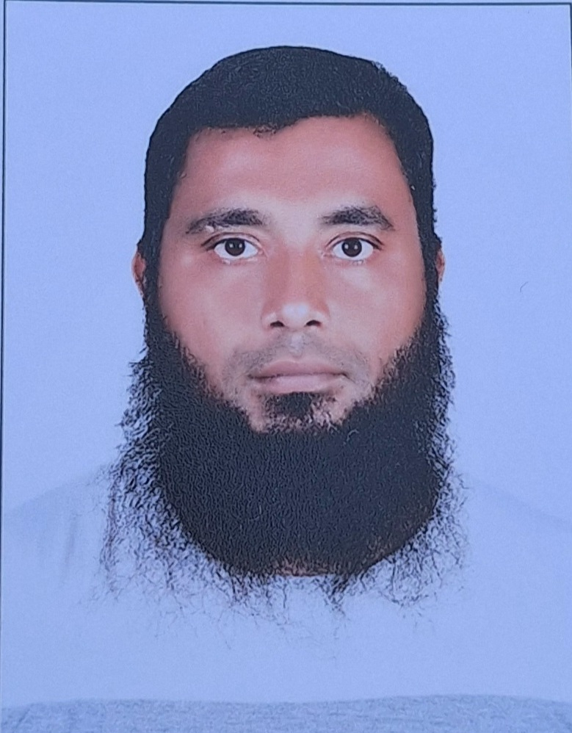
MOHAMMED AWAISE
Email Id: awaise823@gmail.com
Mobile Number: +966-570032534 (KSA)
Locally Available In Saudi Arabia
Transferable Visa

Position Applied for “CIVIL SUPERVISOR /General Foreman for Infrastructure Works, Utilities works & Excavation & Back Filling Works ,Asphalt works ,Concrete works,Form works,Corditnation with MEP team,Civil Team.

OVERVIEW
An enthusiastic, perspective communicator, with extensive technical knowledge and experience in Earth works & Asphalt Road works construction industry across diverse portfolios with successful track record in project documentation & coordination. Having strong execution skills, ensure deliverance of professional objectives and value addition.

WORK EXPERIENCE DETAILS: -
1.Wael Mori Contracting. As a Civil Supervisor From August 1st to till date .
2.Aramcoproject.Expansion of gas plant (BGCS.5Gas plant.Dhuruma.Saudia Ariabia Riyadh)

2.From January 2016 to June 2025 working as a CIVIL SITE SUPERVISOR. With M/S: Metito Overseas Qatar Engineering Contracting Co.WLL, Doha, Qatar.

- Projects Working Metito Qatar:
Main Contractor: Metito Overseas Qatar
Supervision Consultant: Ashghal (Under Direct Supervision of Public Works Authority of Qatar).

- Project -01: Doha South Foul Sewer House Connections Phase-02 Reinstatement and laying of asphalt works.
- Project -02: Doha South-143 Umm Salal Ali Roads and Infrastructures Works (Road Works: -Sub Grade, Subbase, Road Base, Asphalt Base Course, Wearing Course, and installation of kerb stone and interlock works and all Dry and Wet Utilities Construction.

2.From September 2013 to July 2015 date working as a CIVIL SUPERVISOR/General Foreman M/S: Confident Contracting & Green Delta (JV) Contracting Co.WLL, Doha, Qatar.

- Projects Working Confident Contracting:
Main Contractor: Confident Contracting & Green Delta (JV) Contracting Co.
Supervision Consultant: Qatar Design Consortium Engineering and Project Management WLL.

- Project -01: Al Khor Community Housing Project (Asphalt Roads, Court Yards& Parking lots and Interlock & Pavement works etc)
- Project -02: Qatar University (Road Works, Kerb stone installation, Signage Installations Etc)
- Project-03: Qatar Gas and Ras Gas Qatar (Internal Road Works, Kerb stone installation, Signage Installations Etc).
3.From September 2010 to August 2012 date working as a CIVIL SUPERVISOR/General Foreman M/S: Afcon Construction Contracting Company Nalgonda (dist.), Telangana State, India.

- Projects Working Afcon Contracting:

- Project-01: Hi-Tech City Housing Project Includes (Earth works, Asphalt Roads, Court yards, Kerb stone installation, interlock & pavement works, Road markings and Road signages installation).
RESPONSIBLITIES
- Experience in constructing Roads and Highway Projects
- Roads Site execution work as per drawings which is approved by consultants and clients.
- Execution Of Roads and Infrastructures & Residential Commercial, Health Care Project Works
- Taking active part in submission of Project related Documents, Company Profile, material submittals, sample submittals.
- Coordinating with HSE & QA / QC Department, to obtain HSE related permits and QC work Inspections and Material approvals.
- Implementation of Approved Project Quality Plan and HSE Plan and SOPs as Project requirement.
- Able to work with Approved Shop Drawings, Project Specifications and QCS Standards.
- Execution of various Infrastructural works (Installation of Interlock, curbstones, Asphalt Roads).
- Laying of Sub-base and Road Base and compactions works as per QCS & Project requirement Standards.
- Conducting and witnessing material and work-related tests with QA/QC Engineer and Consultant Engineers.
- Supervising of Civil Works, taking out Quantities, Quality Control materials for use preparing progress report
- Supervises and assists in excavation, grading, drainage, and embankment projects.
- Supervises in vertical, road, bridge, and airfield construction and rigging, bridging, and demolition activities.
- Timely arrangements of the materials manpower& equipment’s needed for the work.
- Supervises and assists in the cleaning of ditches, culverts, and basins.
- Supervises Of Asphalt Works Like Subbase, Base Course, Bitumen Base Course
- Supervises Of Utility Works Strom Line, Foul Sewer Line, Potable Line
- Supervises and participates in the construction of gravel, macadam, asphalt, or concrete roads, curbs and sidewalks.
- Drafted daily/weekly work reports and reported to higher officials.
- Checking Survey Data to Daily Works in Site
- Checking the works before & after installation of interlocks, Curbstone & follow up with Sub Contractors in compliance with drawings, specifications, and Consultant’s requirement.
- Upon completion of work activity, checking of work and raising Work Inspection Request (IR) for consultant’s Inspection and getting approvals.
- Responsible for day-to-day site work. Assisting to Project Engineer in arranging manpower, procuring material, and arranging machinery, equipment etc., as per site progress and look ahead program.
- Snagging & De snagging for handing over of works.
- Implementing of Handing over procedure for final handing over to the Contractor. Compilation of all documents and submission to the Main Contractor.
- Making daily report and reporting to the Construction manager.
- Site survey works and providing excavation alignment in accordance with the construction drawings.
- Visually inspecting stockpiles, materials sources, plant, and truck loads at plant sites.

ACADEMIC QUALIFICATIONS
- Intermediate Telangana State Board of Intermediate Education Nampally, TS, and India.
- Secondary School Certificate from State Board of Secondary Education, Hyderabad, TS, and India.
SOFTWARE SKILLS
- MS-Office (Excel, Word, Publisher & Power Point).
PERSONAL INFORMATION
Name : MOHAMMAD AWAISE
Marital Status : Married
Nationality : Indian
Languages Known : Arabic, English, Urdu, Hindi & Telugu
DECLARATION

I hereby declare that all the above furnished details are true to the best of my knowledge and belief.

MOHAMMED.AWAISE

