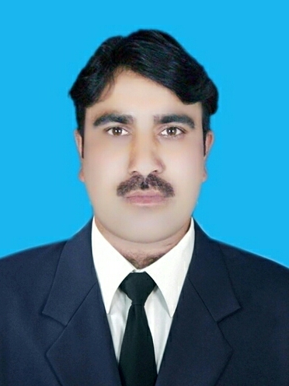
Name : Raheel Ahmad
Contact : 00966541182017
Email : raheel0016@gmail.com

“Post Applied for Asphalt batching plant operator”
- Objective
To work in an environment which offer a good opportunity
To share my knowledge and skill with others and participate myself and work
towards for a complete satisfaction of the company.

- Personal Detail
- Name : Raheel Ahmad.
- Date of Birth : 12/03/1985.
- Languages : Arabic, English,Urdu.
- Nationality : Pakistani.
- Marital Status : Married.
- Religion : Islam.
- Qualification : intermediate

- Passport Details
- Passport No : EB1152644
- Date of issue : 28 July 2025
- Date of Expiry : 27 july 2035
- Visa status : Employment

- Work Experience
  - From( 2012 to 2016) Asphalt batching plant operator (Al Rosan contracting Company KSA ALQASSIM).Al asiah to Buredha city road (Al qassim ).
  - From (2022 to present) asphalt batching plant operator ( Ubaid awad al mutairi contracting company KSA MAKKAH).Non Muslim road (Al jamoom Makkah )

Skills, Ability,& Work Field
- ​Asphalt Plant Operation & Calibration
- ​Quality Control & Mix Ratio Management
- ​Preventative Maintenance & Troubleshooting
- ​Site Safety & Resource Management
- Declaration
I hereby declare that the above mentioned statement is correct
& true to the best of my knowledge & belief.
Raheel Ahmad

