Criz Ismael J. Puyales
09292984518/09175043538
papacharlie0283@gmail.com

---------------------------------------------------------------------------------------------------------------------

September 4, 2022

To: To Mr. David Brian Medrana
Angkas Phillipines
11 Ortigas Avenue, Cainta,
Metro Manila Philippines

Dear Sir,

Your recent job posting is looking for a responsible, experienced worker to join your team. Throughout my career, I have taken pride in my ability to offer a reliable and courteous services. I work hard to meet deadlines efficiently. I am determined and dedicated to do the things I am tasked for. I have experiences in field operations. Though meeting delivery time is important, I prioritize safety above all else, taking the necessary steps to ensure a safe work environment for me and my fellow colleagues. If you’re looking for someone who takes initiative and strives to help the company grow, I believe and I am confident that I am the one you are looking for. I look forward to speaking with you in your most convenient time.

Thank you

Respectfully yours,

CRIS ISMAEL J. PUYALES
Safety Officer Applicant

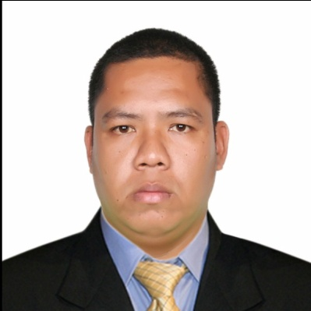
Criz Ismael Juevesano – Puyales
#431 Centro Iponan, Cagayan de Oro City, Philippines
09217 – 504 – 3538 / 0929 – 298 – 4518
PAPACHARLIE0283@gmail.com

I. PERSONAL INFORMATION

Date of Birth: 28 August 1983
Place of Birth: Surigao City, Surigao Del Norte
Sex: Male
Civil Status: Married
Citizenship: Filipino
Religion: Roman Catholic
Height (ft): 5’9”
Weight (kgs.): 120 kgs.

II. FAMILY BACKGROUND

Name of Spouse: Camila Fe Maagad – Puyales
Occupation: Teacher 1
Employer’s Name: DepEd
Employer’s Address: PEDRO “OLOY” N. ROA SR. ELEMENTARY SCHOOL
Calaanan, Canitoan, Cagayan de Oro City, Philippines

Name of Child: Cristina Angelica M. Puyales
Date of Birth: 08 August 2007

Name of Child: Calah Athara M. Puyales
Date of Birth: 30 May 2020

Name of Father: Manuel E. Puyales
Occupation: Government Employee

Name of Mother: Soledad J. Puyales
Occupation: Licensed Civil Engineer (Ret.)

Parents’ Address: #614 Sofia’s Compound Zone 1 Lower Bulua,
Cagayan de Oro City, Philippines

III. EDUCATIONAL BACKGROUND

Level School Year Graduated

Elementary: Barra Elementary School 1996
Secondary: Bulua National High School 2001
Tertiary: Capitol University 2003

Course: Bachelor of Science in Civil Engineering (under graduate)

IV. SKILLS

Driving (with Philippines license; code 1, 2, 3, 8)
Automotive Air condition Technician

V. OTHER SKILLS
Crane Operator (certified ARAMCO)
AutoCAD Operator
Computer Literate
Safety officer

VI. EMPLOYMENT RECORD

November 2020 – November 2021 Secretary Puyales Law Office
Zone 8, Molugan
El Salvador City

February 10, 2018 – May 25, 2019 Marketing Officer Markbuilt Enterprises
Purok Bagong Pag – asa
Mahayahay, Iligan City
Lanao del Norte

October 2015 to Jan. 23, 2018 Crane Operator Al – Khonaini International
Company Limited
P.O Box

Jun. 2014 to October 2015 Transport Driver Elsie Mendoza Transportation
Company
Kauswagan, Cagayan de Oro

July 2012 – October 2013 Survey Aide – A National Irrigation
Administration
Bukidnon Irrigation
Management Office (BIMO)
Bagong Taas, Valencia City

April 12,2010 to Auto Air condition Abdullah Ahmad Dossary
May 25, 2012 Technician Company (Holdings)
P.O Box 973, Al-khobar
31952 Khobar
Kingdom of Saudi Arabia

March 2009 – Jan. 2010 Driver Mechanic – B National Irrigation Administration
Barra, Opol Misamis Oriental

VII. CHARACTER REFERENCES

Rex Lusdoc Police Officer c/o PNP Headquarters
(0917 – 770 – 8056) Camp Alagar, Lapasan
Cagayan de Oro City

Engr. Aparicio, Harold Civil Engineer Block 1 – Lot 6, Lamirande
(0917 – 158 – 8525) Trails, Grand Europa,
Lumbia, Cagayan de Oro City

PO3 Shiela S. Appari Police Officer 3 Camp Alagar, Lapasan
Philippine National Cagayan de Oro City
Police Headquaters R-X
(0926 – 764 – 4472)

Peter Plaza Ty Founder/Owner Molawan Street
Rescue Line Riders Brgy. Kauswagan
International Cagayan de Oro City
(0917 – 507 – 5309)

