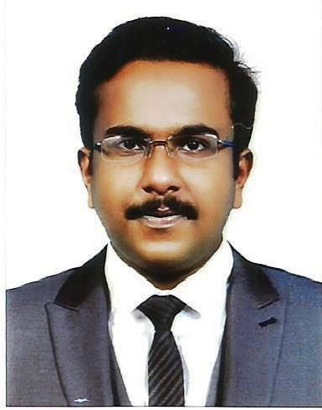

TAHARSHA MOHAMMED SHAW
CONSTRUCTION MANAGER
Doha, Qatar | +974 3103 8052 | taharshamohamedshaw@gmail.com

EXECUTIVE PROFILE

Senior construction professional with 14+ years of GCC experience in Qatar and UAE, specializing in large-scale precast, civil, and infrastructure projects. Proven capability in leading multidisciplinary teams, managing schedules, coordinating with clients and consultants, controlling quality, and delivering projects safely, on time, and within budget. Strong exposure to oil & gas, infrastructure, commercial, and hospitality developments.

KEY SKILLS & EXPERTISE

• Project & Construction Management
• Precast Concrete & Structural Works
• Planning, Scheduling & Risk Management
• Client, Consultant & Stakeholder Coordination
• QA/QC, HSE & Method Statements
• Variation, Claims & Progress Invoicing
• Manpower, Subcontractor & Resource Control

PROFESSIONAL EXPERIENCE

Construction Manager
Union Precast Concrete Qatar LLC (HBK Group) | Doha, Qatar
Dec 2020 – Present
- Lead execution of precast and civil works for major infrastructure and oil & gas projects including Doha Airbase, Ras Laffan Petrochemical Projects, and QatarEnergy LNG expansion.
- Manage project planning, sequencing, manpower deployment, and coordination with multiple stakeholders.
- Oversee foundations, pipe supports, shelters, pedestals, and structural elements.
- Ensure compliance with contract specifications, drawings, HSE, and QA/QC requirements.
- Support variation works, commercial documentation, and progress certification.

SENIOR PROJECT ENGINEER
United Precast Concrete Qatar LLC (BPC Group) | Doha, Qatar
Dec 2018 – Dec 2020
- Managed precast manufacturing, erection, and cladding works across multiple projects in Qatar.
- Coordinated technical submittals, shop drawings, materials approvals, and inspections.
- Controlled daily site activities, logistics, and subcontractor performance.

SENIOR PROJECT ENGINEER
United Precast Concrete Dubai LLC (BPC Group) | Dubai, UAE
Dec 2014 – Feb 2018
- Supervised precast erection and cladding works for Al Habtoor Townhouses and Metropolitan Hotel.
- Managed site execution, formwork systems, embedded items, and alignment works.
- Prepared as-built drawings and supported commercial documentation.

PROJECT ENGINEER
RISE AND SHINE TRADING AND CONTRACTING (FIRE STOPING,FIRE PROOFING CO) QATAR
Dec 2004 – Feb 2013
- managed multiple projects in Doha.

ACADEMIC QUALIFICATIONS

Secondary school of examination from Central Board of Secondary Examination. Higher Secondary in Biology Science group from Kerala Higher Secondary Education Board. Diploma in Civil Engineering in Auto Cad from Collage of Engineering, Trivandrum.

EDUCATION & CERTIFICATIONS

• Diploma in Civil Engineering – Model College of Engineering, India
•BE in Civil Engineering – Model College of Engineering, India
• Six Sigma Green Belt – Certified
• Diploma in AutoCAD Civil (2D)
• Diploma in Computer Applications (MS Office)

LANGUAGES

English, Hindi, Malayalam, Tamil (Fluent) | Arabic (Basic)

LICENSES & AVAILABILITY

• Valid Qatar Driving License
• Valid UAE Driving License
• Availability: Immediate

PERSONAL INFORMATION

Name in full : TAHARSHA MOHAMED SHAW

Visa status : Qatar Resident Visa

Fathers name : M.N. Shaw

Nationality : Indian

Age : 37

Date of birth : 08-04-1988

Marital status : married

Passport number & validity : S5785050 valid until 26-05-2028

Current address : EZDHAN 31,AL WUKAIR,DOHA ,QATAR

I, Taharsha Mohamed Shaw, do hereby solemnly affirm that the information provided above is true and correct to the best of my knowledge and belief.

Place: DOHA, QATAR
Taharsha Mohamed Shaw
Date: 15/01/2026 +974-31038052

