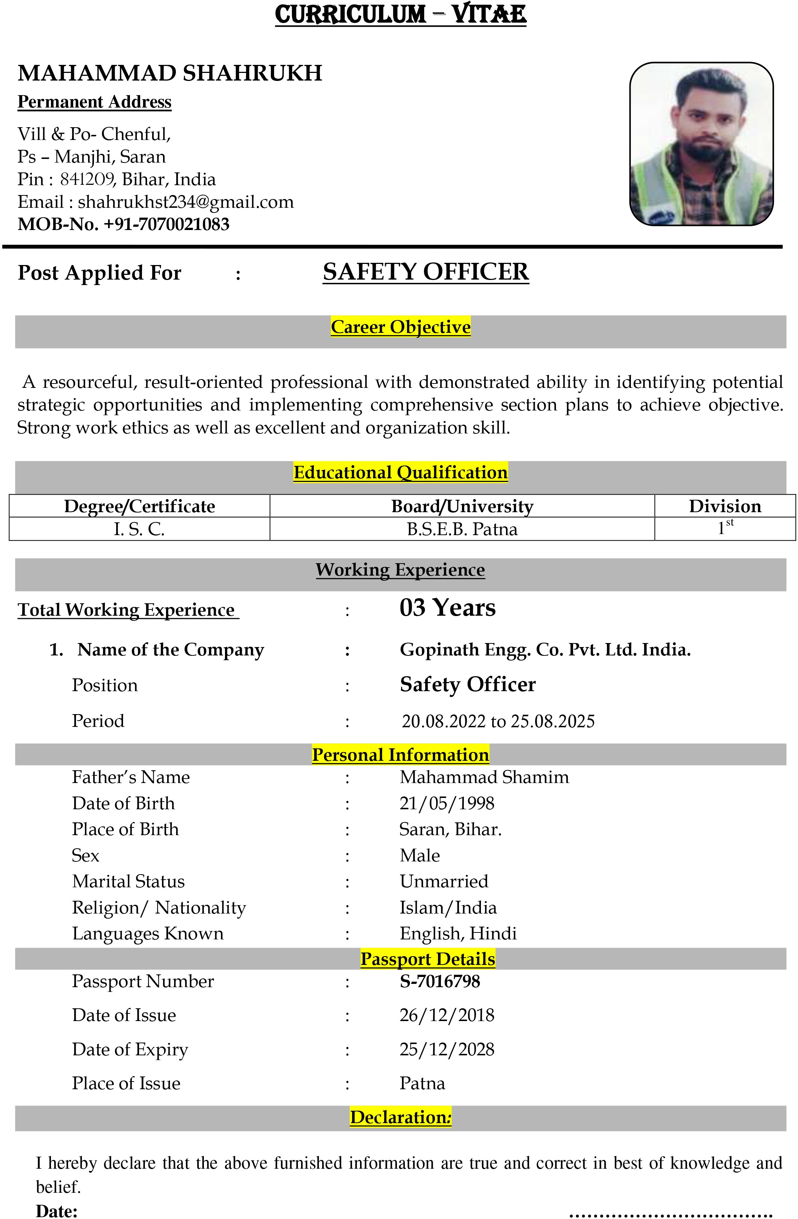

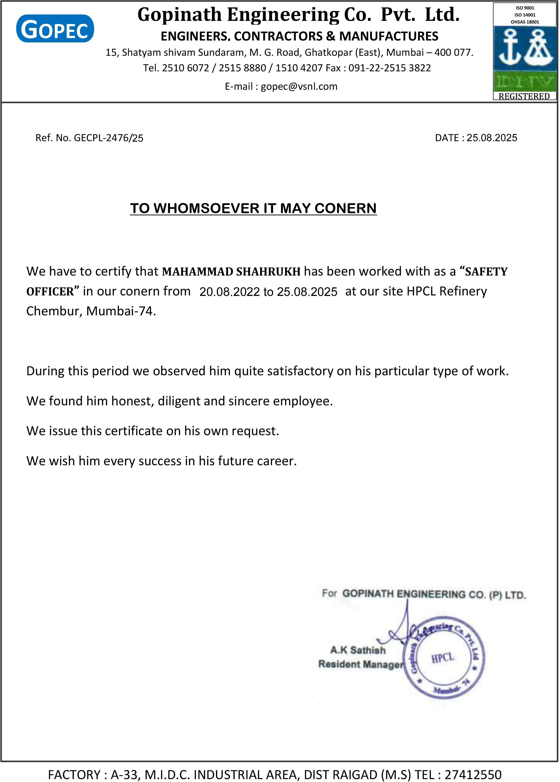

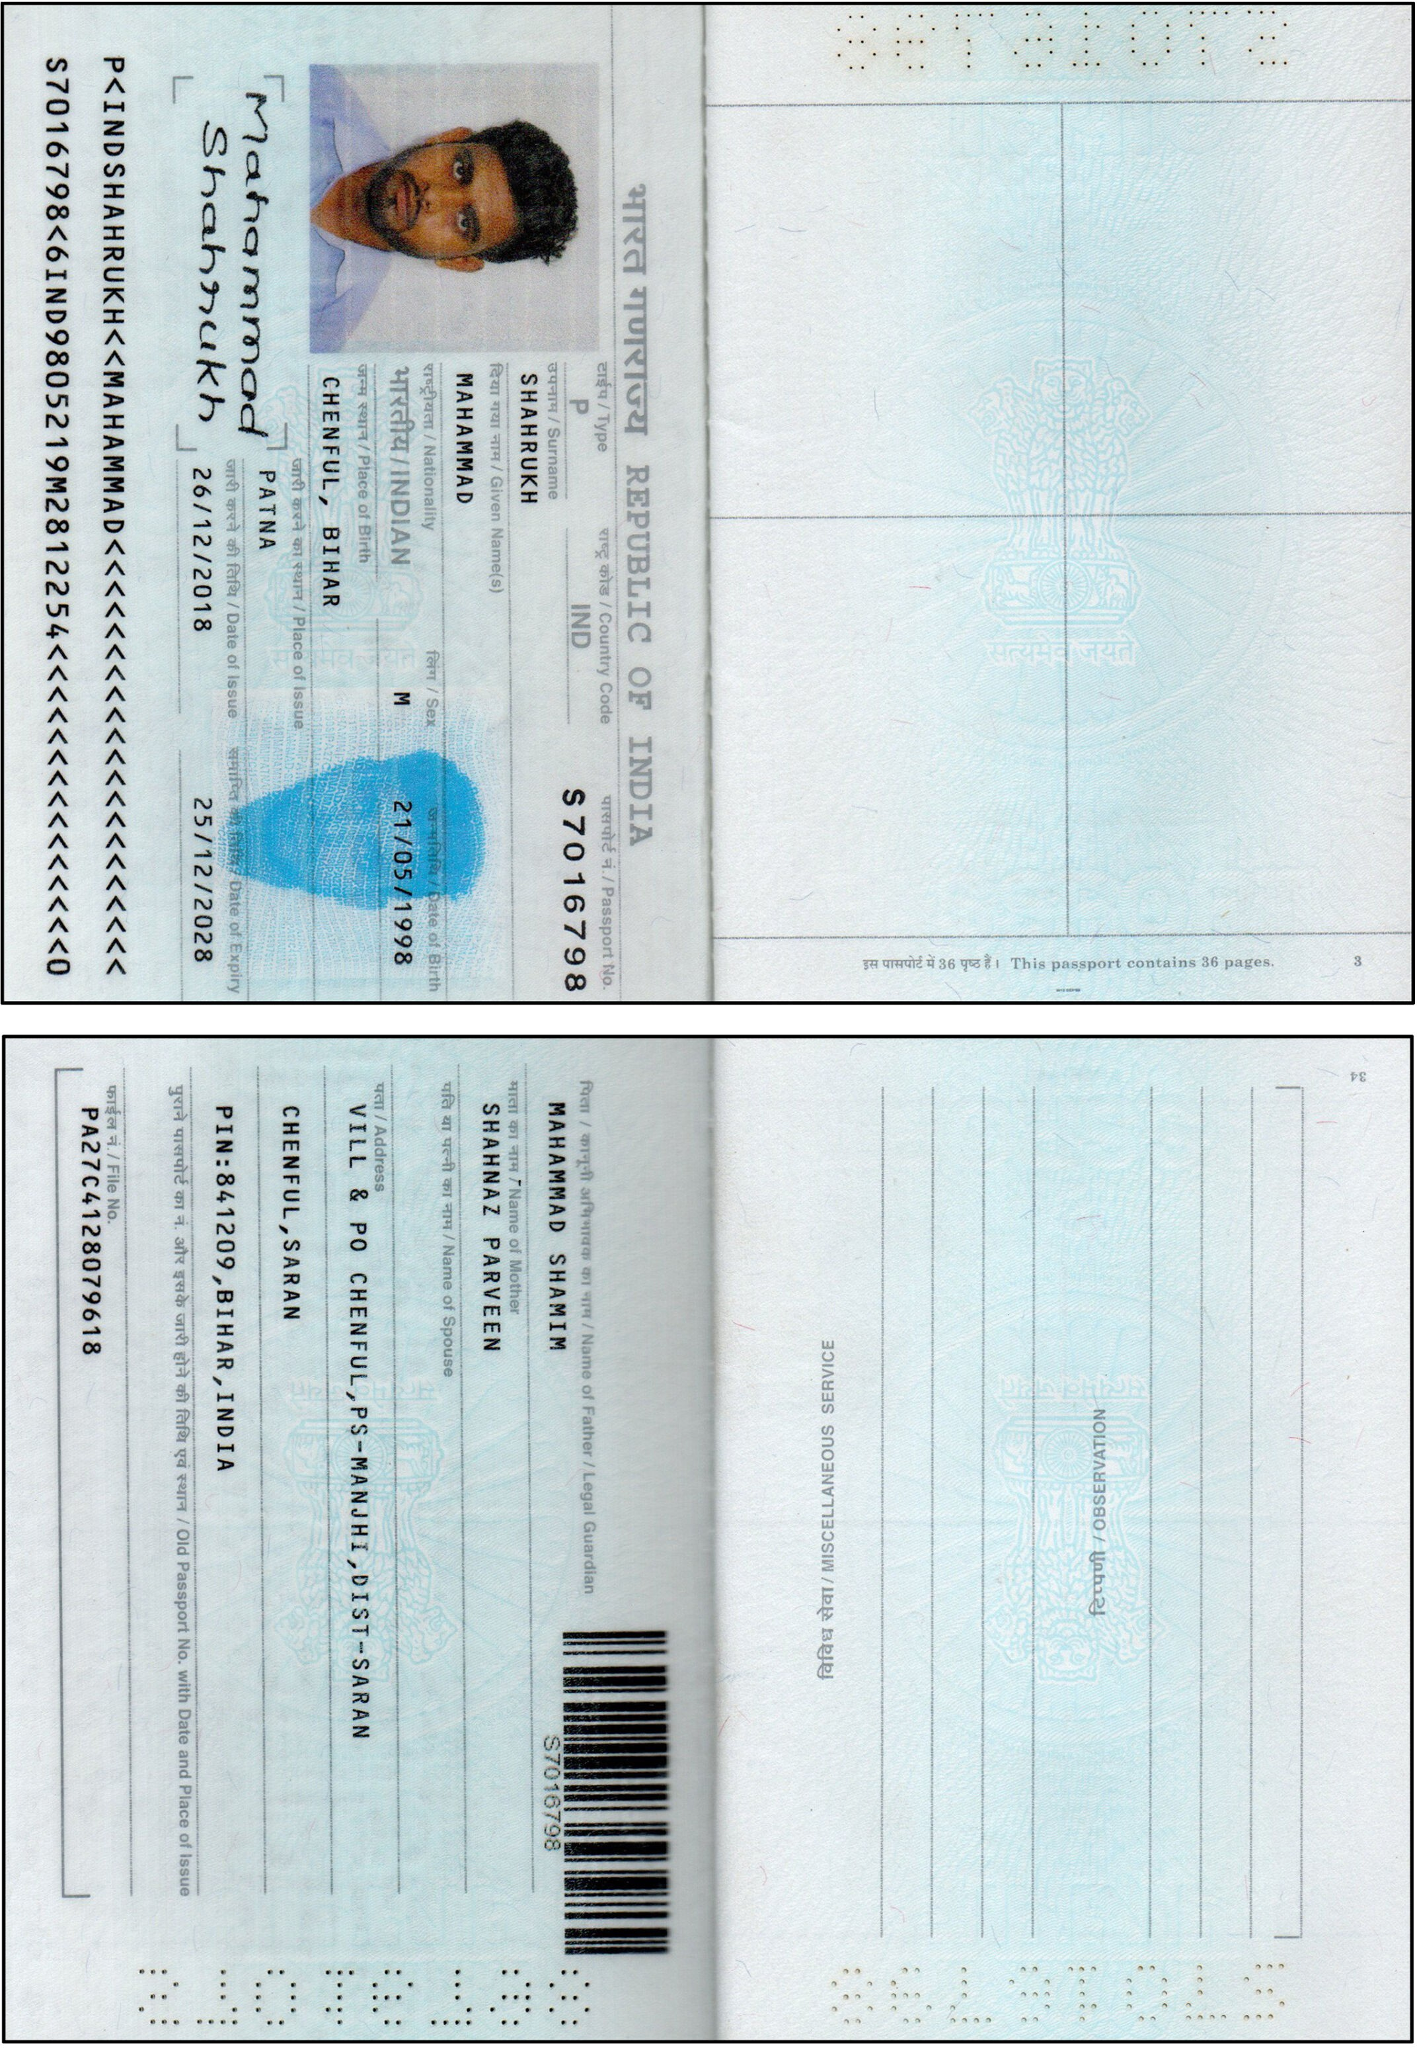

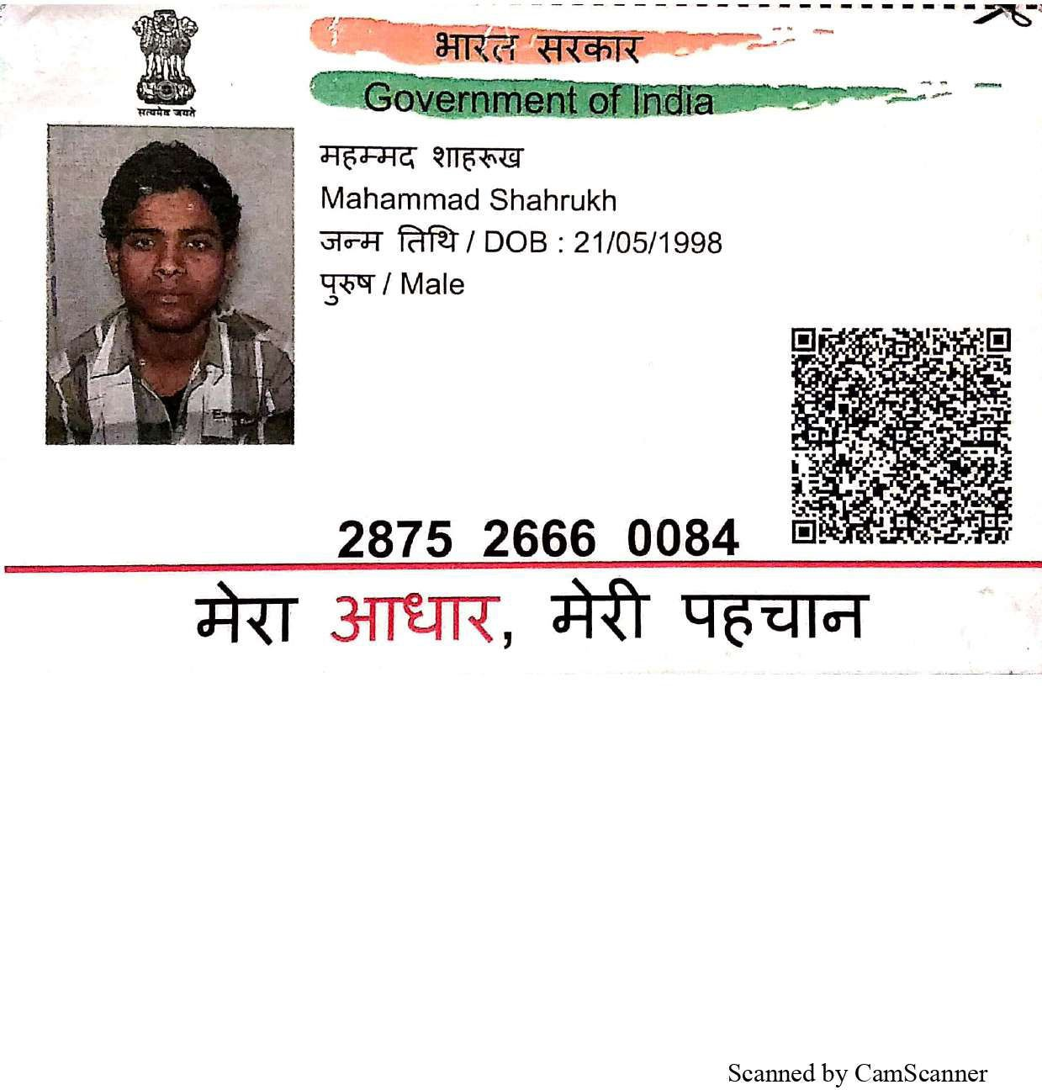

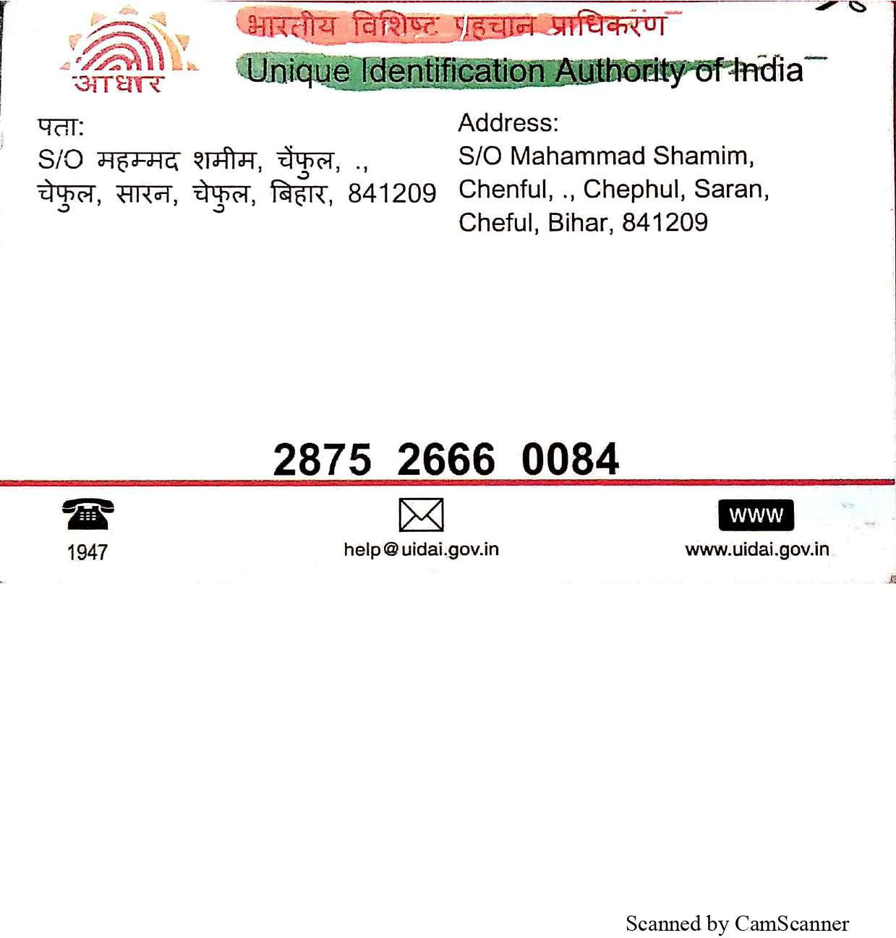

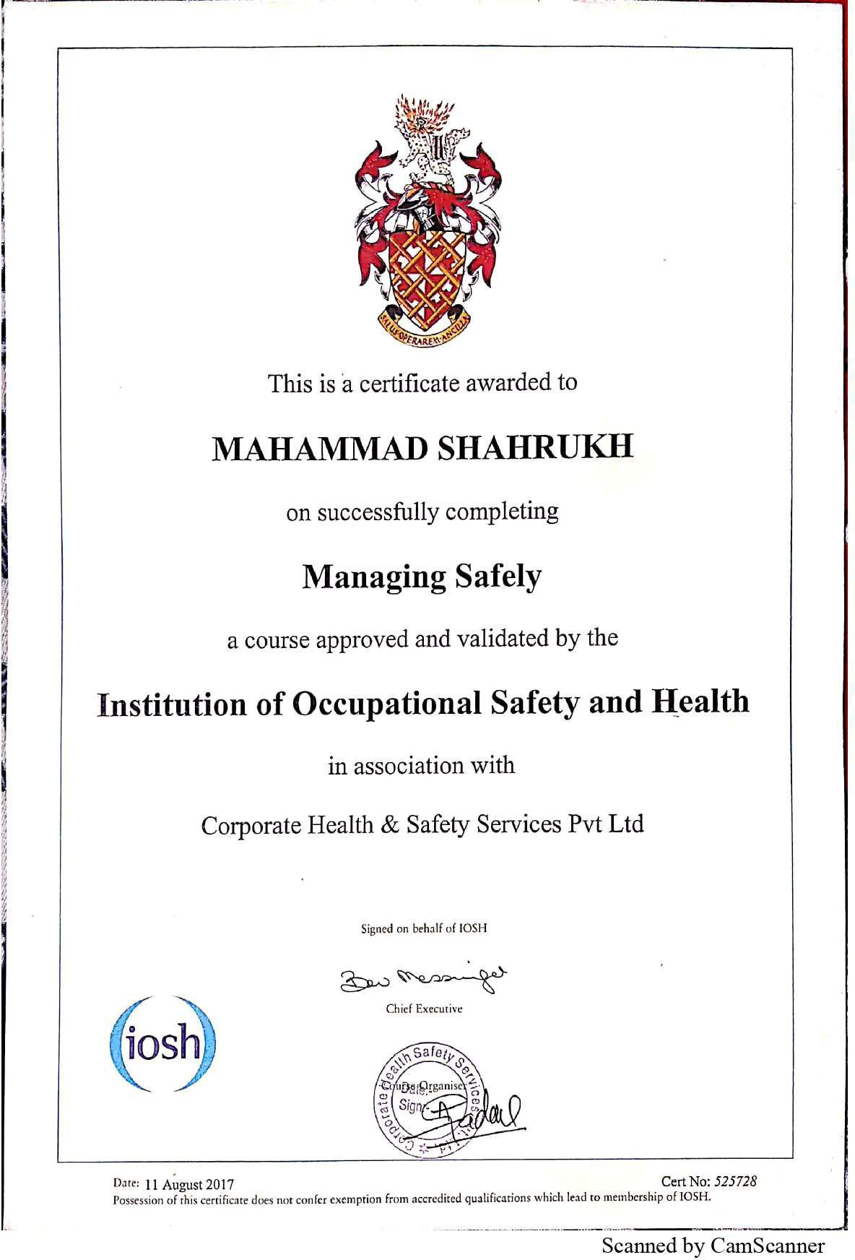

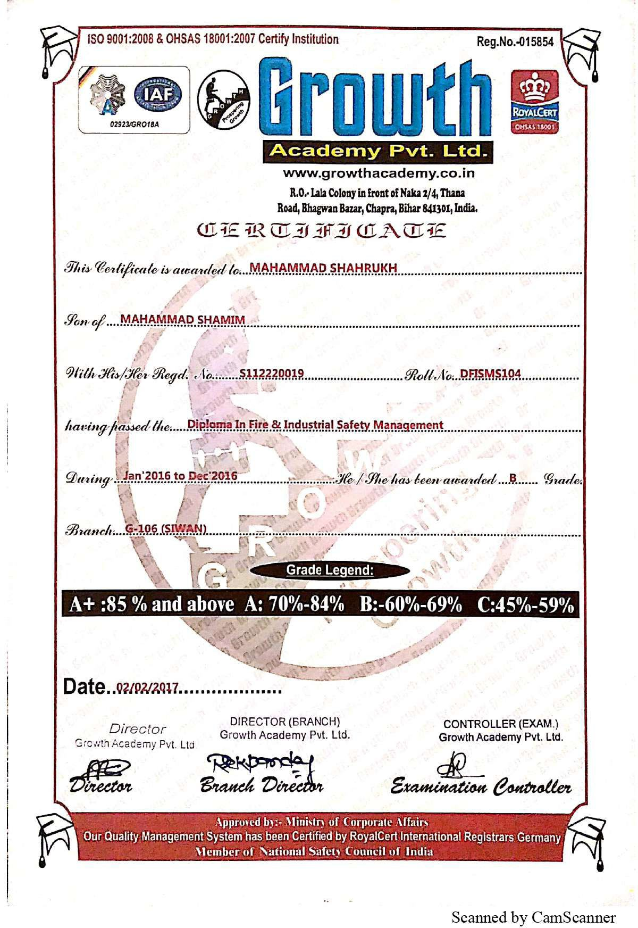

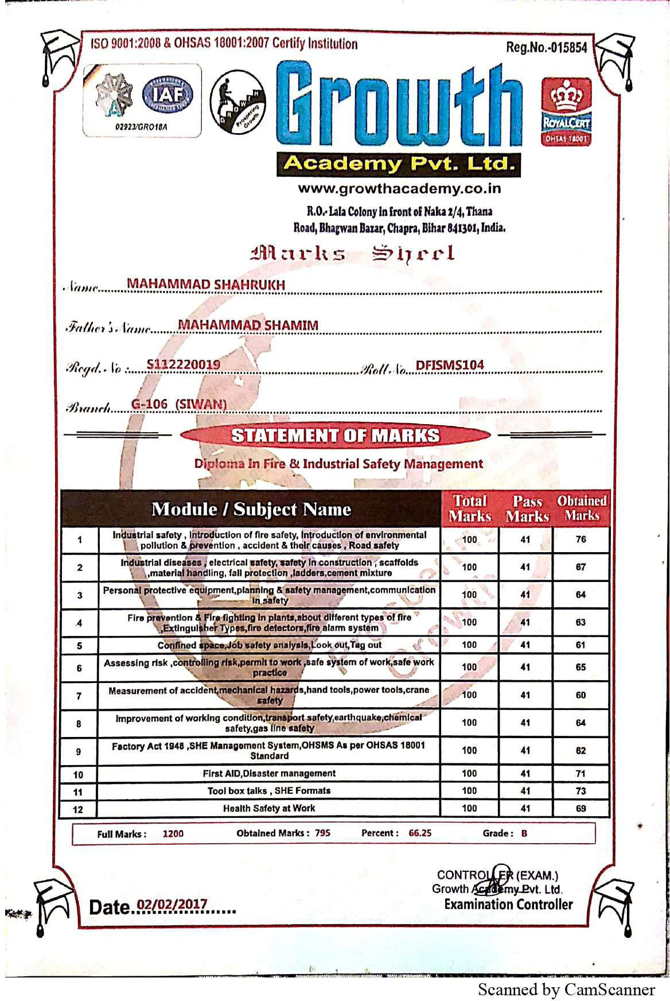

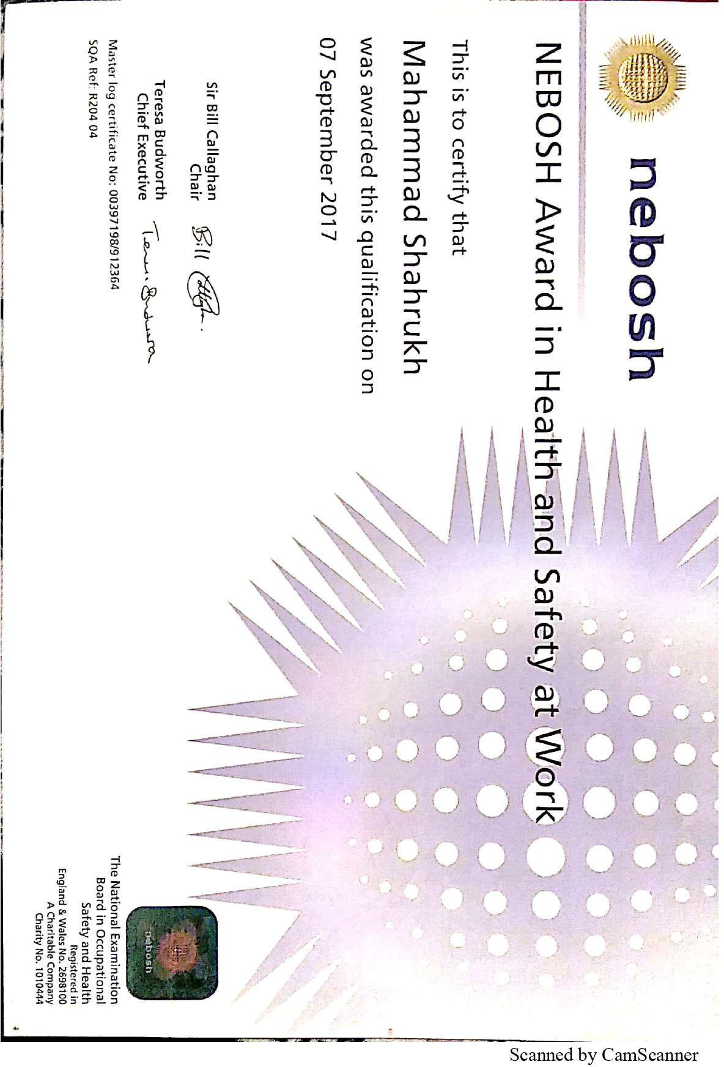

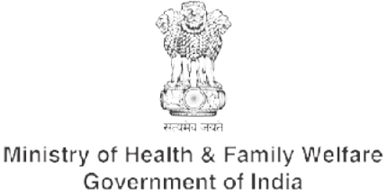
Certiﬁcate for COVID-19 Vaccination
Issued in India by Ministry of Health & Family Welfare, Govt. of India

Certiﬁcate ID
56108386811

Beneﬁciary Details
Beneﬁciary Name / लाभाथ चे नाव Age / वय
Gender / ल ग
ID Veriﬁed / ओळखप Unique Health ID (UHID)
Beneﬁciary Reference ID Vaccination Status / लसीकरण ती
Vaccination Details Vaccinated By / यां ा ार लसीकरण Vaccination At / लसीकरणाचे ळ

Mahammad Shahrukh 25
Male
Passport # S7016798

52749077379260
Fully Vaccinated (2 Doses) and a Precaution Dose

Dr falguni
MBMC WPideal park 1, Thane, Maharashtra

Dose Number Date of Dose डोस मांक डोसची तारीख
Vaccine Name लसीचे नाव
Batch Number बॅच मांक
Vaccine Type Manufacturer
लस कार उ पादक


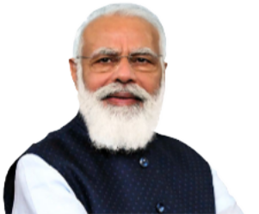

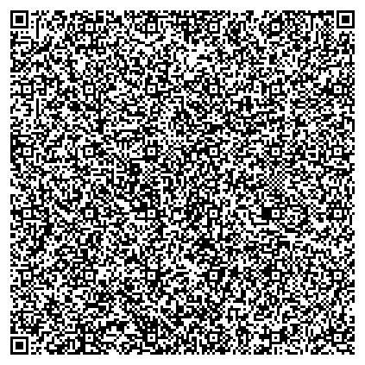
औषध सु ा आ ण श सु ा
Together, India will defeat COVID-19”
- पंत धान ी. नर मोदी
In case of any adverse events, kindly contact the nearest Public Health Center/
Healthcare Worker/District Immunization Oﬃcer/State Helpline No. 1075
कोणतेही तकलू प रणाम आढळून आ यास कृ पया जवळचे साव ज नक आरो य क / आरो यसेवा कम चारी/ ज हा लसीकरण अ धकारी/ रा य ह पलाइन मांक १०७५ वर संपक साधा.
This certiﬁcate can be veriﬁed by scanning the QR code at
http://verify.cowin.gov.in
1/2 | 13 Oct 2021 | COVISHIELD | COVID-19 vaccine, Serum Institute of India Pvt.  4121z007m non-replicating viral vector Ltd.
2/2 | 07 Jan 2022 | COVISHIELD | COVID-19 vaccine, Serum Institute of India Pvt.  4121Z259 non-replicating viral vector Ltd.
Precaution dose | 12 Aug 2022 | COVISHIELD | COVID-19 vaccine, Serum Institute of India Pvt.  223204321A non-replicating viral vector Ltd.



