BIM MODELER / AUTOCAD DRAFTSMAN
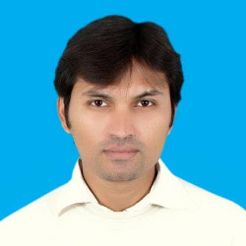
Name: Muhammad Shahid Saleem
Phone: 0556358765
Email: honey945.sgd@gmail.com
Location: JEDDAH
Revit/AutoCAD/3D Models
(ARCH./ STR./ ELECT. / AND MECH.)

Objectives
To obtain a responsible and challenging career position within an
organization where there are opportunities for personal growth and career Development.

Academic Qualification

Matriculation (2004) SARGODHA Pakistan (2004)
AUTOCAD NICON COLLAGE 6TH ROAD RAWALPINDI (2014)
AUTOCAD JINNAH INSITUTE SARGODHA Pakistan (2008)
3D STUDIO MAX JINNAH INSITUTE SARGODHA Pakistan (2008)
REVIT 2021 BIM PAK (2023)
NEWIS WORK BIM PAK (2023)

I Have 17 Year Working Experience in This Field as a
BIM MODELER AND AUTOCAD DRAFTSMAN
4 years CAD Draftsman Experience in Pakistan with SCE (Shahzad Consulting Engineer). As a Structural Draftsman
13years BIM MODLING / CAD Draftsman Experience in Saudi Arabia with (STS/DW) Working Time Period: 2013 to till Now. As a General Draftsman (Architectural, Structural, Electrical and Mechanical)

CORE SKILLS
- Building Information Modeling (BIM)
- Revit (Architecture / Structure / MEP)
- Navisworks Manage / Clash Detection
- AutoCAD 2D & 3D
- 3D Visualization (Optional: Enscape
- Model Coordination
- Shop Drawings / As-built Drawings
- Quantity Take-off (QTO)
- Family Creation – Revit
- LOD 100–500 Modeling
- Interdisciplinary Coordination
- IFC Export / COBie Data
- Project Documentation
AutoCAD & Drafting
- AutoCAD 2D/3D
- Structural Drawings.
- Architecture Drawings.
- Civil Drawings.
- Electrical Drawings.
- Mechanical Drawings.
- 3D Studio Max.
- Light, Camera & Environment settings.
- Rendering.

Work Experience in Saudi Arabia
- Worked in STS/DW AL ATF’UF COMPANY FOR ELECTRICAL WORKS /DEVELOPMENT WORKS as a Draughtsman Since -23rd MARCH 2013 to TILL NOW.
Work Experience in Pakistan
- Worked in SEC SHAHZAD CONSULTENT ENGINEER as a Draughtsman Since -01st AUG 2008 to 18 DEC 2012.
- In this period worked architectural working structural drawings and electrical drawings of various educational, residential & commercial projects.
Computer Skills
- Operating system Windows XP/Vista/Server.
- Auto CAD 2004/2006/2008/2009/2022MEP.
- MS Office, Power point, Word, Visio, Excel.
Internet.
- Adobe Photo shop 7/CS-2/CS-4.
- Corel Draw 11/12.
- 3D Studio Max.
- 3D SKETCHUP
- REVIT 2023

Interest
- Architectural drafting
- Structural drafting
- Electrical drafting
- Mechanical
- Study
Projects in Saudi Arabia
- MILITERY HOUSING PROJECT (NUAIRIYAH KSA)
- (PHASE-1 & PHASE-2)
- UNIVERIESTY RESIDENTIONAL BUILDINGS (AL QASSIM)
- SNB AL AHLI BANK MAIN BRANCH (AL KHOBAR)
- CUSTOMS AUTHORITY RESIDENCE BUILDINGS PROJECT IN DURRA/HAQAL
- UNIVERESTY HOSPITAL PROJECT IN TABUK
- SULMAN HABIB HOSPITAL JEDDAH (AS A BIM MODELER / ELECT & MECH.)
- FOUR SEASONS HOTAL JEDDAH (AS A BIM MODLER / ELECT & MECH.) STILL WORKING
Projects in Pakistan
- DHA Tower (20 Story) DHA Phase-II, Islamabad.
- Rehman Abad Tower (8 story Commercial/Office building) on Plot No.26-B Satellite Town, Murree Road Rawalpindi.
- 7-Storey Building for State Bank of Pakistan at G-5/2 Islamabad.
- Fast University Faisalabad All Structure Drawings
- Fast University Lahore All Structural Drawings
- RAI HOSPITAL SARGODHA PAKISTAN
- 5 STAR HOTAL BUILDING SWAT/KALAM
- And More Residence Project Architectural, Structural Drawings
Language
English Good
Arabic Good
Urdu My National Language
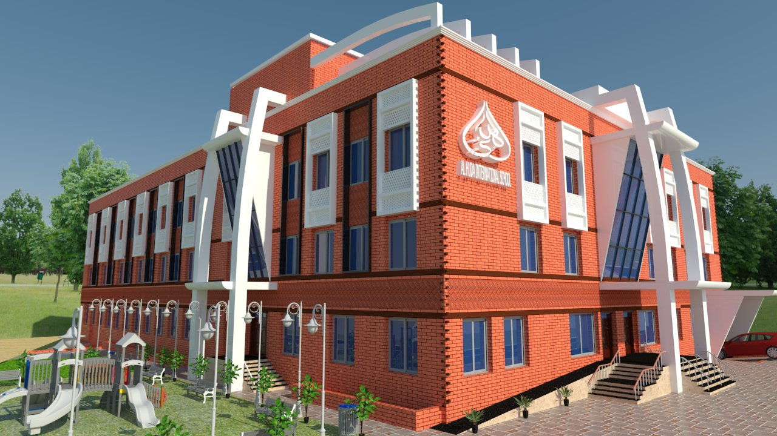
Panjabi My City language
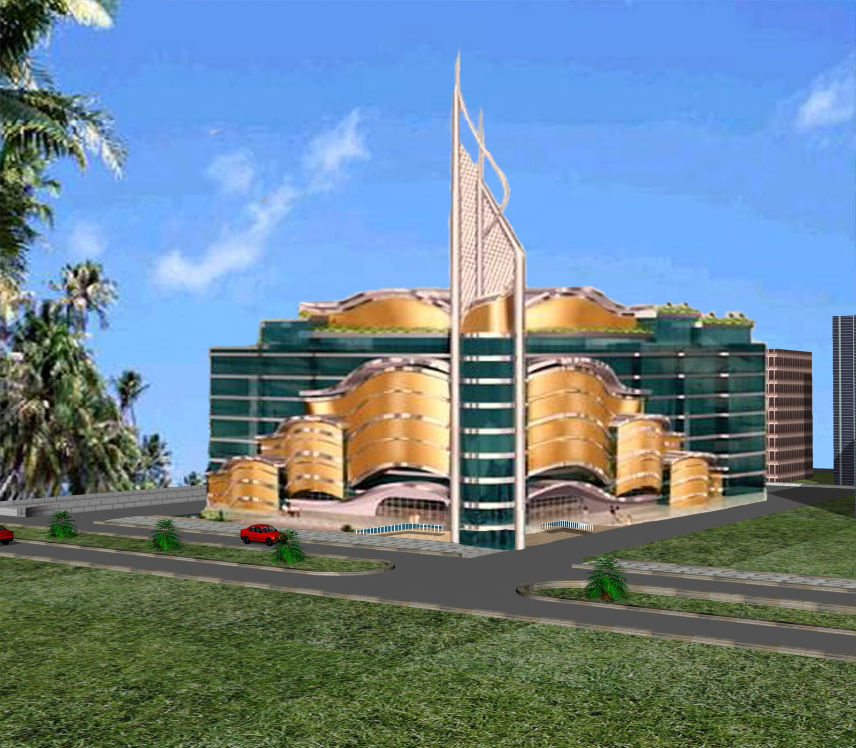

REVIT WORK 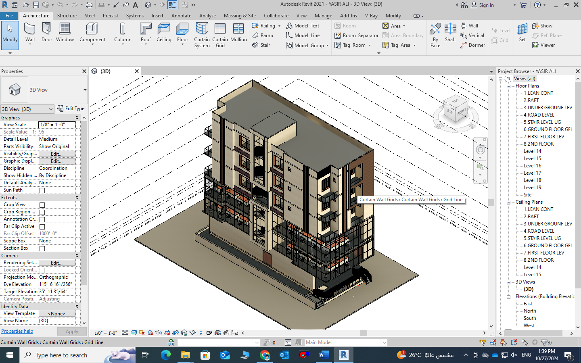
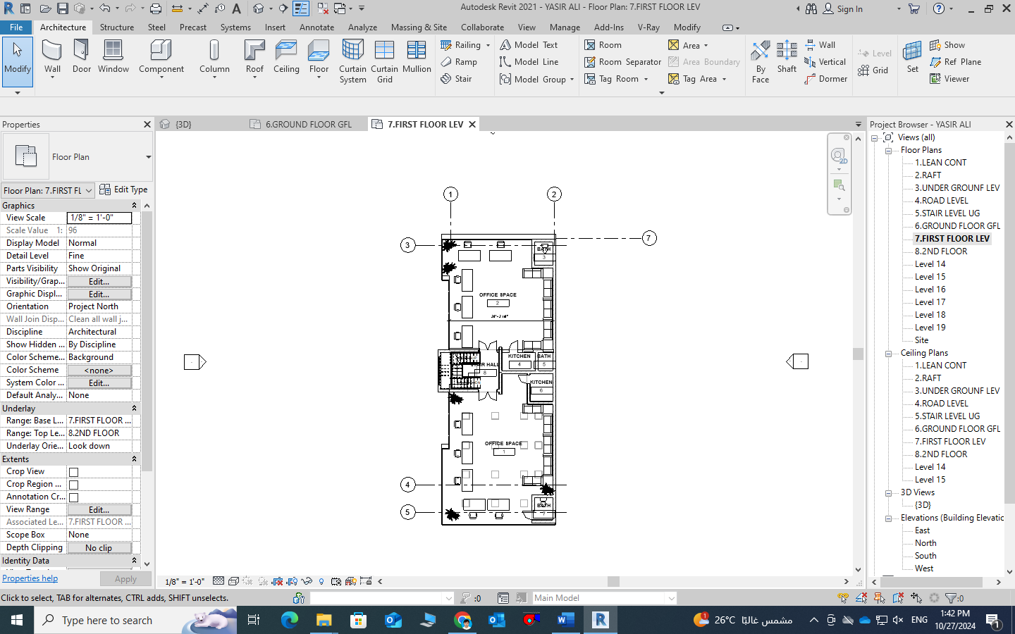

PROJECT: FOUR SEASONS JEDDAH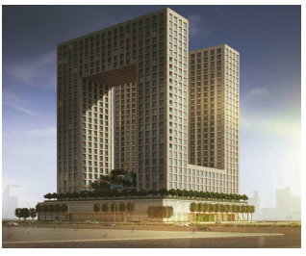

LEVEL CORRDINATION DRAWING (FOR SAMPLE)