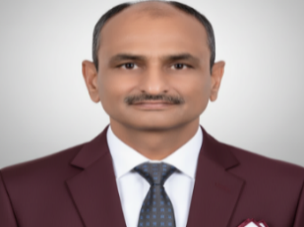 MUHAMMAD.SHOAIB QURESHI
Personal Information:
Date OF Birth: 20th October 1970
Religion: Islam
Nationality: Pakistan
Qualification: Intermediate
Passport No: DB4919413
Date Expiry: 23 FEB 2030
Driving License: Saudi Arabia
Mobil No. PK – 00923052555971 KSA 00966544227503 / 00966572455423
Email: mohd.muhammadshoaibq758@gmail.com
Job: Batching Plant / Workshop Supervisor:
Working Experience:
- 2001-2004:
AL KIFHA BATCHING PLANT CO. HAFOF SAUDI ARABIA PLANT ERECTION.
Sound Knowledge in Plant Erection/Control Panel Wiring’s-UAE-QATAR-KUWAIT, Plant Erection.
- 27th May 2005 to 30 April 2008:
AL-MAHALIYA READY MIX CONCRETE COMPANY KUAWIT.
Batching Plant Libber Machine 3M3 Wet Mix Plant with Alkon Version 6 Software’s 9M3 Dry Mix Plant with Alkon 4.44 Version Software.AL-Kifah 4M3 Wet Mix Plant Alkon Version 6 Software.
- 2008 to 2011:
UNI BETON READY MIX CONCRETE COMPNY. UAE
Three Year experience UAE. X.Tak Plant 3M3 / 4.5M3 Dorner Software V.5.
O-Cuoghi-C-Plant Double shouts 4.5M3 Mixer.
- 2011 to 2015:
AL KHODARI COMPNY (KSA)
Three Year Experience Plant Supervising. AirPort Project UM AL MELH KSA.
- 2015- 2023:
Workshop Supervisor Mastour Ready Mix KSA Jeddah
MAN / VOLVO / ACTARAS / concrete pumps / Loaders
Excavators / Concrete mixers. Asphalt Plant /Crusher plant.
Checking and troubleshooting of all type Electrical Control Panels.
Workshop all type Breakdown trucks.
- All Type Crusher Plant Experience Electrical work.

